‘Do you know’ questions
Answers
1 Chemical changes and structure
1.1 Periodicity (p. 8)
1 More energy is required to break the strong metallic bonds holding magnesium atoms together than to break the weak LDF between oxygen molecules.
2 Sodium has delocalised electrons.
3 Covalent
4 a 8; b 4
5 Monatomic
6 The number of electrons in the halogen molecules increases so the LDF strength increases.
1.2 Trends in the periodic table (p. 10)
1 An atom of potassium has more electron shells than a lithium atom.
2 a Mg(g) → Mg⁺(g) + e⁻
b Mg⁺(g) → Mg²⁺(g) + e⁻
3 Fluorine atoms have a higher nuclear charge than lithium atoms.
4 A magnesium atom has electron arrangement 2,8,2. To remove the third electron, you have to remove it from the second shell (closer to the nucleus and less screened). The first and second electrons are removed from the third shell (further from the nucleus and screened by the inner shells).
5 P atoms and H atoms have an identical electronegativity value (2.2) so electrons are equally shared in the bond.
1.3 Structure and bonding (p. 18)
1 London dispersion forces (weakest); pdp–pdp; hydrogen bonding (strongest)
2 a Hydrogen bonds; b hydrogen bonds; c hydrogen bonds; d LDF; e pdp–pdp
3 The LDF between propane molecules are stronger than the LDF between methane molecules.
4 Sodium chloride (most ionic); hydrogen chloride; phosphorus hydride (most covalent)
5
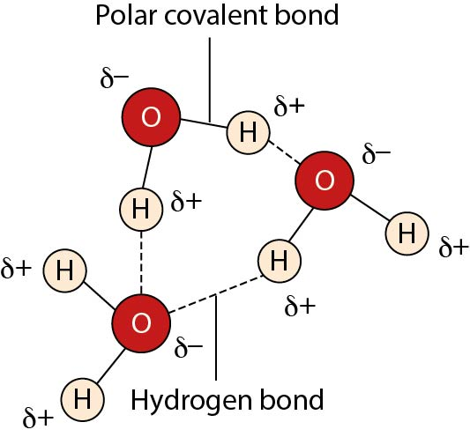
1.4 Oxidising and reducing agents (p. 21)
1 Ca + F₂ → Ca²⁺ + 2F⁻
2 a Cl₂; b Al
3 BiO₃⁻ + 6H⁺ + 2e⁻ → Bi³⁺ + 3H₂O
4 2IO₃⁻ + 12H⁺ + 10e⁻ → I₂ + 6H₂O
5 They are used as antiseptics because they can destroy bacteria, fungi and viruses.
6 F₂ (strongest), Br₂, Cu, Na
2 Nature’s chemistry
2.1 Systematic carbon chemistry (p. 28)
1 a 4,4-dimethylpent-1-ene
b 4-ethylhex-2-ene
c Buta-1,3-diene
d Methylcyclopropane
2 a But-2-ene
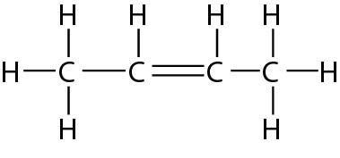
b Cyclobutane
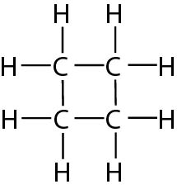
Methylpropene
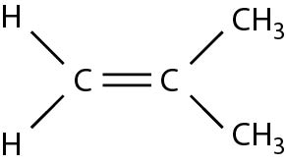
3 a Butane
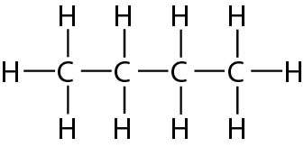
b Butan-1-ol
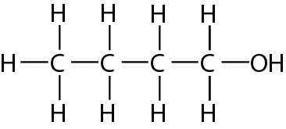
Butan-2-ol
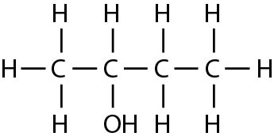
4 Propene and water
5 But-1-ene has larger molecules than ethene so the strength of LDF between but-1-ene molecules is greater than that between ethene molecules. It takes more energy to overcome the forces between but-1-ene molecules so it has a higher boiling point.
2.2 Alcohols and carboxylic acids (p. 32)
1 a Hexan-3-ol
b (2-)methylpropan-1,2-diol
c Methanol
d 2-methylbutan-1-ol
2 a Secondary; c primary; d primary
3
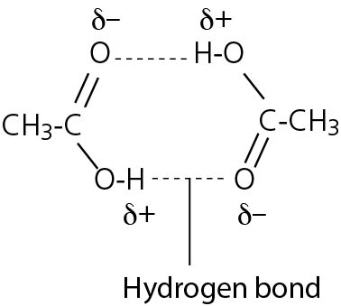
4 a Sodium carbonate and methanoic acid
b Potassium oxide (or potassium hydroxide) and ethanoic acid
c Calcium oxide (or calcium hydroxide) and octanoic acid
5 They can hydrogen bond efficiently to water.
2.3 Esters, fats and oils (p. 36)
1 a
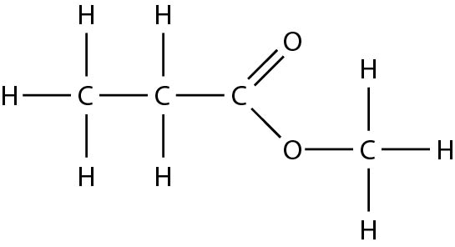
b
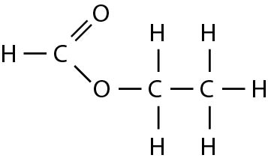
2 a Butyl methanoate
b Ethyl ethanoate
3 3 : 1
4 The presence or absence of double bonds
5 Condensation
2.4 Soaps, detergents and emulsions (p. 39)
1 Add an alkali to hydrolyse the fat
2 The carboxylate section of the soap molecule ‘sits’ on the outside of the oil droplet.
3 The long hydrocarbon tail (because it is non-polar)
4 Detergents do not have a carboxylate head; they have an ionic or polar head.
5 An emulsifier
2.5 Proteins (p. 42)
1 a
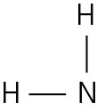
b
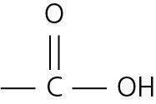
c
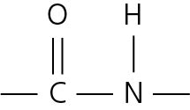
2 a
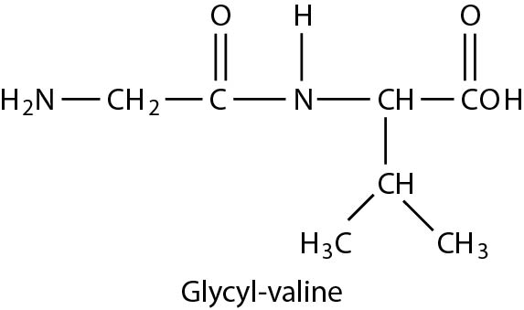
b Condensation
3
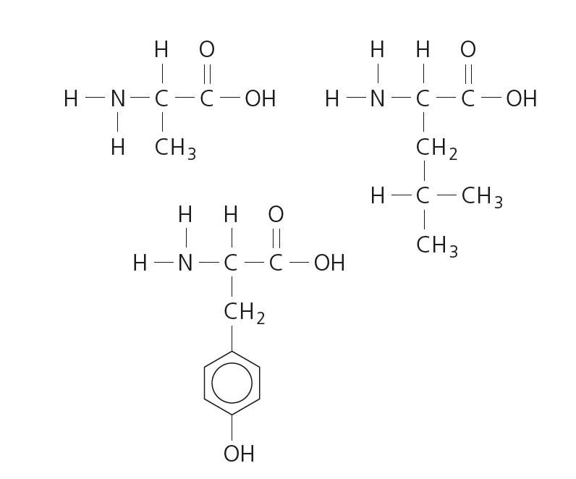
4 Denature/denaturing
5 An amino acid that the body must obtain through the diet because it cannot be made by the body.
2.6 Oxidation of food (p. 46)
1 A Propanone
B Pentan-2-one
C Pentanal
D Pentan-3-one
E 5-methylhexan-2-one
F 3-methylpentanal
G 3-methylbutanoic acid
H Pentanoic acid
I 2-methylbutanoic acid
2 C gives pentanoic acid; F gives 3-methylpentanoic acid
3 Fehling’s solution; acidified dichromate; Tollens’ reagent
4 Edible oils
5 a i Propanal
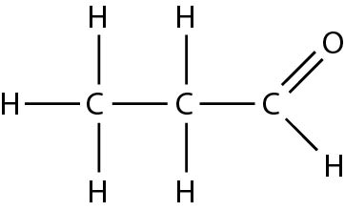
ii Propanone
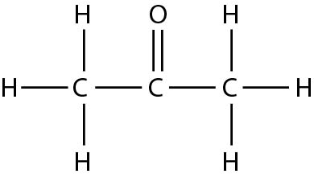

iii Propanoic acid
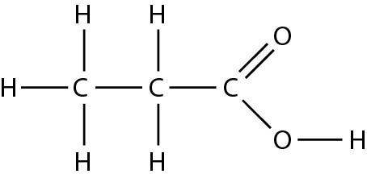
b Reduction
2.7 Fragrances (p. 48)
1 Insoluble in water; volatile
2
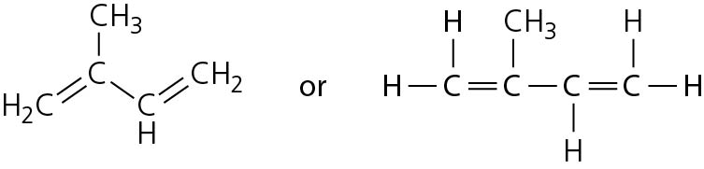
3 6 units
4
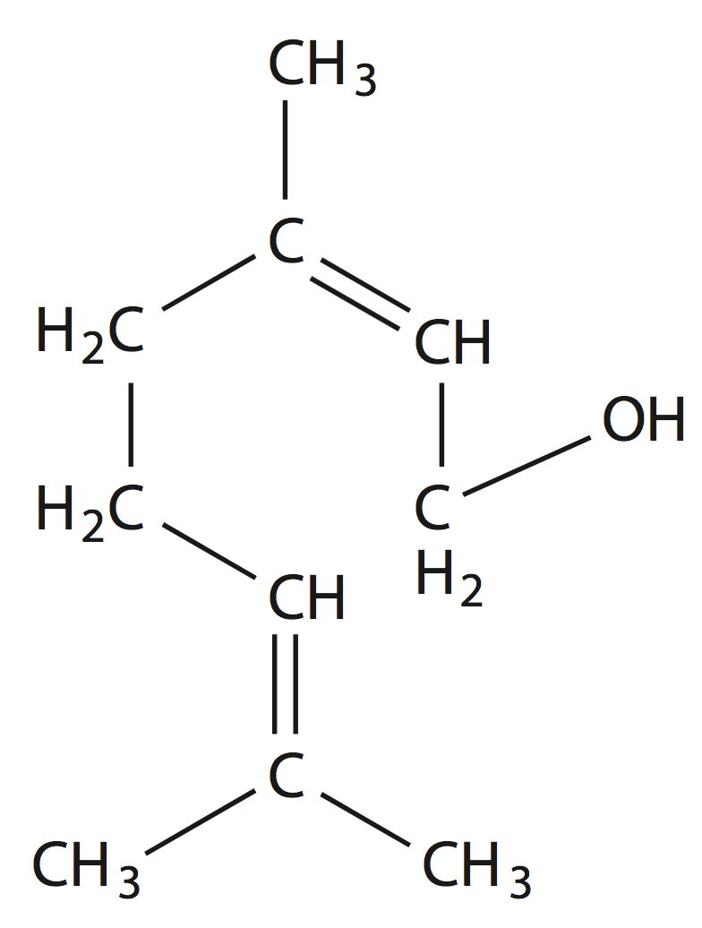
5 Essential oils tend to be insoluble in water (and contain hydrocarbons such as terpenes) and so are likely to be non-polar molecules, like hexane.
2.8 Skin care (p. 50)
1 a Br₂ → Br• + Br•
b F₂ → F• + F•
2 C₂H₆ + Cl• → C₂H₅• + HCl
C₂H₅• + Cl₂ → C₂H₅Cl + Cl•
3 CH₃• + Cl• → CH₃Cl
4 a An atom or molecule that has unpaired electrons
b A substance that reacts with free radicals to form stable molecules
5 It has a high energy; sufficient to break covalent bonds.
3 Chemistry in society
3.1 Getting the most from reactants (p. 55)
1 a Exothermic reactions:
- can use the heat released to heat reactions or provide warmth
- can be costly to cool or can lead to the reaction getting out of control if the temperature is not monitored carefully.
b Endothermic reactions:
- unlikely to lead to loss of control/explosion because the temperature stays low
- heat must usually be supplied, which is expensive.
2 Nitrogen; hydrogen
3 By-products can be re-used (if they are unused reactants) or sold for profit.
4 Oxides of nitrogen, sulfur dioxide and carbon dioxide are all acidic gases so if released into the environment they can lower the pH of surrounding water (rivers, sea etc.) or can cause acid rain to form. Carbon dioxide is a greenhouse gas, so most countries impose limits on the volume that can be released.
5 The sea is a reliable source of water and this can be used for cooling. It is also a source of salts that may be used in chemical reactions. After treatment, waste water can be discharged into the sea. Crude oil and natural gas are extracted from the sea bed. Locating near to a refinery allows ease of access to crude oil, natural gas or the feedstocks obtained from these raw materials.
Many reactants and products can be transported by container ship.
3.2 Chemical calculations (p. 58)
1 26.125 g

2 50 cm³ of oxygen
200 cm³ of carbon dioxide
300 cm³ of water
3 3.2 litres
4 a 56.8%
b 71%
3.3 Controlling the rate (p. 61)
1 a 100
b 40
c 0.04
d 0.01
2 At the higher temperature the particles have more energy so more particles have an energy equal to or greater than the activation energy.
3 A catalyst lowers the activation energy.
4 a 70 kJ mol⁻¹
b −30 kJ mol⁻¹
5 An unstable arrangement of atoms of high energy, formed at the top of the activation energy curve. It is an intermediate between the reactants and the products.
3.4 Chemical energy (p. 64)
1 −111.03 kJ
2 33.65 g
3 −310 kJ mol⁻¹
4 −128 kJ mol⁻¹
5 −545 kJ mol⁻¹
3.5 Equilibria (p. 66)
1 a Lowers; b no effect; c no effect
2 a Shifts to the right; b shifts to the right
3 a Shifts to the right; b shifts to the left
4 The catalyst speeds up the rates of the forward and reverse reactions by the same amount.
5 …the rate of the forward reaction is equal to the rate of the reverse reaction.
3.6 Chemical analysis (p. 69)
1 a E
b E
c Dilute the sample
2 0.267 mol litre⁻¹
3 A solution of accurately known concentration
4 0.063 g
5 Self-indicating

