**STEP, MAT, TMUA: Skills for success in University Admissions Tests for Mathematics**

**Full solutions – Part 2**

**Chapter 7: Graph sketching, identification and transformation**

**Two questions to think about (page 80)**

1. Considering where the product $\sin\left(2x-90°\right)×\cos\left(45°-x\right)$ is positive or $0$ (the $2$ will not change where this is).

Sketching the graphs of $y=\sin\left(2x-90°\right)$ and $y=\cos\left(45°-x\right)$ is one way of answering this question.

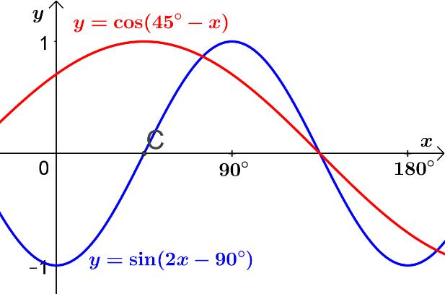

For the given domain $y=\sin\left(2x-90°\right)$ is negative for $0≤x<45°$, positive for $45°<x<135°$ and negative for $135°<x<180°$. It is $0$ for $x=45°$ and $x=135°$

For the given domain $y=\cos\left(45°-x\right)$ is positive for $0≤x<135°$ and negative for $135°<x<180°$. It is $0$ for $x=135°$.

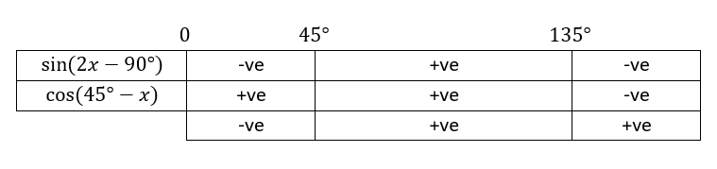

The product is positive (or equal to $0$) for $45°≤x≤180°$

This is $\frac{3}{4}$ of the domain so the correct option is E.

1. The graphs of $y=\log_{10}{x}$ and $y=x^{2}+8x-2$ are sensible starting points.

Completing the square for $y=x^{2}+8x-2$ gives $y={\left(x+4\right)}^{2}-18$. The sketch will be a parabola with a vertex at $\left(-4, -18\right)$. The graph will intercept the $x$ axis at $x=-4±3\sqrt{2}$.

The graph of $y={\left(x+4\right)}^{2}-18$ will be below the $x$ axis for $-4-3\sqrt{2}<x<-4+3\sqrt{2}$

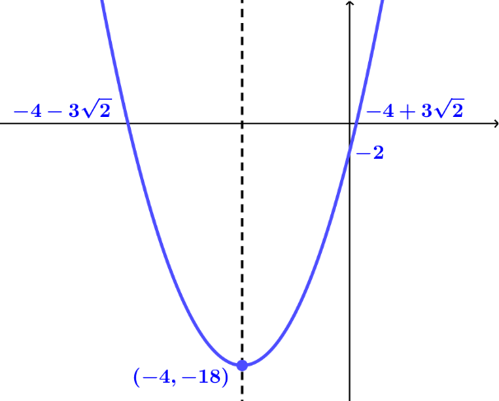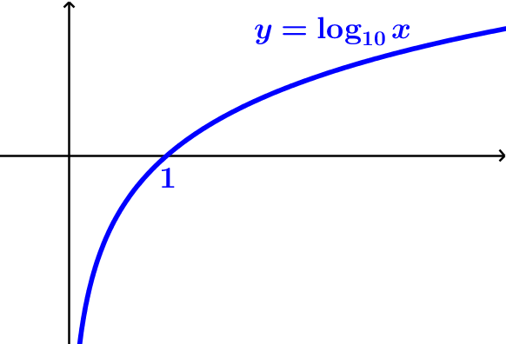

$\log_{10}{x}$ is undefined for $x≤0$ so the graph of $y=\log_{10}\left(\frac{1}{x^{2}+8x-2}\right)$ will be undefined for $-4-3\sqrt{2}≤x≤-4+3\sqrt{2}$

As $x→-4-3\sqrt{2}$ from the left, $\left(x^{2}+8x-2\right)→0$ (from the positive direction) so $\frac{1}{x^{2}+8x-2}→∞^{+}$ and $\log_{10}\left(\frac{1}{x^{2}+8x-2}\right)→∞^{+}$

As $x→-4+3\sqrt{2}$ from the right, $\left(x^{2}+8x-2\right)→0$ (from the positive direction) so $\frac{1}{x^{2}+8x-2}→∞^{+}$ and $\log_{10}\left(\frac{1}{x^{2}+8x-2}\right)→∞^{+}$

$y={\left(x+4\right)}^{2}-18$ has the line of reflection symmetry $x=-4$ so the graph of $y=\log_{10}\left(\frac{1}{x^{2}+8x-2}\right)$ will also have the line of symmetry $x=-4$.

As $x→∞^{+}$, $\left(x^{2}+8x-2\right)→∞^{+}$ so $\frac{1}{x^{2}+8x-2}→0$ and $\log_{10}\left(\frac{1}{x^{2}+8x-2}\right)→∞^{-}$

As $x→∞^{-}$, $\left(x^{2}+8x-2\right)→∞^{+}$ so $\frac{1}{x^{2}+8x-2}→0$ and $\log_{10}\left(\frac{1}{x^{2}+8x-2}\right)→∞^{-}$

Since $\log_{10}{1}=0$, when $\frac{1}{x^{2}+8x-2}=1$, the graph of $y=\log_{10}\left(\frac{1}{x^{2}+8x-2}\right)$ will intercept the $x$ axis.

$\frac{1}{x^{2}+8x-2}=1\overset{⇔}{ } x^{2}+8x-2=1$

$x^{2}+8x-3=0$ has solutions $x=-4±\sqrt{19}$

Putting this information together gives the sketch graph

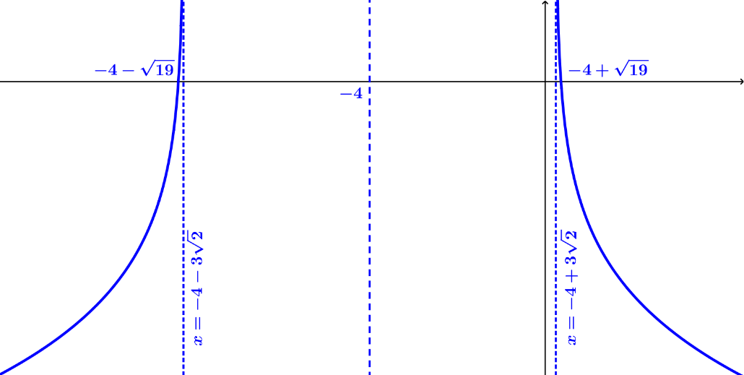

**Try it out (page 82)**

1. The sum and difference of two even functions

If $f\left(x\right)$ and $g\left(x\right)$ are even functions, $f\left(-x\right)=f\left(x\right)$ and $g\left(-x\right)=g\left(x\right)$

Let the function $h\left(x\right)=f\left(x\right)+g\left(x\right)$

then $h\left(-x\right)=f\left(-x\right)+g\left(-x\right)$

$h\left(-x\right)=f\left(x\right)+g\left(x\right)$ since $f\left(x\right)$ and $g\left(x\right)$ are even functions so $h\left(-x\right)=h\left(x\right)$

The sum of two even functions is an even function

Similarly if $h\left(x\right)=f\left(x\right)-g\left(x\right)$

then $h\left(-x\right)=f\left(-x\right)-g\left(-x\right)$

$$h\left(-x\right)=f\left(x\right)-g\left(x\right)=h\left(x\right)$$

The difference between two even functions is an even function

1. The sum and difference of two odd functions

If $f\left(x\right)$ and $g\left(x\right)$ are odd functions, $f\left(-x\right)=-f\left(x\right)$ and $g\left(-x\right)=-g\left(x\right)$

Let the function $h\left(x\right)=f\left(x\right)+g\left(x\right)$

then $h\left(-x\right)=f\left(-x\right)+g\left(-x\right)$

$h\left(-x\right)=-f\left(x\right)-g\left(x\right)$ since $f\left(x\right)$ and $g\left(x\right)$ are even functions

so $h\left(-x\right)=-\left(f\left(x\right)+g\left(x\right)\right)=-h\left(x\right)$

The sum of two odd functions is an odd function

Similarly if $h\left(x\right)=f\left(x\right)-g\left(x\right)$

then $h\left(-x\right)=f\left(-x\right)-g\left(-x\right)$

$$h\left(-x\right)=-f\left(x\right)+g\left(x\right)=-\left(f\left(x\right)-g\left(x\right)\right)=-h\left(x\right)$$

The difference between two odd functions is an odd function

1. The sum and difference of an even function and an odd function

If $f\left(x\right)$ is an even function and $g\left(x\right)$ is an odd function then

$f\left(-x\right)=f\left(x\right)$ and $g\left(-x\right)=-g\left(x\right)$

Let the function $h\left(x\right)=f\left(x\right)+g\left(x\right)$

then $h\left(-x\right)=f\left(-x\right)+g\left(-x\right)$

$h\left(-x\right)=f\left(x\right)-g\left(x\right)$ since $f\left(x\right)$ is an even function and $g\left(x\right)$ is an odd function

The resulting function is neither even nor odd (unless one of the functions is equal to $0$ over the given domain)

Similarly if $h\left(x\right)=f\left(x\right)-g\left(x\right)$

then $h\left(-x\right)=f\left(-x\right)-g\left(-x\right)$

$$h\left(-x\right)=f\left(x\right)+g\left(x\right)$$

The resulting function is neither even nor odd (unless one of the functions is equal to $0$ over the given domain)

1. The product and quotient of two even functions

If $f\left(x\right)$ and $g\left(x\right)$ are even functions, $f\left(-x\right)=f\left(x\right)$ and $g\left(-x\right)=g\left(x\right)$

Let the function $h\left(x\right)=f\left(x\right)g\left(x\right)$

then $h\left(-x\right)=f\left(-x\right)g\left(-x\right)=f\left(x\right)g\left(x\right)=h\left(x\right)$

The product of two even functions is an even function

Let the function $h\left(x\right)=\frac{f\left(x\right)}{g\left(x\right)}$

then $h\left(-x\right)=\frac{f\left(-x\right)}{g\left(-x\right)}=\frac{f\left(x\right)}{g\left(x\right)}$ since $f\left(x\right)$ and $g\left(x\right)$ are even functions so $h\left(-x\right)=h\left(x\right)$

The quotient of two even functions is an even function

1. The product and quotient of two odd functions

If $f\left(x\right)$ and $g\left(x\right)$ are even functions, $f\left(-x\right)=-f\left(x\right)$ and $g\left(-x\right)=-g\left(x\right)$

Let the function $h\left(x\right)=f\left(x\right)g\left(x\right)$

then $h\left(-x\right)=f\left(-x\right)g\left(-x\right)=-f\left(x\right)×-g\left(x\right)=f\left(x\right)g\left(x\right)=h\left(x\right)$

The product of two odd functions is an even function

Let the function $h\left(x\right)=\frac{f\left(x\right)}{g\left(x\right)}$

then $h\left(-x\right)=\frac{f\left(-x\right)}{g\left(-x\right)}=\frac{-f\left(x\right)}{-g\left(x\right)}$ since $f\left(x\right)$ and $g\left(x\right)$ are odd functions so $h\left(-x\right)=\frac{f\left(x\right)}{g\left(x\right)}=h\left(x\right)$

The quotient of two odd functions is an even function

1. The product and quotient of an even function and an odd function

If $f\left(x\right)$ is an even function and $g\left(x\right)$ is an odd function then $f\left(-x\right)=f\left(x\right)$ and $g\left(-x\right)=-g\left(x\right)$

Let the function $h\left(x\right)=f\left(x\right)g\left(x\right)$

then $h\left(-x\right)=f\left(-x\right)g\left(-x\right)=f\left(x\right)×-g\left(x\right)=-f\left(x\right)g\left(x\right)=-h\left(x\right)$

The product of an even and an odd function is an odd function.

Similarly if $h\left(x\right)=\frac{f\left(x\right)}{g\left(x\right)}$

then $h\left(-x\right)=\frac{f\left(-x\right)}{g\left(-x\right)}=\frac{f\left(x\right)}{-g\left(x\right)}=-\frac{f\left(x\right)}{g\left(x\right)}=-h\left(x\right)$

The quotient of an even and an odd function is an odd function.

**Try it out (page 82)**

$y=\sin{x}+\cos{2x}$

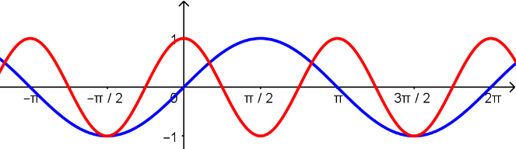

The graph of $y=\sin{x}$ has a period of $2π$ radians and the graph of $y=\cos{2x}$ has a period of $π$. Sketching each graph individually on the same axes makes it clear that their sum will repeat every $2π$ radians so the graph of $y=\sin{x}+\cos{2x}$ is periodic with period $2π$. The two sketches are simultaneously symmetrical about the lines $x=-\frac{π}{2}$, $x=\frac{π}{2}$, $x=\frac{3π}{2}$ and so on. These are the positive and negative odd number multiples of $\frac{π}{2}$. In general, any line of the form $x=\left(2n+1\right)\frac{π}{2}, n∈Z$ will be a line of reflection symmetry.

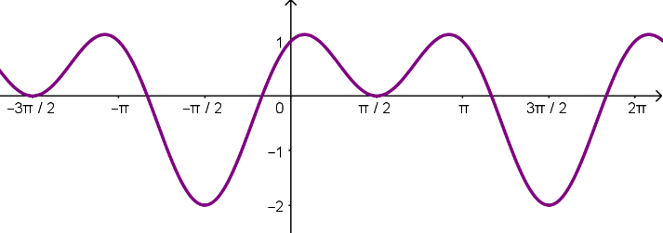

Sketching the sum of the two (by imagining the sum of the $y$ values of the previous two sketches) shows that there is no rotation symmetry.

$y=\frac{1}{2}e^{-x^{2}}$

This is an even function since $e^{-{\left(-x\right)}^{2}}≡e^{-x^{2}}$. It will have reflection symmetry in the line $x=0$. Imagining sketches of the graphs of $y=e^{x}$ and $y=x^{2}$ should be enough to indicate that the graph has no more symmetry.

$x^{2}y^{2}=\frac{3}{x+y}$

Substituting $x$ for $y$ and $y$ for $x$ into this will not change it so its graph will have reflection symmetry in the line $y=x$. If the graph were to be sketched, considering values that result in division by $0$ indicates that the line $y=-x$ is an asymptote. Rewriting the equation as $x+y=\frac{3}{x^{2}y^{2}}$ and considering division by $0$ indicates that the lines $x=0$ and $y=0$ are asymptotes. If both $x$ and $y$ are negative then $x^{2}y^{2}$ would be negative so which is not possible for real numbers so the graph does not exist in the third quadrant. This is enough to indicate that all the symmetry has been identified.

$y=2^{\left(1-2x-x^{2}\right)}$

The quadratic part of the function, $1-2x-x^{2}$, can be rewritten by completing the square as $2-{\left(x+1\right)}^{2}$. This has reflection symmetry in the line $x=-1$ so the graph of $y=2^{\left(1-2x-x^{2}\right)}$ will also have reflection symmetry in $x=-1$. Imagining the sketches of $y=2-{\left(x+1\right)}^{2}$ and $y=2^{x}$ should be enough to indicate that there is no further symmetry.

$y=\cos\left(x^{2}\right)$

This is an even function since $\cos\left({\left(-x\right)}^{2}\right)≡\cos\left(x^{2}\right)$. It has reflection symmetry in $x=0$. Although $\cos{x}$ is periodic, $\cos\left(x^{2}\right)$ will not be as $x^{2}$ does not increase at a uniform rate. Considering where the graph crosses the $x$ axis indicates that the “waves” get closer and closer together as $x$ increases in both the positive and negative directions.

$y=\frac{1}{x^{3}-x}$

This is an odd function. Rewriting it as $y=\frac{1}{x\left(x^{2}-1\right)}$ helps to show this. $\frac{1}{\left(-x\right)\left({\left(-x\right)}^{2}-1\right)}=-\frac{1}{x\left(x^{2}-1\right)}$. It has rotation symmetry about $(0, 0)$. Considering division by $0$ indicates that $x=0$, $x=-1$ and $x=1$ are asymptotes. As $x→∞^{+}$, the graph approaches $y=0$ from above and as $x→∞^{-}$, the graph approaches $y=0$ from below. There is no further symmetry.

**Try it out (page 83)**

Sketch the graph of $y=\sqrt{x^{2}-x-6}$.

$x^{2}-x-6≡\left(x-3\right)\left(x+2\right)≡{\left(x-\frac{1}{2}\right)}^{2}-\frac{25}{4}$.

$\left(x-3\right)\left(x+2\right)<0$ for $-2<x<3$ so the graph does not exist between $x=-2$ and $x=3$.

${\left(x-\frac{1}{2}\right)}^{2}-\frac{25}{4}$ shows that the graph has reflection symmetry in $x=\frac{1}{2}$

$\sqrt{x}$ and $x^{2}-x-6$ both increase as $x→∞^{+}$. This gives the part of the graph for $x>3$. The reflection symmetry can be used to sketch the rest of the graph.

The graph touches the $x$ axis when $\left(x-3\right)\left(x+2\right)=0$ i.e. at $x=-2$ and $x=3$

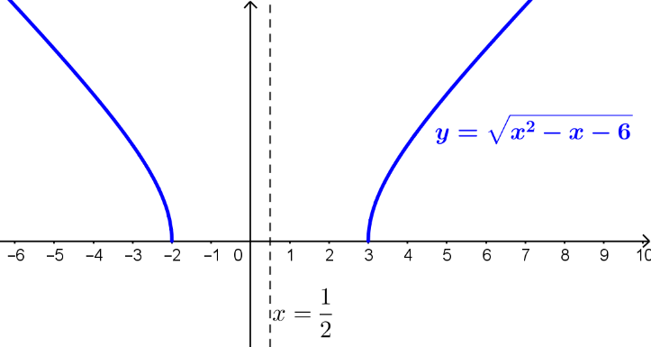

**Try it out (page 85)**

$$y=\frac{x^{3}-x^{2}+1}{x^{2}-x}$$

From the form $y=\frac{x-1+\frac{1}{x^{2}}}{1-\frac{1}{x}}$, for large positive $x$ e.g. $x=1000$, $x-1=999$

rewriting the expression as $y=\frac{x^{2}\left(x-1\right)+1}{x\left(x-1\right)}=x+\frac{1}{x\left(x-1\right)}$ and substituting $x=1000$ gives $y=1000+$ a small positive value. This is greater than $999$ indicating that the graph approaches $y=x-1$ from above for large positive $x$.

For large negative $x$, e.g. $x=-1000$, $x-1=-1001$. Using $y=x+\frac{1}{x\left(x-1\right)}$ once more gives $y=-1000+$ a small positive value. This is greater than $-1001$ indicating that the graph approaches $y=x-1$ from above for large negative $x$.

As the graph approaches $x=0$ from the left, i.e. $x$ is negative and small:

Consider $y=x+\frac{1}{x\left(x-1\right)}$. Since $\frac{1}{x\left(x-1\right)}$ approaches $∞$ and $x\left(x-1\right)$ will be positive (the product of two negative numbers) this indicates that $y$ approaches $+∞$

As the graph approaches $x=0$ from the right, i.e. $x$ is positive and small:

Consider $y=x+\frac{1}{x\left(x-1\right)}$. Since $\frac{1}{x\left(x-1\right)}$ approaches $∞$ and $x\left(x-1\right)$ will be negative ( $x-1<0$ for $x<1$) this indicates that $y$ approaches $-∞$

As the graph approaches $x=1$ from the left, i.e. $x<1$ but is close to $1$

$\frac{1}{x\left(x-1\right)}$ approaches $∞$ and $x\left(x-1\right)$ will be negative ( $x-1<0$ for $x<1$) indicating that $y$ approaches $-∞$

As the graph approaches $x=1$ from the right, i.e. $x>1$ but is close to $1$

$\frac{1}{x\left(x-1\right)}$ approaches $∞$ and $x\left(x-1\right)$ will be positive ($x>0$ and $x-1>0$ for $x>1$) indicating that $y$ approaches $+∞$

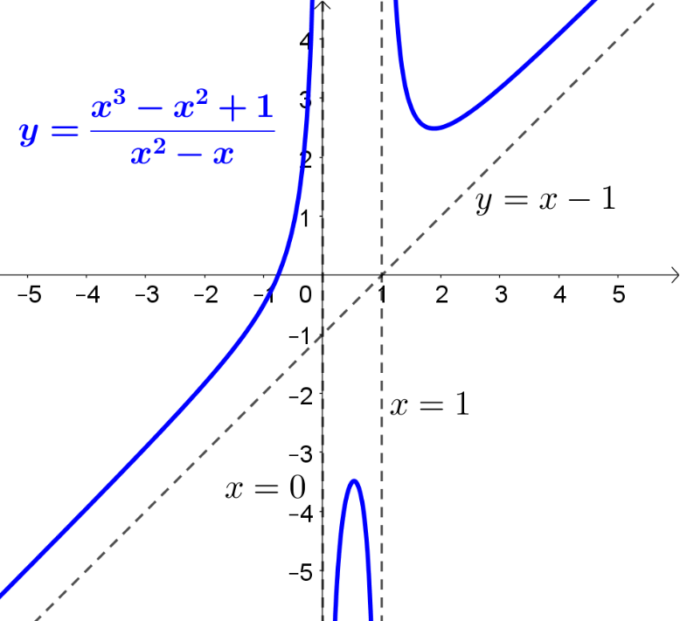

**Try it out (page 86)**

$x^{2}-4x+5$ is strictly increasing for $x > 2$ and decreasing for $x < 2$ so there won’t be any stationary points other than at $x=2$. The sketch of F shows two stationary points of inflection so it cannot be F, but it could be B.

**Try it out (page 87)**

$$y=e^{x}\sin{x}$$

Consider the graph of $y=A\sin{x}$ where $A$ is a real constant. $A$ acts as a multiplier stretching the graph of $y=\sin{x}$ by a scale factor of $A$. Since $\sin{x}$ is constrained between $y=-1$ and $y=+1$, $A\sin{x}$ will be constrained between $y=-A$ and $y=+A$. Using a multiplier of $e^{x}$ rather than $A$ will mean that there is a variable scale factor that increases as $x→∞^{+}$ and decreases (approaches $0$) as $x→∞^{-}$. $e^{x}\sin{x}$ will be constrained between $y=-e^{x}$ and $y=e^{x}$.

This is difficult to sketch with any real degree of accuracy but enough information can be conveyed to give the right idea.

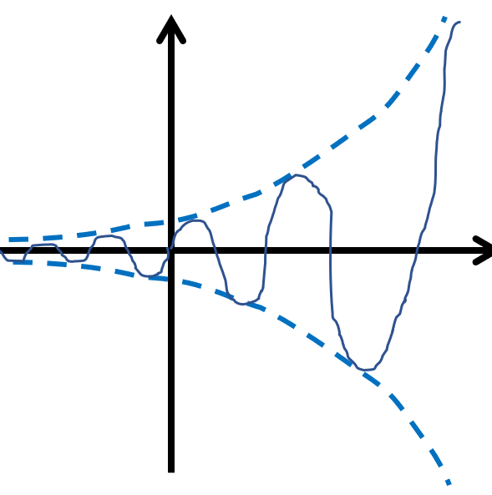

$$y=e^{x}\sin{x}$$

$$y={-e}^{x}$$

$$y=e^{x}$$

$$y=\frac{1}{10}\cos{6x}+\cos{x}$$

This is another example that is difficult to sketch that accurately but for which the main information can be conveyed.

Carefully sketching the two graphs $y=\frac{1}{10}\cos{6x}$ and $y=\cos{x}$ and then imagining the sum of their $y$ coordinates is a sensible approach to take.

$y=\frac{1}{10}\cos{6x}$ is constrained between $y=-\frac{1}{10}$ and $y=\frac{1}{10}$. It has period $\frac{2π}{6}=\frac{π}{3}$.

$y=\cos{x}$ is constrained between $y=-1$ and $y=1$. It has period $2π$

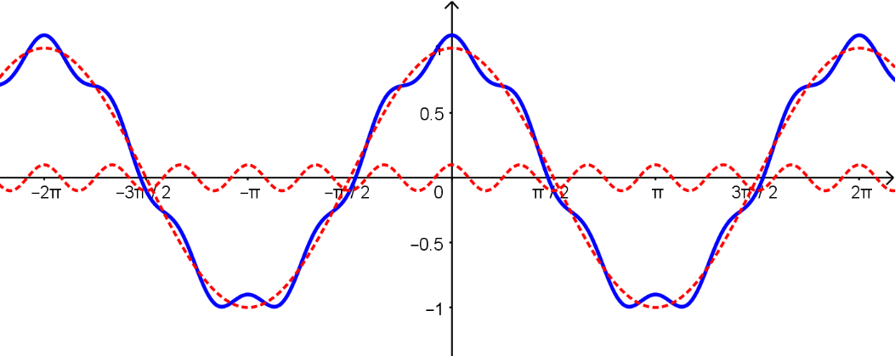

**Try it out (page 89)**

Rewriting $e^{x^{2}+3x+2}$ as $e^{{\left(x+\frac{3}{2}\right)}^{2}-\frac{1}{4}}$ and then as $e^{-\frac{1}{4}}e^{{\left(x+\frac{3}{2}\right)}^{2}}=k×e^{{\left(x+\frac{3}{2}\right)}^{2}}$ indicates that there is a translation in the $x$ direction and a stretch in the $y$ direction. This eliminates options a), b), c), d) and e) leaving only f) which must be the correct option.

No more work is required but if you wish to confirm this, let $f\left(x\right)=e^{x^{2}}$.

$e^{x^{2}+3x+2}=kf\left(x+\frac{3}{2}\right)$ so the translation occurs before the stretch.

**Try it out (page 91)**

$$y=\frac{x^{2}}{x^{2}+x-6}$$

The hint for this question should lead to the equation being rewritten as $y=1-\frac{x-6}{x^{2}+x-6}$ and, eventually $y=1-\frac{x-6}{\left(x+3\right)\left(x-2\right)}$

From the original equation, considering division by $0$ indicates that the graph will have vertical asymptotes at $x=-3$ and $x=2$.

As $x→-3$ from the left, $\frac{x-6}{\left(x+3\right)\left(x-2\right)}=\frac{-ve}{-ve × -ve}$ so $\frac{x-6}{\left(x+3\right)\left(x-2\right)}→∞^{-}$ and $y→∞^{+}$ (as you are subtracting a very large negative value from $1$)

As $x→-3$ from the right, $\frac{x-6}{\left(x+3\right)\left(x-2\right)}=\frac{-ve}{+ve × -ve}$ so $\frac{x-6}{\left(x+3\right)\left(x-2\right)}→∞^{+}$ and $y→∞^{-}$ (as you are subtracting a very large positive value from $1$)

As $x→2$ from the left, $\frac{x-6}{\left(x+3\right)\left(x-2\right)}=\frac{-ve}{+ve × -ve}$ so $\frac{x-6}{\left(x+3\right)\left(x-2\right)}→∞^{+}$ and $y→∞^{-}$ (as you are subtracting a very large positive value from $1$)

As $x→2$ from the right, $\frac{x-6}{\left(x+3\right)\left(x-2\right)}=\frac{-ve}{+ve × +ve}$ so $\frac{x-6}{\left(x+3\right)\left(x-2\right)}→∞^{-}$ and $y→∞^{+}$ (as you are subtracting a very large negative value from $1$)

From the form $y=1-\frac{x-6}{x^{2}+x-6}$, dividing all terms in the fraction by $x^{2}$ gives $y=1-\frac{\frac{1}{x}-\frac{6}{x^{2}}}{1+\frac{1}{x}-\frac{6}{x^{2}}}$

As $x→∞^{±}$, $\frac{1}{x}→0$ and $\frac{1}{x^{2}}→0$ so $y→1-\frac{0}{1+0}=1$ indicating that $y=1$ is a horizontal asymptote.

As $x→∞^{+}$, $x-6>0$ and $x^{2}+x-6>0$ so $\frac{x-6}{x^{2}+x-6}>0$ and $1-\frac{x-6}{x^{2}+x-6}<1$. The graph will approach $y=1$ from below. It must cross $y=1$ as $x$ increases from $2$ and then approach it from below.

As $x→∞^{-}$, $x-6<0$ and $x^{2}+x-6>0$ so $\frac{x-6}{x^{2}+x-6}<0$ and $1-\frac{x-6}{x^{2}+x-6}>1$. The graph will approach $y=1$ from above.

When $x=0$, $y=0$

This is enough information to sketch the graph.

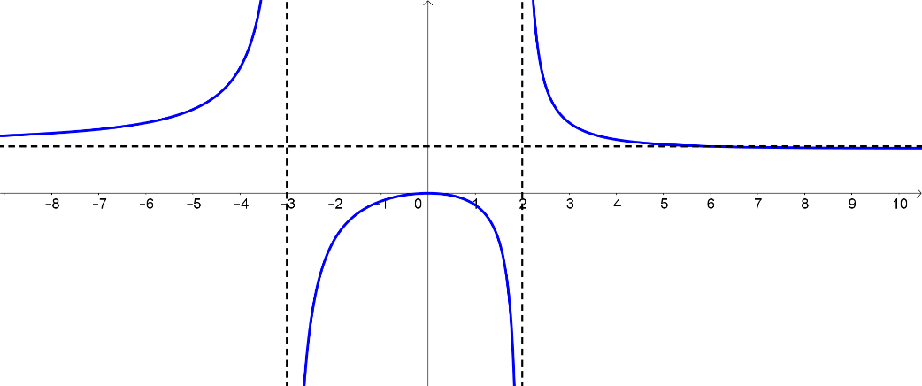

**Exercise 1**



$y=e^{\left|x-3\right|}$

$e^{\left|x-3\right|}=e^{\left|\left(-x\right)-3\right|}=e^{\left|-\left(x+3\right)\right|}=e^{\left|x+3\right|}$ so this is neither an odd nor an even function.

$\left|x-3\right|$ has reflection symmetry in the line $x=3$ so $e^{\left|x-3\right|}$ has reflection symmetry in $x=3$

It is not periodic.

$y=3x^{5}-6x$

$3{\left(-x\right)}^{5}-6\left(-x\right)=-3x^{5}+6x=-\left(3x^{5}-6x\right)$ so this is an odd function. It has rotation symmetry about $(0, 0)$

$y=\log_{2}\left(x^{2}-6x+5\right)$

$\log_{2}\left({\left(-x\right)}^{2}-6\left(-x\right)+5\right)=\log_{2}\left(x^{2}+6x+5\right)$ so this is neither an odd nor an even function. Since $x^{2}-6x+5≡{\left(x-3\right)}^{2}-4$ it has reflection symmetry in the line $x=3$

$y=\sin\left(\cos{x}\right)$

$\sin\left(\cos\left(-x\right)\right)=\sin\left(\cos{x}\right)$ so this is an even function. It has reflection symmetry in the line $x=0$.

$\cos{x}$ is periodic with period $2π$ radians and $\sin\left(-x\right)=-\sin{x}$ so $\sin\left(\cos{x}\right)$ is periodic with period $2π$ radians.

$\cos{x}$ has reflection symmetry in lines of the form $x=nπ$ where $n∈Z$ so $\sin\left(\cos{x}\right)$ also has reflection symmetry in $x=nπ$, $n∈Z$.

$\cos{x}$ has rotation symmetry about points of the form $\left(\left(2n+1\right)\frac{π}{2},0\right)$ where $n∈Z$ so $\sin\left(\cos{x}\right)$ will also have rotation symmetry about $\left(\left(2n+1\right)\frac{π}{2},0\right)$, $n∈Z$.

$y=\sin\left(\cos{x}\right)$ resembles $y=\cos{x}$ but does not reach a maximum of $1$ and a minimum of $-1$ since $\sin\left(\cos{0}\right)=\sin{1}$ and $\sin{1}<1$ and $\sin\left(\cos{π}\right)=\sin\left(-1\right)$ and $\sin\left(-1\right)>-1$

$y=\cos\left(\sin{x}\right)$

$\cos\left(\sin\left(-x\right)\right)=\cos\left(-\sin{x}\right)=\cos\left(\sin{x}\right)$ so this is an even function. It has reflection symmetry in the line $x=0$.

$\sin{x}$ is periodic with period $2π$ radians but $\cos\left(-x\right)=\cos{x}$ so $\cos\left(\sin{x}\right)$ is periodic with period $π$ radians (the negative values for $\sin{x}$ will return the same as their equivalent positive values when calculating $\cos\left(\sin{x}\right)$).

$\sin{x}$ has reflection symmetry in lines of the form $x=nπ$ where $n∈Z$. Since $\cos\left(-x\right)=\cos{x}$, $\cos\left(\sin{x}\right)$ has reflection symmetry in $x=\frac{nπ}{2}$, $n∈Z$.

The maximum value of $\cos\left(\sin{x}\right)$ will occur when $x=0$. This is $\cos\left(\sin{0}\right)=\cos{0}=1$. The minimum value will occur when $x=\frac{π}{2}$. This is $\cos\left(\sin{\frac{π}{2}}\right)=\cos{1}$ this is equal to $0.54$ to 2 d.p.

The graph will have rotation symmetry about a point on the curve half way between the maximum and the minimum points. These will be at points $\left(\left(2n+1\right)\frac{π}{4},0.75\right)$, $n∈Z$. Note that the $0.75$ is approximation, the value is actually $0.77$ to 2 d.p.

$y=\frac{e^{x^{2}}}{x}$

$\frac{e^{{\left(-x\right)}^{2}}}{\left(-x\right)}=-\frac{e^{x^{2}}}{x}$ so this is an odd function and has rotation symmetry about $\left(0, 0\right)$

$\frac{xy}{\left(x+y\right)}=100$

Swapping $x$ and $y$ does not change this so the graph has reflection symmetry in the line $y=x$

$y=2x^{3}-6x^{2}+3x+3$

Neither odd nor even.

$f\left(x\right)=2x^{3}-6x^{2}+3x+3$

$f^{ '}\left(x\right)=6x^{2}-12x+3x$

$6x^{2}-12x+3=0$

$2x^{2}-4x+1=0$

$x=1±\frac{\sqrt{2}}{2}$ possible symmetry about $x=1$, $y=2-6+3+3=2$

Translate $\left(\begin{matrix}-1 \\ -2\end{matrix}\right)$ to make this easy to identify

$g\left(x\right)=2{\left(x-1\right)}^{3}-6{\left(x-1\right)}^{2}+3\left(x-1\right)+3-2$

$g\left(x\right)=2x^{3}-3x$ which is an odd function.

$g\left(x\right)$ has rotation symmetry about $\left(0, 0\right)$ so $f\left(x\right)$ has rotation symmetry about $\left(1, 2\right)$

$y=\frac{x^{2}-2}{\left(x+1\right)\left(x-1\right)}$

Even function. It has reflection symmetry in $x=0$ and no other symmetry

$y=\tan\left(\sin{2x}\right)$

Since $\sin{2x}$ is periodic with period $π$, $\tan\left(\sin{2x}\right)$ will be periodic with period $π$

$f\left(x\right)=\tan\left(\sin{2x}\right)$

$f\left(-x\right)=\tan\left(\sin\left(-2x\right)\right)=\tan\left(-\sin{2x}\right)=-\tan\left(\sin{2x}\right)$

Odd function. It has rotation symmetry about $\left(0,0\right)$ and every point $\left(\frac{nπ}{2},0\right)$ where $n∈Z$ since $\sin{2x}=0$ for $x=$ $\frac{nπ}{2}$, $n∈Z$

It has reflection symmetry in $x=(2n+1)\frac{π}{4}$, $n∈Z$

1. Need to show $f^{'}\left(-x\right)=-f^{'}\left(x\right)$

$f^{'}\left(x\right)=\lim_{h→0}{\frac{f\left(x+h\right)-f\left(x\right)}{h}}$

$f^{'}\left(-x\right)=\lim_{h→0}{\frac{f\left(-x+h\right)-f\left(-x\right)}{h}}$

$f^{'}\left(-x\right)=\lim_{h→0}{\frac{f\left(-\left(x-h\right)\right)-f\left(-x\right)}{h}}$

As $f$ is an even function, $f\left(-x\right)=f\left(x\right)$

hence $f^{'}\left(-x\right)=\lim_{h→0}{\frac{f\left(x-h\right)-f\left(x\right)}{h}}$

As $h→0$, $f\left(x-h\right)-f\left(x\right)→-\left(f\left(x+h\right)-f\left(x\right)\right)$

$f^{'}\left(-x\right)=\lim_{h→0}{\frac{-\left(f\left(x+h\right)-f\left(x\right)\right)}{h}}=-\lim_{h→0}{\frac{f\left(x+h\right)-f\left(x\right)}{h}}=-f^{'}\left(x\right)$

The differential of an even function is an odd function.

To show that the differential of an odd function is an even function:

Need to show that if $f\left(-x\right)=-f\left(x\right)$ then $f^{'}\left(-x\right)=f^{'}\left(x\right)$

$f^{'}\left(x\right)=\lim_{h→0}{\frac{f\left(x+h\right)-f\left(x\right)}{h}}$

$f^{'}\left(-x\right)=\lim_{h→0}{\frac{f\left(-x+h\right)-f\left(-x\right)}{h}}$

$f^{'}\left(-x\right)=\lim_{h→0}{\frac{f\left(-\left(x-h\right)\right)-f\left(-x\right)}{h}}$

As $f$ is an odd function, $f\left(-x\right)=-f\left(x\right)$

Hence $f^{'}\left(-x\right)=\lim_{h→0}{\frac{-f\left(x-h\right)+f\left(x\right)}{h}}=\lim_{h→0}{\frac{-\left(f\left(x-h\right)-f\left(x\right)\right)}{h}}=-\lim_{h→0}{\frac{f\left(x-h\right)-f\left(x\right)}{h}}$

As $h→0$, $f\left(x-h\right)-f\left(x\right)→-\left(f\left(x+h\right)-f\left(x\right)\right)$

$f^{'}\left(-x\right)=-\lim_{h→0}{\frac{-\left(f\left(x+h\right)-f\left(x\right)\right)}{h}}=\lim_{h→0}{\frac{f\left(x+h\right)-f\left(x\right)}{h}}=f^{'}\left(x\right)$

The differential of an odd function is an even function..



$x^{2}-11x+28>0$

$\left(x-4\right)\left(x-7\right)>0$

Exists for $x<4∪x>7 in x∈R$



$6+x-x^{2}>0$

$x^{2}-x-6<0$

$\left(x-3\right)\left(x+2\right)<0$

Exists for $-2<x<3$ in $x∈R$

$x^{3}-2x^{2}-x+2>0$

$\left(x-1\right)\left(x^{2}+kx-2\right)≡x^{3}-2x^{2}-x+2$

Coefficients of $x^{2}$: $k-1=-2$ so $k=-1$

$\left(x-1\right)\left(x^{2}-x-2\right)>0$

$\left(x-1\right)\left(x-2\right)\left(x+1\right)>0$

Exists for $-1≤x≤1∪x≥2 in x∈R$

$\log_{10}\left(x^{2}+3x-3\right)>0$

$x^{2}+3x-3>1$

$x^{2}+3x-4>0$

$\left(x+4\right)\left(x-1\right)>0$

Exists for $x≤-4∪x≥1 in x∈R$

$2x^{2}-3x-2≠1$

$2x^{2}-3x-2>0$

$\left(2x+1\right)\left(x-2\right)>0$

Exists for

1. 1. as ,

as the curve approaches from below. As $x→+∞$ the curve approaches from above.

This can be confirmed by calculating that the graph crosses the $x$ axis once at $x=3$

There is no vertical asymptote

1. $y=\frac{x^{2}+3x+2}{x+4}$ $x=-4$ is a vertical asymptote

$x=-4$ as $x→-4$ from the left ($x<-4)$, $y→-∞$. As $x→-4$ from the right

( $x>-4),$ $y→∞$.

$$\frac{x^{2}+3x+2}{x+4}=x-1+\frac{6}{x+4}$$

oblique asymptote $y=x-1$

$y=\frac{\left(x+1\right)\left(x+2\right)}{x+4}$ test using large(ish) $\left|x\right|$.

$x=100, y=\frac{101×102}{104}$ and $x-1=99$ to compare, multiply both by $104$

$101×102>99×104$ so approaches from above

$x=-100, y=\frac{-99×-98}{-96}$ and $x-1=-101$ to compare, multiply both by

- so approaches from below

$y=\frac{2x}{4+3x-x^{2}}=-\frac{2x}{x^{2}-3x-4}=\frac{-2x}{\left(x-4\right)\left(x+1\right)}$

$x=-1$ as $x→-1$ from the left ($x<-1)$, $y→∞$. As $x→-1$ from the right

( $x>-1),$ $y→-∞$.

$x=4$ as $x→4$ from the left ($x<4)$, $y→∞$. As $x→4$ from the right ($x>4),$

$y→-∞$.

$y=\frac{-\frac{2}{x}}{1-\frac{3}{x}-\frac{4}{x^{2}}}$. As $x→±∞$, $y→0$

$y=0$ as $x→-∞$ the curve approaches from above. As $x→+∞$ the curve approaches from below.

$y=\frac{x^{2}+5x-4}{\left(x-1\right)\left(x-4\right)}$

$x=1$ as $x→1$ from the left ($x<1)$, $y→∞$. As $x→1$ from the right ($x>1),$

$y→-∞$.

$x=4$ as $x→4$ from the left ($x<4)$, $y→-∞$. As $x→4$ from the right ($x>4),$

$y→∞$.

$y=\frac{x^{2}+5x-4}{x^{2}-5x-4}=\frac{1+\frac{5}{x}-\frac{4}{x^{2}}}{1-\frac{5}{x}-\frac{4}{x^{2}}}$. As $x→±∞$, $y→1$

$y=1$ as $x→-∞$ the curve approaches from below. As $x→+∞$ the curve approaches from above.

$y=\frac{\left(2x+3\right)\left(x+1\right)\left(x-4\right)}{\left(x-3\right)\left(x+2\right)}$

$x=3$ as $x→3$ from the left ($x<3)$, $y→∞$. As $x→3$ from the right ($x>3),$

$y→-∞$.

$x=-2$ as $x→-2$ from the left ($x<-2)$, $y→-∞$.

As $x→-2$ from the right ( $x>-2),$ $y→∞$.

$$y=\frac{\left(2x+3\right)\left(x+1\right)\left(x-4\right)}{\left(x-3\right)\left(x+2\right)}=2x-1-6\left(\frac{x+3}{\left(x-3\right)\left(x+2\right)}\right)$$

$y=2x-1$ as $x→-∞$ the curve approaches from above. As $x→+∞$ the curve approaches from below.



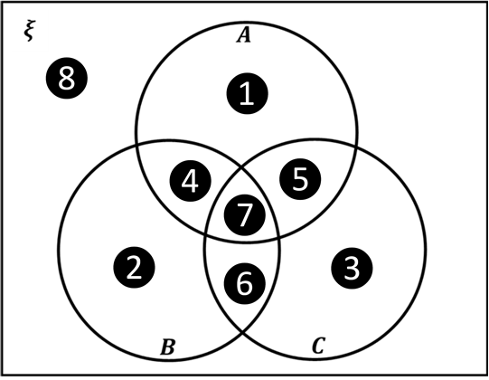

The following answers show one possibility for each region. There are several answers for some regions. You may wish to check your results using a graph plotting app.

* 1. This is not possible
  2. This is not possible

$y=\frac{x^{5}-3}{x^{2}+1}$

For $y=\frac{p\left(x\right)}{q\left(x\right)}$ where $p\left(x\right)$ is a polynomial of degree $n$ (numerator) and $q\left(x\right)$ is a polynomial of degree $d$ (denominator) then

* If $n>d$ there will be no horizontal asymptote
* If $n<d$ the $x$ axis will be a horizontal asymptote
* If $n=d$ there will be a horizontal asymptote
* If $n=d+1$ there will be an oblique asymptote

For region 6, the graph would need to have horizontal and oblique asymptotes but not vertical asymptotes. The condition for oblique asymptotes is that $n=d+1$ and the condition for horizontal asymptotes is $n≤d$. These two things cannot both be true at the same time.

For region 7, the graph would need all three types of asymptote. As region 7 is entirely contained in region 6 it is not possible to find graph for the same reason.

For each region in the Venn diagram below, find an example of a graph of a rational function, $\frac{p\left(x\right)}{q\left(x\right)}$ where $p\left(x\right)$ and $q\left(x\right)$ are both polynomials in $x$.



$y=\frac{1}{x^{2}+4}$

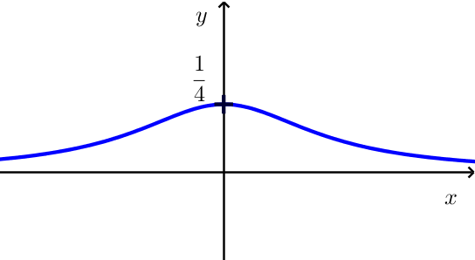

$y=\frac{1}{\sin{x}}$

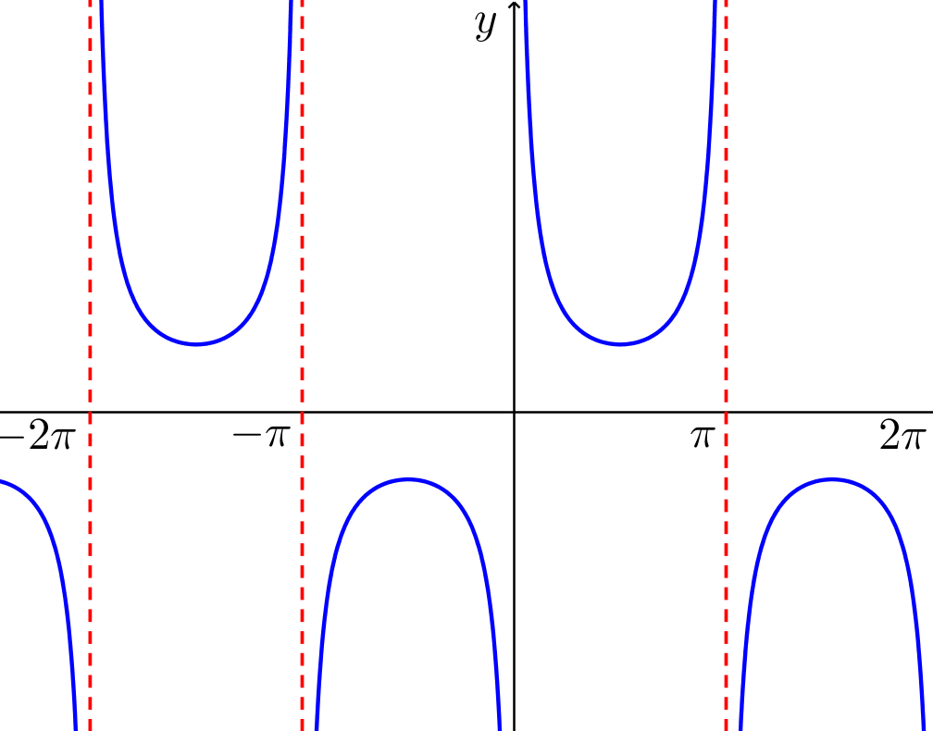

$y=\cos^{2}{x}$

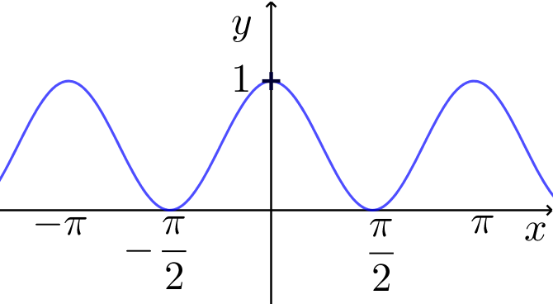

$y=x\sin{2x}$

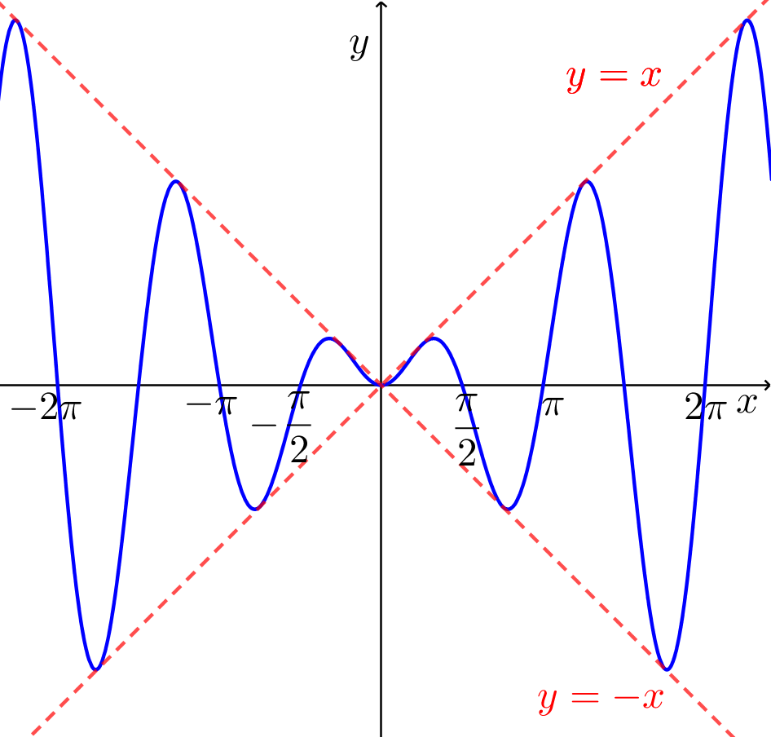

$y=e^{-x^{2}}$

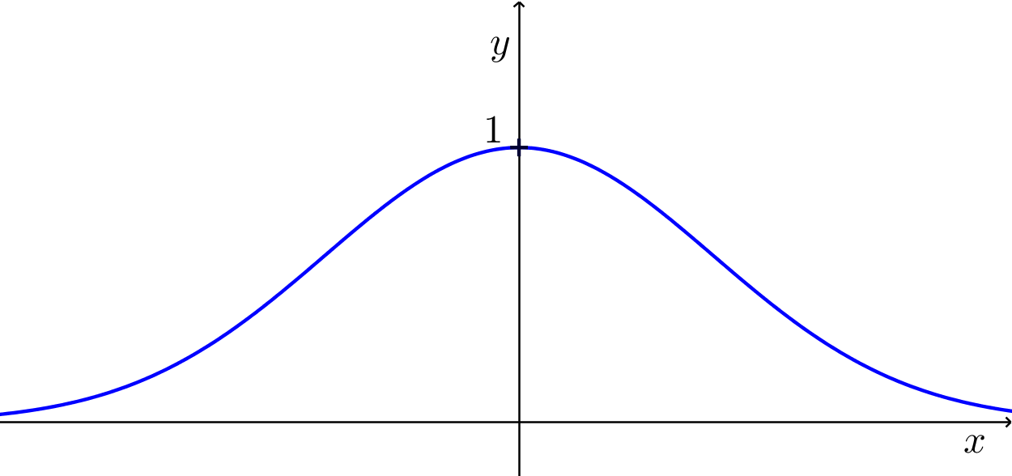

2. Either Reflect in the $x$ axis and then translate $\left(\begin{matrix}-1 \\ 3\end{matrix}\right)$

or Translate $\left(\begin{matrix}-1 \\ 3\end{matrix}\right)$ then reflect in the line $y=3$

1. Either Reflect in the line $y=x$ and then translate $\left(\begin{matrix}-2 \\ -2\end{matrix}\right)$

or Translate $\left(\begin{matrix}-2 \\ -2\end{matrix}\right)$ then reflect in the line $y=x$

1. Either Stretch parallel to the $y$ axis with scale factor 2 followed by a translation by $\left(\begin{matrix}3 \\ 0\end{matrix}\right)$

or Translate $\left(\begin{matrix}3 \\ 0\end{matrix}\right)$ then stretch parallel to the $y$ axis with scale factor $2$

1. Either Translate $\left(\begin{matrix}-3 \\ \frac{1}{4}\end{matrix}\right)$ then stretch parallel to the $y$ axis with scale factor $4$

or Stretch parallel to the $y$ axis with scale factor $4$ followed by a translation by $\left(\begin{matrix}-3 \\ 1\end{matrix}\right)$

1. Either Translate $\left(\begin{matrix}-1 \\ \frac{2}{3}\end{matrix}\right)$ then stretch parallel to the $y$ axis with scale factor $3$

or Stretch parallel to the $y$ axis with scale factor $3$ then translate $\left(\begin{matrix}-1 \\ 2\end{matrix}\right)$

Finding the correct order in which to apply a series of transformations can often cause problems for students. Sometimes swapping the order in which two transformations are applied can have a different effect, sometimes the effect is exactly the same. It is far better to imagine the algebraic consequences of applying any particular transformation and use that to guide your thinking.



$y=7-5x-2x^{2}$

$7-5x-2x^{2}=k$

$2x^{2}+5x+k-7=0$

$∆=25-8\left(k-7\right)$

$25-8\left(k-7\right)=0$

$k-7=\frac{25}{8}$

$k=\frac{81}{8}$ so at the turning point $y=\frac{81}{8}$

$2x^{2}+5x+\frac{81}{8}-7=0$

$2x^{2}+5x+\frac{25}{8}=0$

$x^{2}+\frac{5}{2}x+\frac{25}{16}=0$

${\left(x+\frac{5}{4}\right)}^{2}=0$ so at the turning point $x=-\frac{5}{4}$

The turning point is at $\left(-\frac{5}{4}, \frac{81}{8}\right)$

It is a local maximum as the coefficient of $x^{2}$ in $y=7-5x-2x^{2}$ is negative.

$y=2x^{3}-3x^{2}-12x+2$

$2x^{3}-3x^{2}-12x+2=k$

$2x^{3}-3x^{2}-12x+2-k=0$

${\left(x-a\right)}^{2}\left(2x-b\right)≡$ $2x^{3}-3x^{2}-12x+2-k$

Equating coefficients of $x^{2}$: $-b-4a=-3 \overset{⇔}{ } 4a+b=3$ A

Equating coefficients of $x$: $2ab+2a^{2}=-12 \overset{⇔}{ } ab+a^{2}=-6$ B

Equating the constants: $-a^{2}b=2-k$

From A: $b=3-4a$

In B: $a\left(3-4a\right)+a^{2}=-6$

$a^{2}-a-2=0$

$\left(a-2\right)\left(a+1\right)=0$

$a=2, b=-5$ giving $k=-18$

$a=-1, b=7$ giving $k=9$

$y=-18$ and $y=9$ at the stationary points

Using the general shape of a cubic polynomial curve, both x values give turning points.

$\left(-1,9\right)$ is a local maximum and $\left(2,-18\right)$ is a local minimum

$y=x^{4}-8x^{2}+3$

This is an even function indicating one of the turning points will be at $x=0$ i.e. $\left(0,3\right)$. Considering the shape of the quartic curve, this will be a local maximum.

$x^{4}-8x^{2}+3=k$ will have roots $x=±a$ where $a$ is a value to be found. Each of these roots will come from a repeated factor

${\left(x+a\right)}^{2}{\left(x-a\right)}^{2}≡x^{4}-8x^{2}+3-k$

${\left(x^{2}-a^{2}\right)}^{2}≡x^{4}-8x^{2}+3-k$

$x^{4}-2a^{2}x^{2}+a^{4}≡x^{4}-8x^{2}+3-k$

Equating coefficients of $x^{2}$: $2a^{2}=8$ so $a=±2$

Equating the constants: $a^{4}=3-k$ so $k=-13$ in each case

The other two turning points are $\left(-2,-13\right)$ and $\left(2,-13\right)$. These are both local minima.

$y=\frac{4}{x^{2}-6x-16}$

$\frac{4}{x^{2}-6x-16}=k$

$4=kx^{2}-6kx-16k$

$kx^{2}-6kx-16k-4=0$

$kx^{2}-6kx-4\left(4k+4\right)=0$

Using the discriminant

$∆=36k^{2}+16k\left(4k+1\right)$

For repeated roots $∆=0$

$36k^{2}+16k\left(4k+1\right)=0$

$k\left(100k+16\right)=0$

$k=0$ which is not the case as $k≠0$ from the initial equation

$k=-\frac{16}{100}=-\frac{4}{25}$

$\frac{4}{x^{2}-6x-16}=-\frac{4}{25}$

$x^{2}-6x+9=0$

${\left(x-3\right)}^{2}=0$

The turning point is at $\left(3,-\frac{4}{25} \right)$

By considering the graph shape, this is a local maximum.



$y=x-\sqrt{x^{2}-1}$

$x^{2}-1≥0$

$x^{2}≥1$

$x≥1$ or $x≤-1$

The graph does not exist for $-1<x<1$

$x→∞$, $y→0$ (since $x-\sqrt{x^{2}}=0$)

$x→-∞$, $y→2x$ (since $-x-\sqrt{x^{2}}=2x$)

The graph crosses neither axis.

$x=1$, $y=1$

$x=-1$, $y=-1$

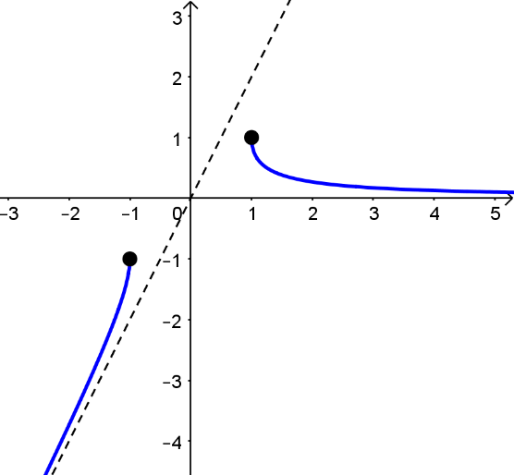

$y=\frac{x^{2}+x-6}{x^{4}-16}$

$y=\frac{\left(x+3\right)\left(x-2\right)}{\left(x^{2}-4\right)\left(x^{2}+4\right)}=\frac{\left(x+3\right)\left(x-2\right)}{\left(x+2\right)\left(x-2\right)\left(x^{2}+4\right)}$

Note: although the $x-2$ factor cancels, it is important to realise that $x≠2$ for the original function. The $y$ coordinate is undefined at $x=2$

Vertical asymptote $x=-2$

As $x→-2$, $x<-2$, $y→-∞$

As $x→-2$, $x>-2$, $y→∞$

$y=\frac{\frac{1}{x^{2}}+\frac{1}{x^{3}}-\frac{6}{x^{4}}}{1-\frac{16}{x^{4}}}$. As $x→±∞$, $y→0$ from above in both cases

Intercepts: $x=0, y=\frac{3}{8}$ $y=0, x=-3$ (or $x=2$ but $y$ is undefined for this)

Using calculus to find the turning points gives a factor for which there are no easy factors. There is a local maximum to the left of $x=-3$, but as this is so difficult to find it is not expected.

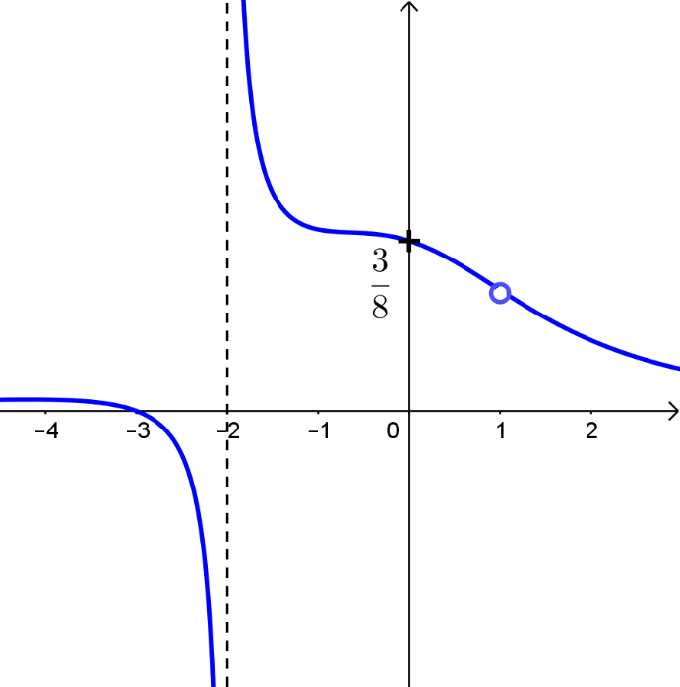

$y=\log_{10}{x^{3}}$

This can be sketched using the graphs of $y=x^{3}$ and $y=\log_{10}{x}$

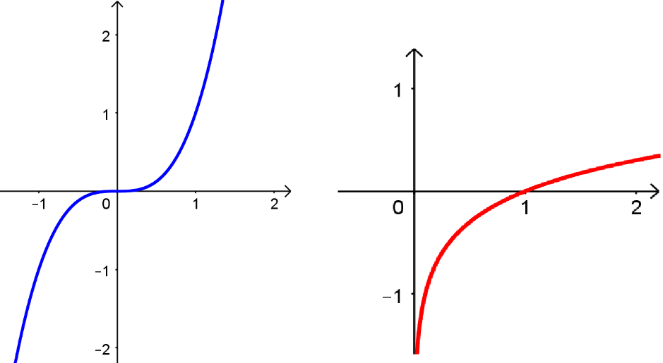

$x^{3}>0$ so that $\log_{10}{x^{3}}$ exists

$y=\log_{10}{x^{3}}=3\log_{10}{x}$

This is a stretch of $y=\log_{10}{x}$ parallel to the $y$ axis with scale factor $3$

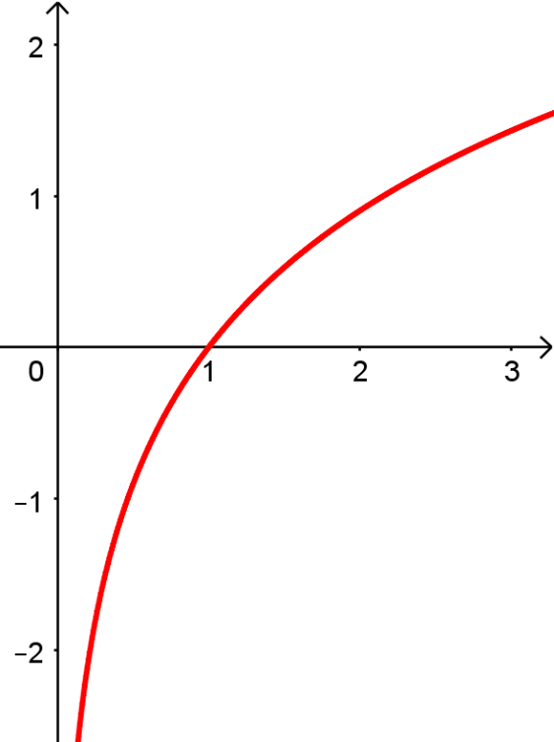

$y=\frac{x^{3}+2x^{2}-x-2}{x+1}$

$\left(x+1\right)$ is a factor of $x^{3}+2x^{2}-x-2$ (using the factor theorem with $x=-1$

$\left(x+1\right)\left(x^{2}+kx-2\right)≡x^{3}+2x^{2}-x-2$

Equating coefficients of $x^{2}$: $k+1=2 \overset{⇔}{ } k=1$

$y=\frac{\left(x+1\right)\left(x-1\right)\left(x+2\right)}{x+1}$

The graph is undefined at $x=-1$

$y=\left(x-1\right)\left(x+2\right)$

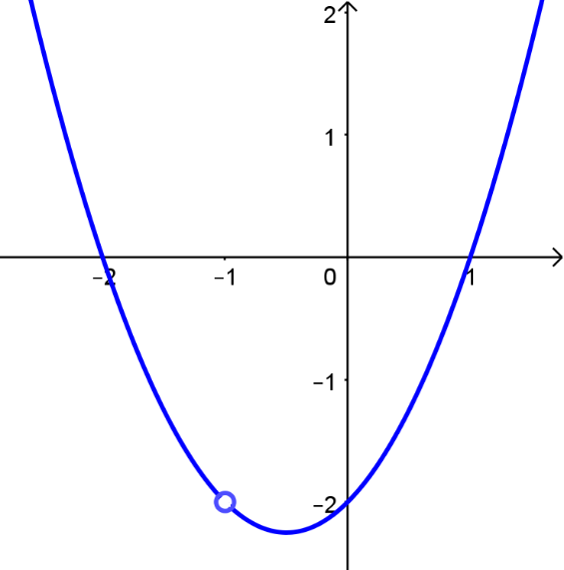

$y=\frac{1}{\left(x+1\right)\left(3-x\right)}$

Vertical asymptotes $x=-1$, $x=3$

$x→-1, x<-1, y→-∞$

$x→-1, x>-1, y→∞$

$x→3, x<3, y→∞$

$x→3, x>3, y→-∞$

$x→±∞, y→0$ from below in both cases

$x=0$, $y=\frac{1}{3}$

$y≠0$

$\frac{1}{\left(x+1\right)\left(3-x\right)}=k$

$1=k\left(3+2x-x^{2}\right)$

$kx^{2}-2kx+1-3k=0$

$∆=4k^{2}-4k\left(1-3k\right)$

$∆=4k^{2}-4k+12k^{2}$

$∆=16k^{2}-4k$

$16k^{2}-4k=0$

$k\left(4k-1\right)=0$

$k≠0$ (from the original function)

$k=\frac{1}{4}$

$x=1$, $y=\frac{1}{4}$ is a local minimum (from the graph shape)

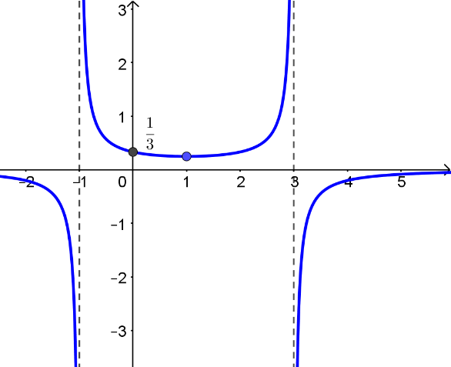

$\left(1,\frac{1}{4}\right)$

1. Sketching the graphs of $y=x^{2}$ and $y=\cos{x}-1$ shows that there is only one real solution, $x=0$.

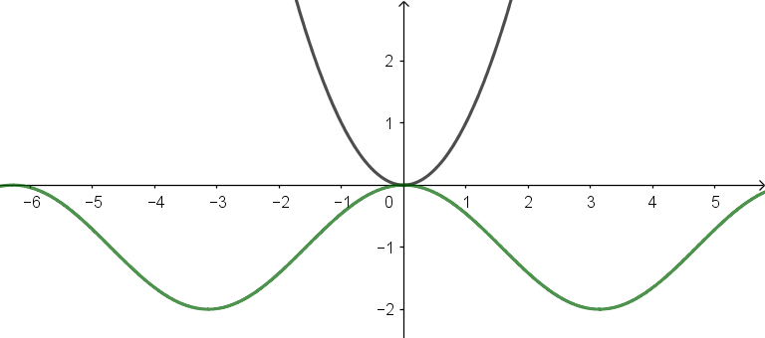

1. Sketching the graphs of $y=e^{x^{2}}$ and $y=\cos{x}$ shows that there is only one real solution,

$x=0$.

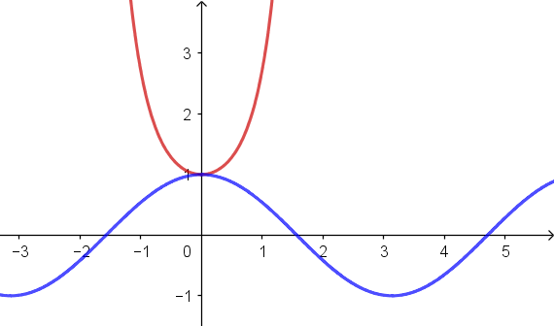

1. How many real solutions does the equation $e^{x}+1=\sin{x}$ have?

As $x→-∞$, $e^{x}+1→1$ from above.

The maximum value of $\sin{x}=1$ so there are no values of $x$ for which $e^{x}+1=\sin{x}$

There are no real solutions for $e^{x}+1=\sin{x}$

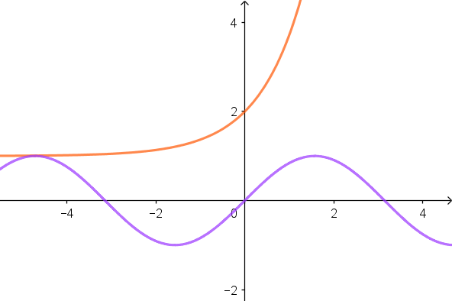

1. Solve the equation $\sin^{2}{x°}=x^{2}-180x+8101$.

$y=x^{2}-180x+8101$

$y={\left(x-90\right)}^{2}-8100+8101$

$y={\left(x-90\right)}^{2}+1$

This is a parabola with a vertex at $\left(90,1\right)$

The maximum value of $\sin^{2}{x°}$ is $1$ and this occurs at $± \left(2n-1\right)×90°$ where $n∈Z^{+}$

There is only one solution at $x=90$

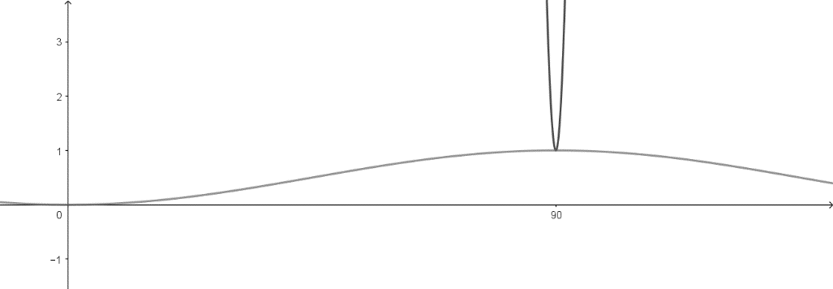

1. How many real solutions does the equation $\cos^{2}{x}=x^{3}$ have?

Sketching the graphs of $y=\cos^{2}{x}$ and $y=x^{3}$ (carefully) shows that here is only one real solution.

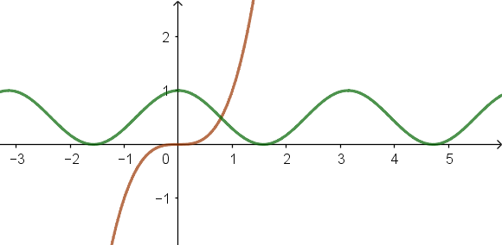

**Exercise 2 Admissions Test Multiple Choice Questions**

**TMUA style questions**

1. Using completed square form: $y=a{\left(x-1\right)}^{2}+5$

$\left(-1,-3\right)$: $-3=4a+5$

$a=-2$

$y=-2{\left(x-1\right)}^{2}+5=-2x^{2}+4x+3$

The correct answer is F

$\left(1-2\cos{2x}\right)\left(1+2\sin{x}\right)≤0$

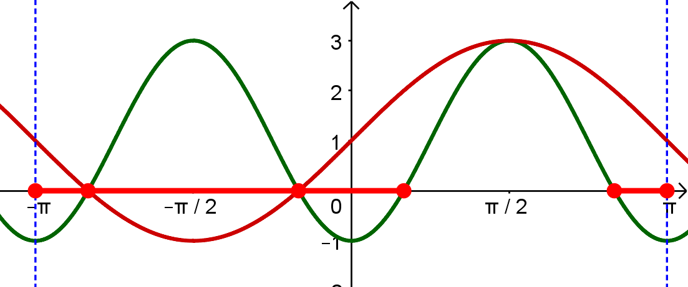

The product of $\left(1-2\cos{2x}\right)$ and $\left(1+2\sin{x}\right)$ will be negative or 0 for all of $-π≤x≤\frac{π}{6}$, positive for $\frac{π}{6}<x<\frac{5π}{6}$ and negative again for $\frac{5π}{6}≤x≤π$

So $\left(1-2\cos{2x}\right)\left(1+2\sin{x}\right)≤0$ for $-π≤x≤\frac{π}{6}$ and $\frac{5π}{6}≤x≤π$

The correct answer is B.

1. The graph of $y=2\cos{\frac{θ}{2}}+1$ can be sketched directly

For $y=\sin{θ}+\cos{θ}$, this can be rewritten using

$R\sin\left(x+α\right)=R\sin{x}\sin{α}+R\cos{x}\cos{α}$

$\sin{θ}+\cos{θ}=\sqrt{2}\sin\left(x+\frac{π}{4}\right)$

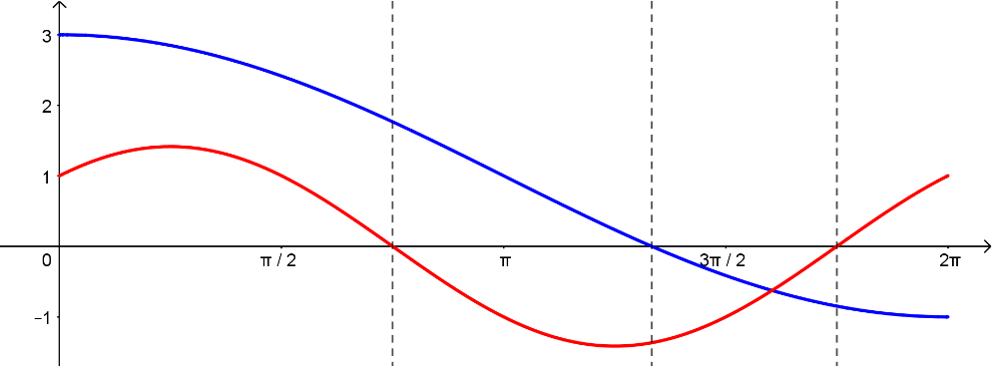

$\frac{3π}{4}≤x≤\frac{4π}{3}$, $\frac{7π}{4}≤x≤2π$

$\frac{4π}{3}-\frac{3π}{4}=\frac{7π}{12}$

$2π-\frac{7π}{4}=\frac{π}{4}$

$\frac{7π}{12}+\frac{π}{4}=\frac{10π}{12}$

Fraction $\frac{10π}{12}÷2π=\frac{5}{12}$

The correct answer is F

1. $y=\left(\sqrt{3}+2\sin{2x}\right)\cos{x}$ for $-\frac{π}{2}≤x≤\frac{π}{2}$

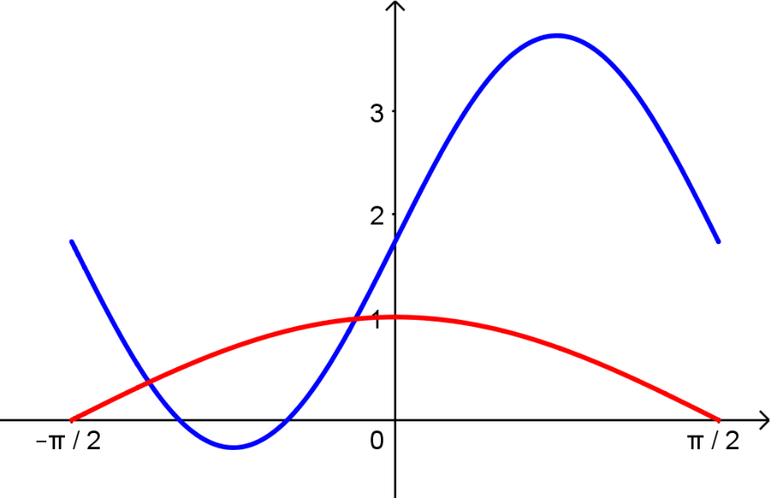

$\sqrt{3}+2\sin{2x}=0$

$\sin{2x}=-\frac{\sqrt{3}}{2}$

$2x=-\frac{π}{3}, -\frac{2π}{3}$

$x=-\frac{π}{6}, -\frac{π}{3}$

$-\frac{π}{3}<x<-\frac{π}{6}$

The correct answer is C.

1. Sketching $y=x\tan{x}$ and $y=\sin{x}$ gives

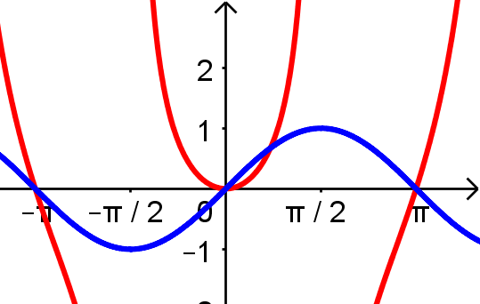

There are 4 real solutions (being careful to include $x=±π$

The correct answer is E.



$x\sin{x}=2\cos{x}$

$\frac{1}{2}\tan{x}=\frac{1}{x}$

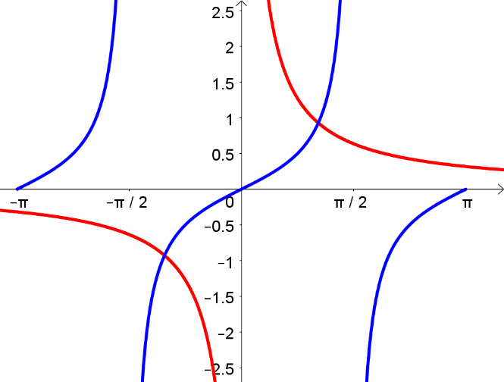

Two real solutions.

The correct answer is C



$3x^{5}-10x^{3}-225x+10=0$

$\frac{dy}{dx}=15x^{4}-30x^{2}-225$

$15x^{4}-30x^{2}-225=0\overset{⇔}{ }x^{4}-2x^{2}-15=0$

$\left(x^{2}+3\right)\left(x^{2}-5\right)=0$

$x^{2}=5$, $x=±\sqrt{5}$

$x=\sqrt{5}$, $y=10-200\sqrt{5}$ which is $<0$

$x=-\sqrt{5}$, $y=200\sqrt{5}+10$ which is $>0$

There are only two turning points so there must be three places that the graph of

$y=3x^{5}-10x^{3}-225x+10$ crosses the $x$ axis.

There are three real solutions.

The correct answer is C.

have?

|  |  |  |  |  |  |
| --- | --- | --- | --- | --- | --- |
| A | $$1$$ | B | $$2$$ | C | $$3$$ |
|  |  |  |  |  |  |
| D | $$4$$ | E | $$5$$ |  |  |



$y=3x^{4}-32x^{3}+72x^{2}+k$

$\frac{dy}{dx}=12x^{3}-96x^{2}+144x$

$12x^{3}-96x^{2}+144x=0$

$x^{3}-8x^{2}+12x=0$

$x\left(x^{2}-8x+12\right)=0$

$x\left(x-2\right)\left(x-6\right)=0$

$x=0$, $y=k$

$x=2$, $y=80+k$

$x=6$, $y=k-432$

From the shape of the graph, the points are in order $\left(0,k\right)$, $\left(2, 80+k\right)$, $\left(6,k-432\right)$

The line $y=0$ (the x axis has to lie between $y=k$ and $y=80+k$ for there to be four distinct real solutions.

$k<0$ and $80+k>0$ so $-80<k<0$

The correct answer is C.

**MAT style questions**

$x^{3}+6x^{2}-63x+k=0$

$y=x^{3}+6x^{2}-63x+k$

$\frac{dy}{dx}=3x^{2}+12x-63$

$3x^{2}+12x-63=0$

$x^{2}+4x-21=0$

$\left(x+7\right)\left(x-3\right)=0$

$x=-7$, $y=k+392$

$x=3$, $y=k-108$

$k+392>0\overset{⇔}{ }k>-392$

$k-108<0\overset{⇔}{ }k<108$

$-392<k<108$

The correct answer is (b)

1. A counter-example is often a powerful way of eliminating options in a multiple choice question.

For this question, a counter example can eliminate all of the options apart from (e)

$x^{2}=x^{3}-ax+12$

$x^{3}-x^{2}-ax+12=0$

$\frac{dy}{dx}=3x^{2}-2x-a$

$3x^{2}-2x-a=0$

Ideally a value for $a$ for which the quadratic expression factorises easily and for which $2<a<8$ can be found and this can be used as the counter-example for (a) to (d)

Either $\left(3x+p\right)\left(x-q\right)≡3x^{2}-2x-a$ A

or $\left(3x-p\right)\left(x+q\right)≡3x^{2}-2x-a$ B

where $p$ and $q$ are positive integers.

For A: $p-3q=-2$ and $pq=a$

If $q=1$, $p=1$ and $a=1$

If $q=2$, $p=4$ and $a=8$

Neither gives a value for $a$ that can be used to eliminate several options at once.

For B: $3q-p=-2$

If $q=1$, $p=5$ and $a=5$

So, $a=5$ provides a suitable test for eliminating options (a) to (d).

(Note: most of the work behind selecting $a=5$ as a suitable counter-example can be done mentally)

$x^{2}=x^{3}-5x+12$

$x^{3}-x^{2}-5x+12=0$

$\frac{dy}{dx}=3x^{2}-2x-5$

$\left(3x-5\right)\left(x+1\right)=0$

$x=\frac{5}{3}$, $y=\frac{125}{27}-\frac{25}{9}-\frac{25}{3}+12=\frac{125-75-225+324}{27}$. This is $>0$

$x=-1$, $y=-1-1+5+12$. This is $>0$.

Both turning points are above the $x$ axis so there is only one real solution.

(a) is not true as the real number $a=5$ does not give three real roots

(b) since $a=5$ is in $2≤a≤8$, this option must be incorrect

(c) since $a=5$ is in $0≤a≤8$, this option must be incorrect

(d) since $a=5$ is in $a≤8$, this option must be incorrect

This leaves option (e) which is not disproved by $a=5$

1. This question does not require an accurate sketch, just a general idea of the shape of each curve and the points of intersection for each possible pair of curves.

Let curve A be $y=x^{3}-x^{2}$, curve B be $y=x^{3}-4x$ and curve C be $y=x^{2}$

Intersection points:

A and B: $x^{3}-x^{2}=x^{3}-4x \overset{⇔}{ } x^{2}-4x=0 \overset{⇔}{ } x\left(x-4\right)=0$

Intersect at $\left(0,0\right)$ and $\left(4,48\right)$

A and C: $x^{3}-x^{2}=x^{2} \overset{⇔}{ } x^{3}-2x^{2}=0 \overset{⇔}{ } x^{2}\left(x-2\right)=0$

Intersect at $\left(0,0\right)$ and $\left(2,4\right)$

B and C: $x^{3}-4x=x^{2} \overset{⇔}{ } x^{3}-x^{2}-4x=0 \overset{⇔}{ } x\left(x^{2}-x-4\right)=0$

Intersect when $x=0$, $x=\frac{1+\sqrt{17}}{2}$ and $x=\frac{1-\sqrt{17}}{2}$

There is no need to actually calculate the $y$ coordinate for each of these, just to know where it lies in relation to the other points.

Since $4<\sqrt{17}<5, \frac{5}{2}<\frac{1+\sqrt{17}}{2}<3$ and $\frac{25}{4}<{\left(\frac{1+\sqrt{17}}{2}\right)}^{2}<9$ i.e. this point is above $\left(2,4\right)$ but below $\left(4,48\right)$

$-2<\frac{1-\sqrt{17}}{2}<-\frac{3}{2}$ and $\frac{9}{4}<{\left(\frac{1+\sqrt{17}}{2}\right)}^{2}<4$ i.e. this point is above $\left(0,0\right)$ but below $\left(2,4\right)$

A rough plot of these points and a sketch of the curves following their general shape allows the number of regions to be counted easily.

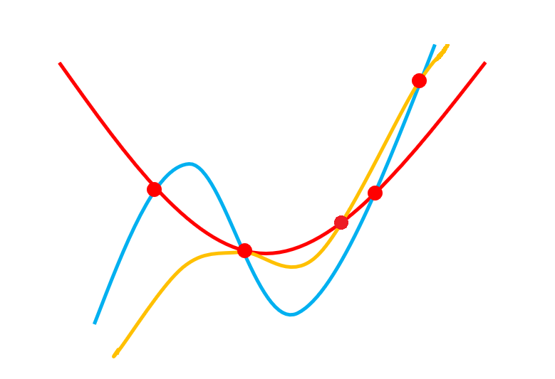

There are 10 distinct regions.

The correct answer is (b)

1. $y=e^{-\frac{1}{x^{2}}}\cos{x^{2}}$ is an even function eliminating option (b) immediately

When $x=0$, $\cos{x^{2}}=1$. $e^{-\frac{1}{x^{2}}}$ is undefined but as $x→0$, $e^{-\frac{1}{x^{2}}}→0$ so the graph should look like it will pass through $\left(0,0\right)$ (even though $y$ is undefined when $x=0$). This eliminates (c)

When $x^{2}=\frac{\left(2n+1\right)π}{2}$, $\cos{x^{2}}=0$ so the graph will pass through $\left(±\sqrt{\frac{π}{2}},0\right)$, $\left(±\sqrt{\frac{3π}{2}},0\right)$, $\left(±\sqrt{\frac{5π}{2}},0\right)$ and so on $\sqrt{\frac{π}{2}}<\sqrt{\frac{3π}{2}}<\sqrt{\frac{5π}{2}}<π<\sqrt{\frac{7π}{2}}$ since squaring gives

$\frac{π}{2}<\frac{3π}{2}<\frac{5π}{2}<π^{2}<\frac{7π}{2}$

$\frac{5π}{2}<π^{2}$ as $2.5×π<3×π$ and $π^{2}<\frac{7π}{2}$ since $3.142×π<3.5×π$

The graph should cross the $x$ axis three times between $x=0$ and $x=π$ (and these points will be reflected in the $y$ axis.

This reduces the options to (a) and (d).

The differences between (a) and (d) is that the local maximum for $0<x<\frac{π}{2}$ has a greater $y$ value for (a) than it does for (b) and that the first intercept for (a) is after $x=\frac{π}{2}$ for (a) and before $x=\frac{π}{2}$ for (d).

The easier test is the second of these two. Since $\frac{π}{2}>1$, $\frac{π}{2}>\sqrt{\frac{π}{2}}$ identifying (d) as the correct answer.

$y=\frac{1}{x^{3}+4x^{2}-4x-16}$

Using the factor theorem, $x-2$ is a factor of $x^{3}+4x^{2}-4x-16$

$\left(x-2\right)\left(x^{2}+kx+8\right)≡of x^{3}+4x^{2}-4x-16$

Equating coefficients of $x^{2}$: $k-2=4 \overset{⇔}{ } k=6$

$x^{3}+4x^{2}-4x-16=\left(x-2\right)\left(x^{2}+6x+8\right)=\left(x-2\right)\left(x+2\right)\left(x+4\right)$

The graph has vertical asymptotes at $x=-4$, $x=-2$ and $x=2$

The only graphs that possibly have these asymptotes are (a) and (e)

At $x=0$, $y=\frac{1}{-2×4×2}<0$ so the correct option is (e)

$y=\log_{10}\left(x^{4}-16\right)$

This is an even function so (b), (d) and € can be eliminated

$x^{4}-16>0$

$x>2$ or $x<-2$

The graph exists for $x>2$ and $x<-2$

As $x→±∞$, $y→∞$

The correct answer is (a)

1. Testing the point $\left(0,0\right)$ gives $\sin{0}=0≠1$ so (a) and (d) can be eliminated.

Testing $\left(0,\frac{π}{2}\right)$ gives $\sin{\frac{π}{2}}=1$. This eliminates (c) as no lines on (c) pass through $\left(0,\frac{π}{2}\right)$

Testing $\left(0,\frac{3π}{2}\right)$ gives $\sin{\frac{3π}{2}}=-1≠1$ so € can be eliminated.

The correct answer is (b)

**Chapter 8: Sequences and series**

**Try it out (page 100)**

$a_{1}=1, a_{2}=1+\frac{1}{2}, a_{3}=1+\frac{1}{2}+{\left(\frac{1}{2}\right)}^{2}$ and so on. In general $a_{n}=1+\frac{1}{2}+…+{\left(\frac{1}{2}\right)}^{n-1}.$ This is a finite geometric progression with $n$ terms. By the usual formula $a_{n}=\frac{a(1-r^{n})}{1-r}=\frac{1-\frac{1}{2^{n}}}{1-\frac{1}{2}}=2-\frac{1}{2^{n-1}}$.

**Try it out (page 101)**

By the identity if $r≠-1$, $a-ar+ar^{2}-$

**Try it out (page 101)**

* 1. and for all positive integers $n$ and so $a_{n}=0$ for all positive integers $n$
  2. $\cos{(nπ})=1$ if $n$ is even and $\cos{(nπ})=-1$ if $n$ is odd. Therefore the sequence could be written as $a_{n}={(-1)}^{n}$ for all positive integers $n$.
  3. $a_{1}=\frac{1}{2}, a_{2}=\frac{1}{2}+{\left(\frac{1}{2}\right)}^{2}$ and so on. In general $a_{n}=\frac{1}{2}+…+{\left(\frac{1}{2}\right)}^{n}.$ This is a finite geometric progression with $n$ terms. By the usual formula $a_{n}=\frac{a(1-r^{n})}{1-r}=\frac{\frac{1}{2}\left(1-\frac{1}{2^{n}}\right)}{1-\frac{1}{2}}=1-\frac{1}{2^{n}}$.
  4. The $n^{th}$ term the sum of $2n$ halves. Therefore $a_{n}=2n×\frac{1}{2}=n$.
  5. $\sum_{r=1}^{n}{\left(2^{r}+2r+2\right)=}\sum_{r=1}^{n}{2^{r}+}\sum_{r=1}^{n}{2r+}\sum_{r=1}^{n}{2}=2\left(2^{n}-1\right)+n\left(n+1\right)+2n$, the first summation is a geometric progression, the second is an arithmetic progression and the final sum is the sum of $n$ twos
  6. In sigma notation, the sum is $\sum_{r=1}^{n}{\frac{2^{n}+1}{2^{n}}}$. This can be written as $\sum_{r=1}^{n}{\frac{2^{n}+1}{2^{n}}}= \sum_{r=1}^{n}{\left(1+\frac{1}{2^{n}}\right)}=\sum_{r=1}^{n}{1}+\sum_{r=1}^{n}{\frac{1}{2^{n}}}=n+1-\frac{1}{2^{n}}$.

**Try it out (page 102)**

$a_{n}=1$ for all positive integers $n$ is an example. Then $a_{n+1}≥a_{n}$ and $a_{n+1}≤a_{n}$ for all positive integers $n$ and so the sequence is both increasing and decreasing.

A strictly increasing and strictly decreasing sequence would require that both $a_{1}>a_{2}$ and that

$a_{2}<a_{1}$ (and the same for any pair of consecutive terms). This is clearly not possible.

**Try it out (page 102)**

1. Assuming $x≠0$ $, a_{1}=x$, $a_{2}=\frac{1}{x}=$, $a_{3}=\frac{1}{\frac{1}{x}}=x$ and so on. This sequence has period 2 unless $x=\frac{1}{x}$. This implies that $x^{2}=1$. So the two values are $x=-1$ and $x=1$.
2. The sequence is  This is periodic with period 6 for all values of 

**Try it out (page 103)**

1. . Therefore .
2. . Therefore  Since the sequence  tends to 0 as *n* tends to infinity so does the sequence .

**Exercise 1**

1. This is an arithmetic progression with first term 1 and common difference 2.

Using the usual formula

.

1. Listing the terms gives 1, 3, 2, 4, 3, 5, 4, 6, 5, 7, 6, 8. Each positive integer appears twice with the exception of 1 and 2 both of which only appear once.  
     
   If *n* is a positive integer greater than 2 then *n* equals  and also  and so .The terms in the sequence are . Then





So the sequence is periodic with period 5.

1. The terms in the sequence are

.

(Note that these terms are only defined if .)

.

So the value of *k* for which the sequence is periodic with period 4 are  and .

1. .



and so on.

So let’s prove that  by induction.

The result is true when . Suppose the result is true for some integer . In other words, suppose that . Then



So the result is then true when . Hence, by induction, the result is true for all integers .

1. If the arithmetic sequence is then the third term is and the tenth term is . The difference between them is . Therefore

 and .

Taking the third term and subtracting  gives the first term, . Therefore 

The sixteenth term is therefore .

1. General law is .

When  both the left hand side and the right hand side are 1. So the result is true when . Suppose the result is true for some integer . In other words, suppose that .

If  is odd then



If  is even then



Therefore, whether  is odd or even, the statement is true when . Hence, by induction, the result is true for all integers .

1. General law is .

When  both the left hand side and the right hand side are . So the result is true when . Suppose the result is true for some integer . In other words, suppose that .

Then.

So the statement is true when . Hence, by induction, the result is true for all integers .

1. , , ,

Noticing that , a sensible conjecture is that . This is true when  by a direct check.

Suppose the result is true for some integer . In other words suppose that .  
  
Then .

So the result is true when . Hence, by induction, the result is true for all integers 

1. If  is odd then .

If  is even then .

This gives that for any , if then 

Taking in the above gives that for any , .



If then  This gives the result.

**Exercise 2**

**TMUA style questions**

1. The correct answer is B.



Noting that the powers of 10 given are in a geometric series:



So .

1. Using the formula for given in part 1, since  which tends to as ,  tends to  as .

So the answer is E.

1. Let  be the first term of the geometric sequence. The sum of the first 8 terms is . The sum of the first four terms is . So  giving  or  Since  this means that  and the answer is D.
2. The sum of the first 100 terms is . The sum of the first 10 terms is . Therefore  and . Therefore  and  Therefore the answer is F.
3. Using the formula for the sum of a geometric progression the sum to infinity of A is . The other geometric progression has common ratio  and so has sum .  
     
   The information given in the question implies that . This leads to the equation.  can be seen to satisfy this. The answer is A.

**MAT style questions**

1. It can be calculated that the sequence has terms 3, 12, 24, 12, 3, 1.5, 3, 12, 24, 12, 3, 1.5,… So the sequence has period 6. The remainder when 2020 is divided by 6 is 4. This means that .

The answer is d).

1. The first term is 2.

The product of the first two terms is .

The product of the first three terms is .

The product of the first four terms is .

The product of the first 20 terms will be .

Using the formula  this is . The answer is b).

1. By direct calculation the first terms in the sequence are 1, 2, 2, 3, 3, 3,….

For a positive integer ,



Since  there are positive integers  for which .

This means that the first 45 terms of the sequence consists of one 1, two 2s, three 3s,… and nine 9s. The sum of these is

 and the answer is a).







…





From the above it follows that 

So the answer is d).

This can be split as the sum of two summations, these are:

 and .

Using the formula for the sum of a geometric progression in both cases gives

 and .

Adding these together gives .

So the answer is d.

**Chapter 9 Trigonometry**

**Try it out (page 110)**

Sketching the graphs of $y=\sin{x}$, $y=\cos{x}$ and $y=\tan{x}$. Use your sketches to work out the exact values of the following (do not use a calculator):

1. $\sin\left(150°\right)$**, $\sin\left(-60°\right)$, $\sin\left(-135°\right)$**   
     
   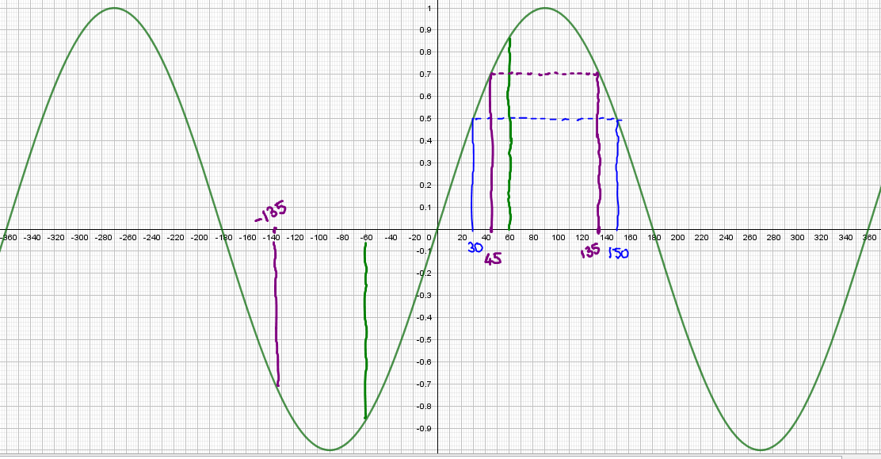 $\sin\left(150°\right)=\sin\left(180°-150°\right)=\sin\left(30°\right)=\frac{1}{2}$ 
     
   . $\sin\left(-60°\right)=-\sin\left(60°\right)=-\frac{\sqrt{3}}{2}$ 
   . $\sin\left(-135°\right)=-\sin\left(135°\right)=-\sin\left(180°-135°\right)=-\sin\left(45°\right)=-\frac{\sqrt{2}}{2}$ 
   .
2. $\cos\left(150°\right)$**, $\cos\left(240°\right)$, $\cos\left(-240°\right)$**  
   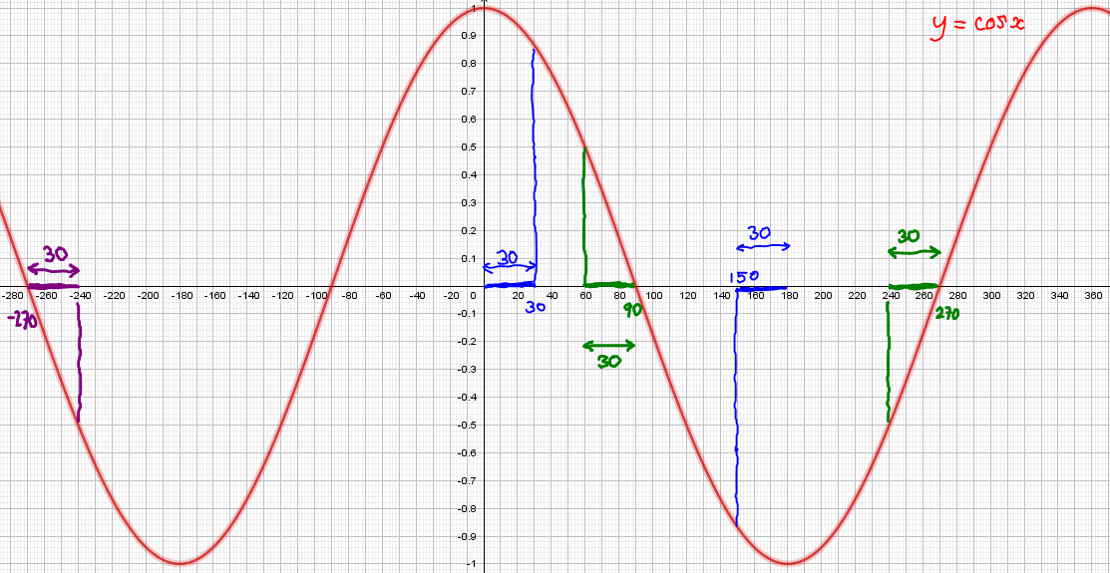 $\cos\left(150°\right)=-\cos\left(30°\right)=-\frac{\sqrt{3}}{2}$ 
     
   . $\cos\left(240°\right)=-\cos\left(60°\right)=-\frac{1}{2}$ 
   . $\cos\left(-240°\right)=-\cos\left(60°\right)=-\frac{1}{2}$ 
   . You could also use the fact that $\cos\left(x\right)=\cos\left(-x\right)$ for all $x$.
3. $\tan\left(-30°\right)$**, $\tan\left(135°\right)$**  
   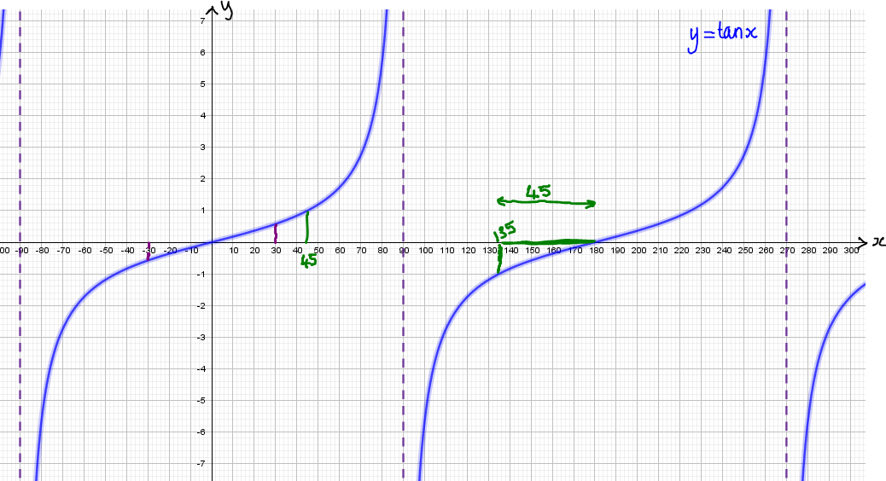 $\tan\left(-30°\right)=-\tan\left(30°\right)=-\frac{\sqrt{3}}{3}$ 
     
   . $\tan\left(135°\right)=-\tan\left(45°\right)=-1$ 
   .

$\sin^{2}\left(120°\right)-\cos^{2}\left(60°\right)$

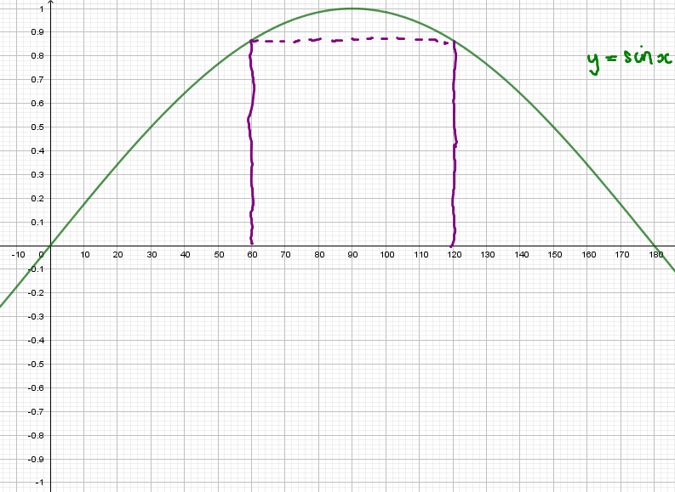 $\sin\left(120°\right)=\sin\left(180°-120°\right)=\sin\left(60°\right)=\frac{\sqrt{3}}{2}$ 
  
, so $\sin^{2}\left(120°\right)={\left(\frac{\sqrt{3}}{2}\right)}^{2}=\frac{3}{4}$. $\cos\left(60°\right)=\frac{1}{2}$ 
, so $\cos^{2}\left(60°\right)={\left(\frac{1}{2}\right)}^{2}=\frac{1}{4}$. $\sin^{2}\left(120°\right)-\cos^{2}\left(60°\right)=\frac{3}{4}-\frac{1}{4}=\frac{1}{2}$ 
  
.

1. $\frac{\sin\left(390°\right)}{\cos\left(420°\right)}$ 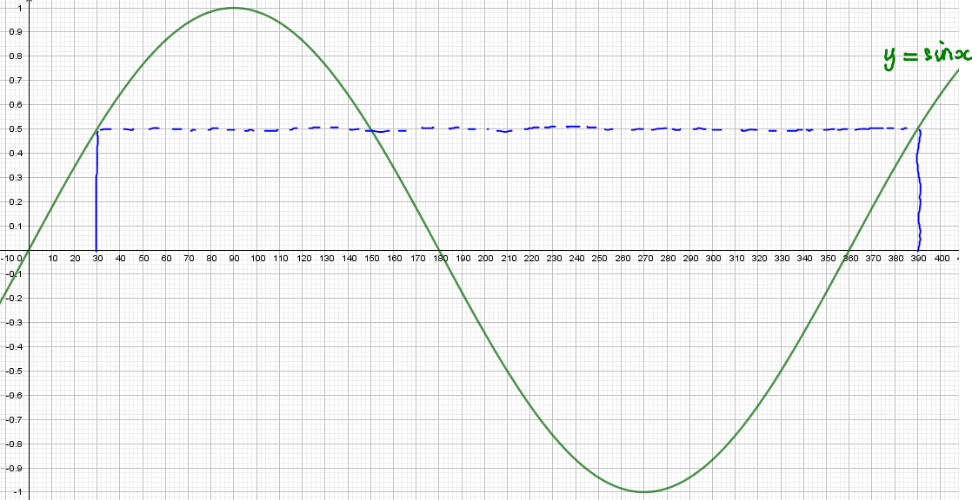 $\sin\left(390°\right)=\sin\left(390°-360°\right)=\sin\left(30°\right)=\frac{1}{2}$ 
     
   .  
     
   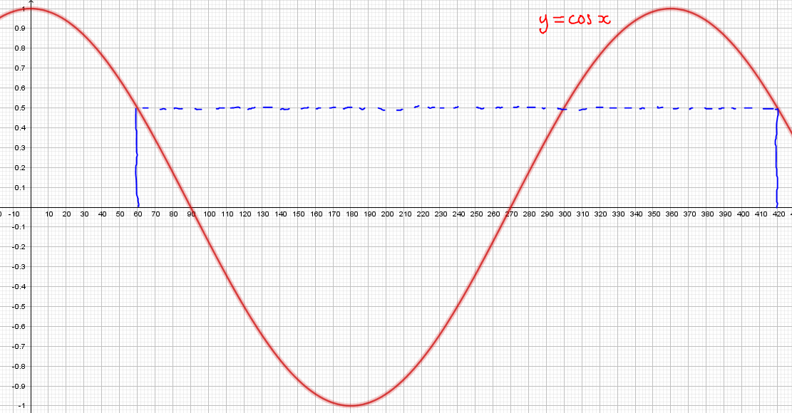 $\cos\left(420°\right)=\cos\left(420°-360°\right)=\cos\left(60°\right)=\frac{1}{2}$ 
     
   .  
     
   So $\frac{\sin\left(390°\right)}{\cos\left(420°\right)}=\frac{\left(\frac{1}{2}\right)}{\left(\frac{1}{2}\right)}=1$.
2. $\tan\left(\frac{2π}{3}\right)$ 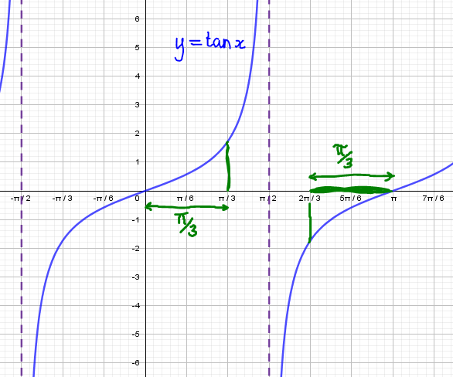 $\tan\left(\frac{2π}{3}\right)=-\tan\left(\frac{π}{3}\right)=-\sqrt{3}$ 
     
   .
3. $\sin\left(-\frac{5π}{3}\right)$ 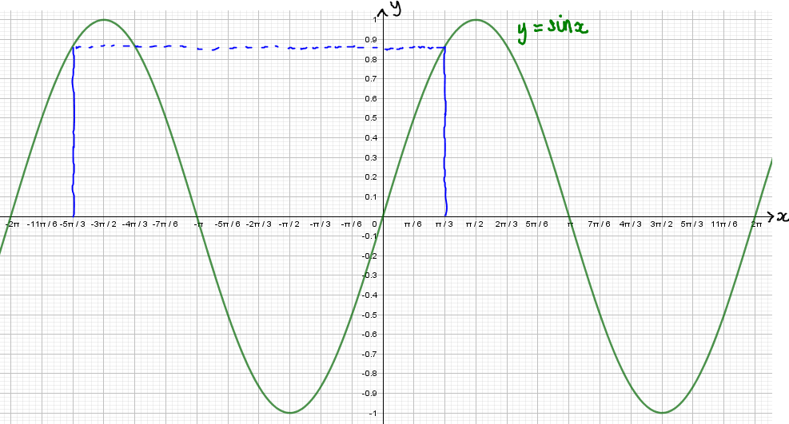 $\sin\left(-\frac{5π}{3}\right)=\sin\left(-\frac{5π}{3}+2π\right)=\sin\left(\frac{π}{3}\right)=\frac{\sqrt{3}}{2}$ 
     
   **.**
4. $\cos\left(\frac{5π}{3}\right)$ 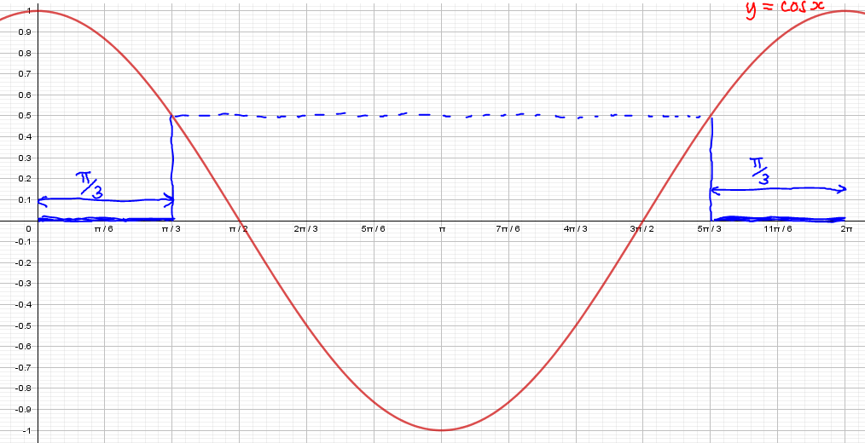 $\cos\left(\frac{5π}{3}\right)=\cos\left(\frac{π}{3}\right)=\frac{1}{2}$ 
     
   .

**Try it out (page 110)**

1. $\cos{x}=-\frac{1}{2}$ 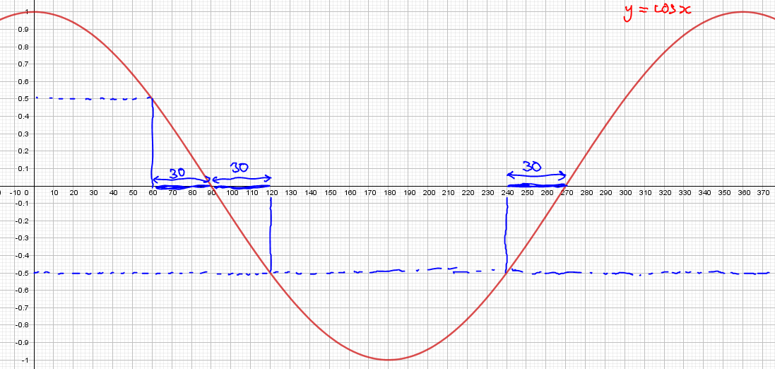  
     
   For $0°≤x≤360°$, $x=90°+30°=120°$ or $x=270°-30°=240°$.  
   All the question asked for was how many solutions the equation has in the given range. The answer is two solutions.
2. $\cos{2x}=-\frac{1}{2}$ $$Since 0°≤x≤360°$$, $0°≤2x≤720°$.  
   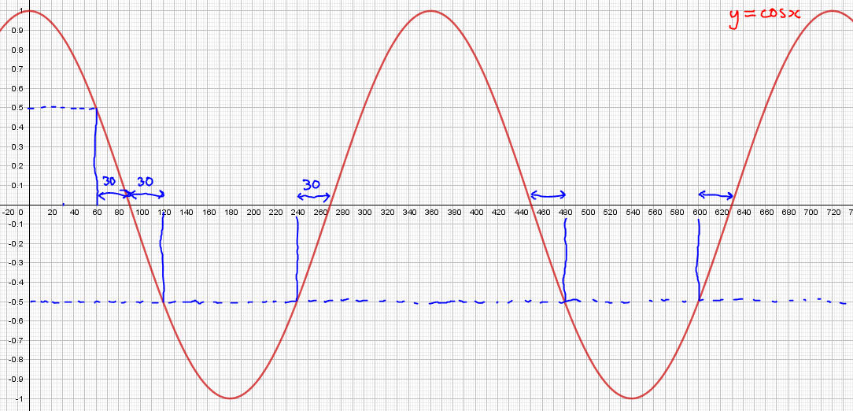  
     
   For $0°≤2x≤720°$, 2 $x=90°+30°=120°$, $2x=270°-30°=240°$, $2x=450°+30°=480°$ or $2x=630°-30°=600°$.  
   So, for $0°≤x≤360°$, $x=60°$, $x=120°$, $x=240°$ or $x=300°$.  
   All the question asked for was how many solutions the equation has in the given range. The answer is four solutions.
3. $\cos^{2}{x}=-\frac{1}{2}$ $$0≤\cos^{2}{x}≤1$$ for all values of $x$. In particular, the equation $\cos^{2}{x}=-\frac{1}{2}$ has no solutions for any interval of values of $x$.

1. $\cos^{2}{x}=\frac{1}{2}$ $$\cos^{2}{x}=\frac{1}{2}⇒\cos{x}=±\frac{1}{\sqrt{2}}$$.  
     
   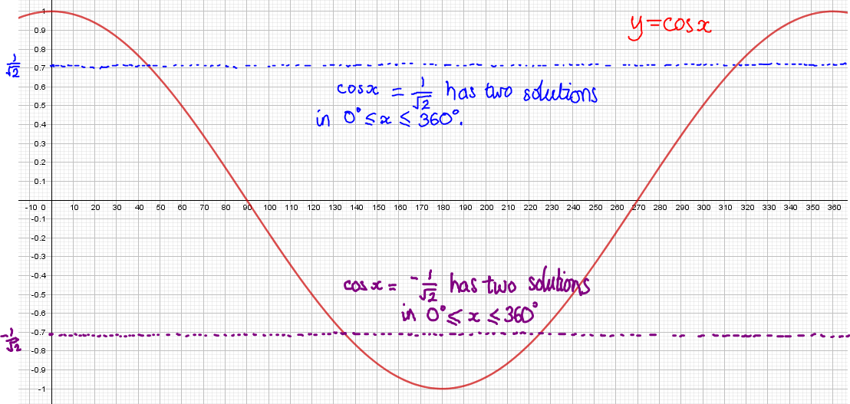  
     
   As the diagram above shows, $\cos{x}=\frac{1}{\sqrt{2}}$ has two solutions in the interval $0°≤x≤360°$, and so does the equation $\cos{x}=-\frac{1}{\sqrt{2}}$. Therefore, the equation $\cos^{2}{x}=-\frac{1}{2}$ has four solutions in the interval $0°≤x≤360°$.

1. $\cos^{2}{x}+3\cos{x}=4$ $$\cos^{2}{x}+3\cos{x}=4⇔\cos^{2}{x}+3\cos{x}-4=0⇔\left(\cos{x}+4\right)\left(\cos{x}-1\right)=0⇔\cos{x}=-4$$ or $\cos{x}=1$.  
     
   Since $-1≤\cos{x}≤1$, $\cos{x}=-4$ has no solutions.  
   As the diagram below shows, $\cos{x}=1$ has two solutions in the interval $0°≤x≤360°$ (yet no solutions in $0°<x<360°$!).  
     
   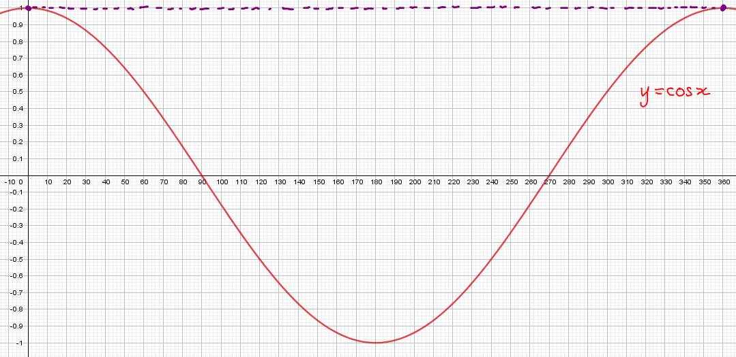  
     
   Therefore, the equation $\cos^{2}{x}+3\cos{x}=4$ has two solutions in the interval $0°≤x≤360°$.
2. $\cos^{2}{x}+3\sin{x}=4$ $$\cos^{2}{x}+3\sin{x}=4⇔1-\sin^{2}{x}+3\sin{x}=4⇔0=\sin^{2}{x}-3\sin{x}+3$$.  
   Thinking of this as a quadratic equation in $\sin{x}$, and realising that the discriminant of this equation, ‘ $b^{2}-4ac$’ $={\left(-3\right)}^{2}-4×1×3=-3<0$, is negative, it follows that there are no real value solutions for the value of $\sin{x}$. Therefore, the equation $\cos^{2}{x}+3\sin{x}=4$ also has no solutions.
3. $4^{\sin{x}}=\frac{1}{5}$ $$Realising that -1≤\sin{x}≤1$$, it follows that $\frac{1}{4}≤4^{\sin{x}}≤4$. Since $\frac{1}{5}<\frac{1}{4}$, it follows that $4^{\sin{x}}=\frac{1}{5}$ has no solutions.

**Exercise 1**

1. In order to compare values, using the identity $\sin\left(90°-x\right)≡\cos\left(x\right)$, either express them all as the sine of an angle, or express them all as the cosine of an angle. Since $y=\sin{x}$ is an increasing function on $0°≤x≤90°$, it is easier to choose this option. $\cos\left(40°\right)=\sin\left(50°\right)$ 
     
    and $\cos\left(80°\right)=\sin\left(10°\right)$. $\cos\left(80°\right)=\sin\left(10°\right)<\sin\left(20°\right)<\cos\left(40°\right)=\sin\left(50°\right)<\sin\left(60°\right)$ 
     
   .
2. $\cos\left(\frac{π}{2}\right)=0$, $\sin\left(\frac{π}{6}\right)=\frac{1}{2}$. $\tan\left(\frac{π}{12}\right)<\tan\left(\frac{π}{6}\right)=\frac{1}{\sqrt{3}}<\frac{1}{2}$ 
   . (That $\tan\left(\frac{π}{12}\right)<\tan\left(\frac{π}{6}\right)$ is because $y=\tan{x}$ is an increasing function on $0°<x<90°$.)  
     
   It follows that $\sin\left(\frac{π}{6}\right)=\frac{1}{2}$ is the largest value. The answer is b).
3. $\frac{2\cos^{2}{x}}{5+\sin{x}}=\sin{x}⇔2\cos^{2}{x}=\sin{x}\left(5+\sin{x}\right)$, since $5+\sin{x}≠0$.  
   So $2\cos^{2}{x}=5\sin{x}+\sin^{2}{x}⇔2\left(1-\sin^{2}{x}\right)=2-2\sin^{2}{x}=5\sin{x}+\sin^{2}{x}⇔0=3\sin^{2}{x}+5\sin{x}-2⇔\left(3\sin{x}-1\right)\left(\sin{x+2}\right)=0⇔\sin{x}=\frac{1}{3}$ or $\sin{x}=-2$.  
   Since $-1<\frac{1}{3}<1$ and $-2<-1$, $\sin{x}=\frac{1}{3}$ has two solutions and $\sin{x}=-2$ has no solutions in the interval $0°≤x≤360°$. There are two solutions in total.
4. Notice that if $\sin{x}=\cos{x}$ then the left-hand side of the equation equals. By the Factor Theorem, this means that $\left(\sin{x}-\cos{x}\right)$ is a factor: $$\sin^{3}{x}-2\sin^{2}{x}\cos{x}-5\sin{x}\cos^{2}{x}+6\cos^{3}{x}=\left(\sin{x}-\cos{x}\right)\left(\sin^{2}{x}-\sin{x}\cos{x}-6\cos^{2}{x}\right)=\left(\sin{x}-\cos{x}\right)\left(\sin{x}+2\cos{x}\right)\left(\sin{x}-3\cos{x}\right)=0$$ 
   So, $\sin{x}=\cos{x}⇔\tan{x}=1$, $\sin{x}=-2cos{x}⇔\tan{x}=-2$ or $\sin{x}=3\cos{x}⇔\tan{x}=3$.  
   As the following diagram shows, in the interval $-45°≤x≤450°$, $\tan{x}=1$ and $\tan{x}=3$ each have three solutions, whereas $\tan{x}=-2$ has just two solutions. There are eight solutions in total.  
   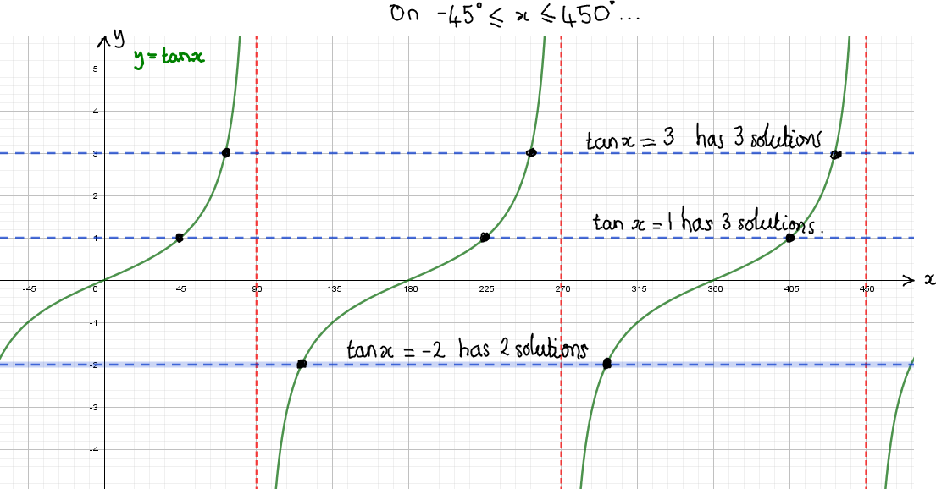

1. For what fraction of the interval $0°≤x≤360°$ is the inequality $2\cos^{2}{x}-\sin{x}-2≥0$ satisfied? $2\cos^{2}{x}-\sin{x}-2≥0⇔2\left(1-\sin^{2}{x}\right)-\sin{x}-2≥0⇔2-2\sin^{2}{x}-\sin{x}-2≥0⇔0≥2\sin^{2}{x}+\sin{x}⇔0≥\sin{x}\left(2sin{x}+1\right)$ 
     
   Since $y\left(2y+1\right)≤0⇔-\frac{1}{2}≤y≤0$, it follows that $-\frac{1}{2}≤\sin{x}≤0$. In the interval $0°≤x≤360°$, this is satisfied precisely when either $0°≤x≤30°$ or $150°≤x≤180°$. This is $\frac{30+30}{360}=\frac{1}{6}$ of the interval $0°≤x≤360°$.  
     
   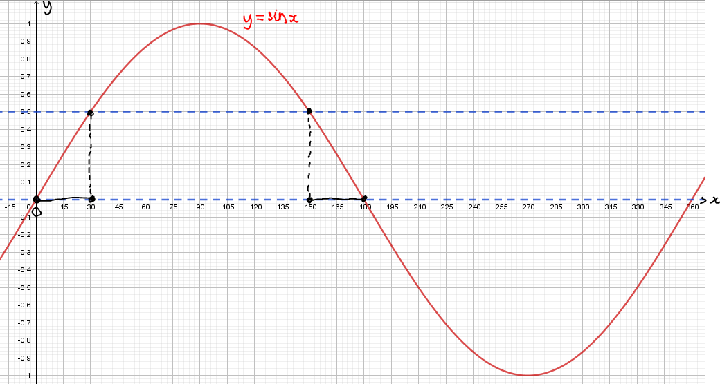
2. The left-hand side equals zero when $\tan{x}=1$, so $\left(\tan{x}-1\right)$ is a factor of the left-hand side: $$3\tan^{3}{x}-3\tan^{2}{x}-\tan{x}+1=\left(\tan{x}-1\right)\left(3\tan^{2}{x}-1\right)≤0$$ 
   Since $\left(y-1\right)\left(3y^{2}-1\right)=\left(\sqrt{3}y+1\right)\left(\sqrt{3}y-1\right)\left(y-1\right)≤0⇔y≤-\frac{1}{\sqrt{3}}$ or $\frac{1}{\sqrt{3}}≤y≤1$, it follows that $\tan{x}≤-\frac{1}{\sqrt{3}}$ or $\frac{1}{\sqrt{3}}≤\tan{x}≤1$. Knowing that $\tan^{-1}{\frac{1}{\sqrt{3}}}=30°$ and $\tan^{-1}{1}=45°$, a sketch shows that the original inequality is satisfied for $0°≤x≤180°$ precisely when $30°≤x≤45°$ or $90°<x≤150°$.  
     
   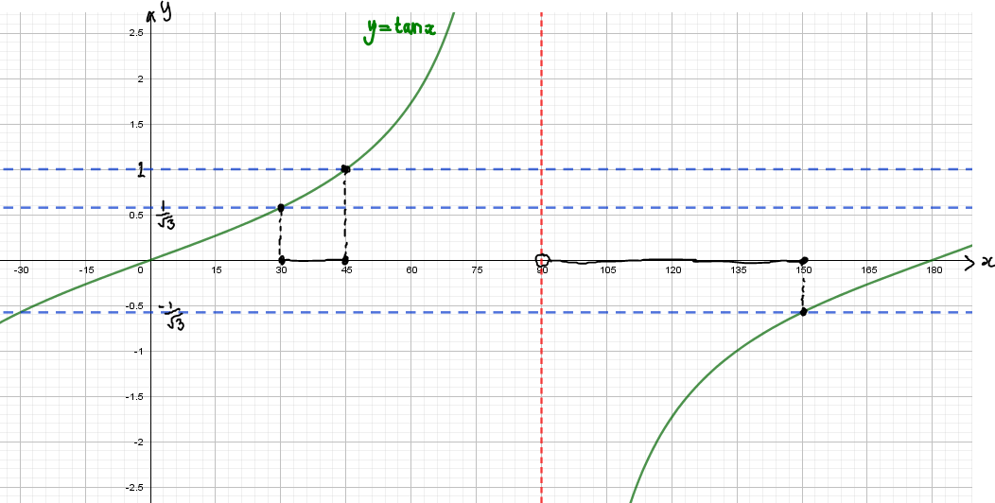
3. $2\cos^{3}{x}+5\cos^{2}{x}-3\cos{x}<0⇔\cos{x}\left(2\cos^{2}{x}+5\cos{x}-3\right)=\cos{x}\left(2\cos{x}-1\right)\left(\cos{x}+3\right)<0$ Since $\left(y+3\right)y\left(2y-1\right)<0⇔y<-3$ or $0<y<\frac{1}{2}$, it follows that $\cos{x}<-3$ or $0<\cos{x}<\frac{1}{2}$. Since $\cos{x}≥-1$, $\cos{x}<-3$ has no solutions. If $0<\cos{x}<\frac{1}{2}$, however, a quick sketch shows that, for $0°≤x≤360°$, either $60°<x<90°$ or $270°<x<300°$.  
     
   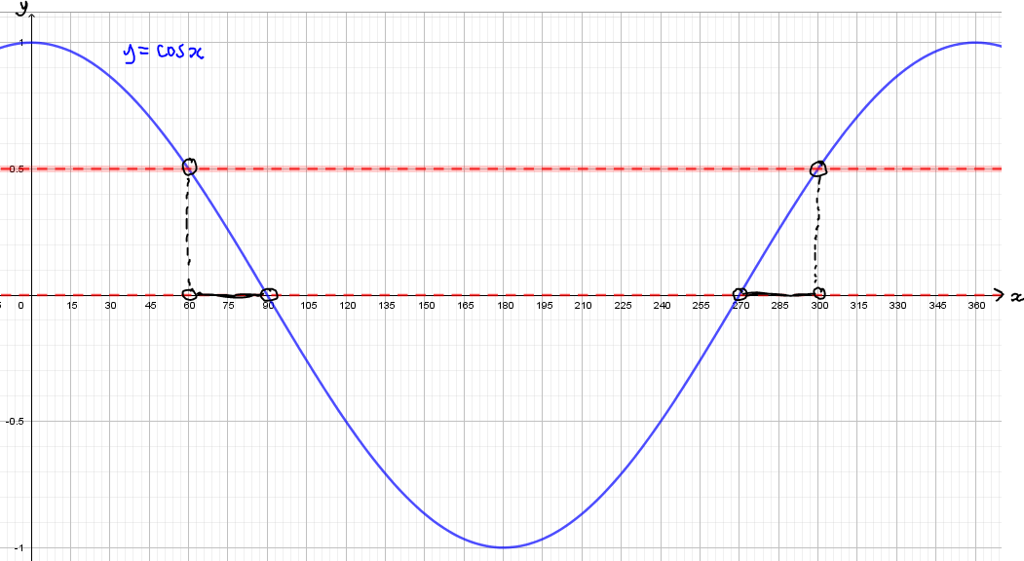
4. It would not make sense for $c$ to be a negative number since then the inequality would always be true, so let $c$ be a positive number. $\cos^{2}{x}≥c⇔\cos{x}≤-\sqrt{c}$ or $\cos{x}≥\sqrt{c}$.  
   A quick sketch helps greatly:  
     
   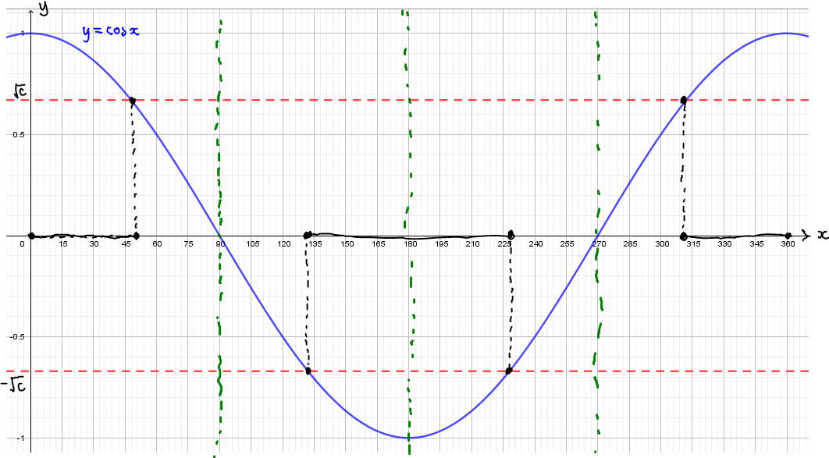  
     
   Appreciating the symmetry of the curve leads to the realisation that the answer to the question would be the same if it were just on the interval $0°≤x≤90°$ and that, since $30$ is one third of $90$ and $\cos{30°=\frac{\sqrt{3}}{2}}$, $\sqrt{c}$ must equal $\frac{\sqrt{3}}{2}$.  
   It follows that $c={\left(\frac{\sqrt{3}}{2}\right)}^{2}=\frac{3}{4}$.
5. It only makes sense for $k$ to be a positive number. $\cos^{2}{x}≤k⇔-\sqrt{k}≤\cos{x}≤\sqrt{k}$, and similarly $\sin^{2}{x}≤k⇔-\sqrt{k}≤\sin{x}≤\sqrt{k}$.  
   A quick sketch helps. For the value of $k$ used in the illustration below, the interval of values that satisfy $\cos^{2}{x}≤k$ do overlap a little with the interval of values that satisfy $\sin^{2}{x}≤k$.  
     
   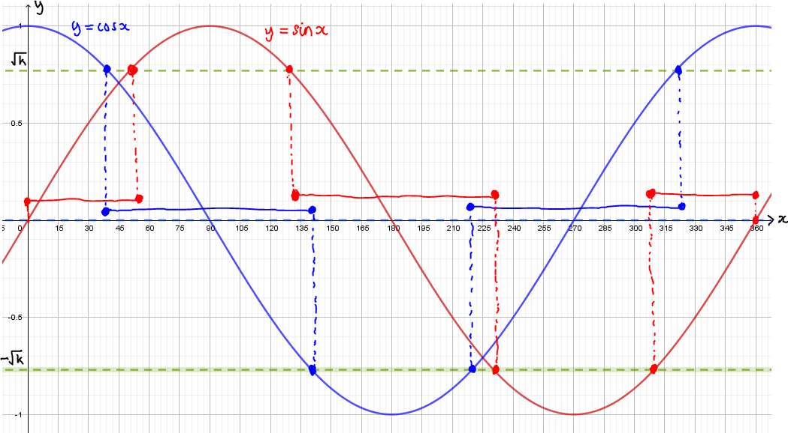  
     
   As the value of $k$ lowers, so does the amount of overlap between the two sets of solutions, each overlap becoming a single point (at $x=45°, x=135°, x=225°$ and $x=315°$) precisely when $\sqrt{k}=\sin\left(45°\right)=\cos\left(45°\right)=\frac{1}{\sqrt{2}}$. Therefore, $k=\frac{1}{2}$ is the smallest value of $k$ such that $\cos^{2}{x}≤k$ and $\sin^{2}{x}≤k$ have solutions in common.
6. $\left|2\sin{x}-1\right|≥1⇔2\sin{x}-1≥1$ or $2\sin{x}-1≤-1⇔\sin{x}≥1$ or $\sin{x}≤0$. The solution to this on the interval $0°≤x≤360°$ is $x=0°$, $x=90°$, or $180°≤x≤360°$.  
     
   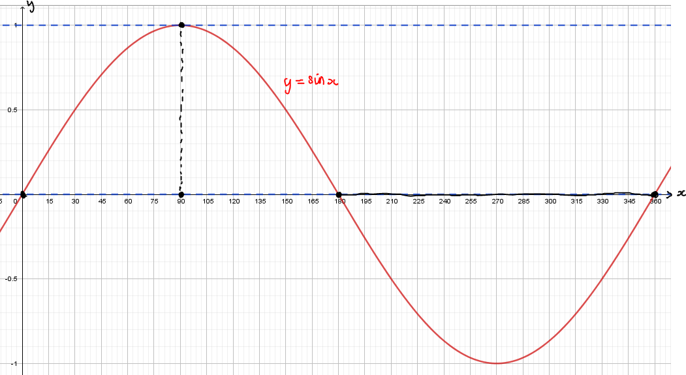

**Exercise 2**

**TMUA style questions**

1. $\cos{θ}+\sin{θ}$ can be rewritten as $R\sin\left(x+α\right)$

$R\sin{α}=1$, $R\cos{α}=1$, $R^{2}=2\overset{⇔}{ }R=\sqrt{2}$. $\tan{α}=-1\overset{⇔}{ }α=\frac{π}{4}$

$$\cos{θ}+\sin{θ}≡\sqrt{2}\sin\left(x+\frac{π}{4}\right)$$

$\sqrt{2}\sin\left(x+\frac{π}{4}\right)<0$ for $\frac{3π}{4}<x<\frac{7π}{4}$

$\frac{\sqrt{3}}{2}+\cos{\frac{1}{2}θ}=0$ when $\cos{\frac{1}{2}θ}=-\frac{\sqrt{3}}{2}$

i.e. $\frac{1}{2}θ=\frac{5π}{6}\overset{⇔}{ } θ=\frac{5π}{3}$ (Note: no other values in $0≤θ≤2π$ give $\cos{\frac{1}{2}θ}=-\frac{\sqrt{3}}{2}$)

For $0≤θ≤\frac{5π}{3}$, $\frac{\sqrt{3}}{2}+\cos{\frac{1}{2}θ}>0$

$\cos^{2}{θ}-1≤0$ for all $θ$

$$\frac{3π}{4}$$

$$2π$$

$$\frac{7π}{4}$$

$$\frac{5π}{3}$$

$$0$$

$\cos{θ}+\sin{θ}$ $+$ $-$ $-$ $+$

$\frac{\sqrt{3}}{2}+\cos{\frac{1}{2}θ}$ $+$ $+$ $-$ $-$

$\cos^{2}{θ}-1$ $-$ $-$ $-$ $-$

$-$ $+$ $-$ $+$

$\left(\cos{θ}+\sin{θ}\right)\left(\frac{\sqrt{3}}{2}+\cos{\frac{1}{2}θ}\right)\left(\cos^{2}{θ}-1\right)≤0$ for $0≤θ≤\frac{3π}{4}$ and $\frac{5π}{3}≤θ≤\frac{7π}{4}$



$\frac{3π}{4}+\left(\frac{7π}{4}-\frac{5π}{3}\right)=\frac{9π}{12}+\frac{21π}{12}-\frac{20π}{12}=\frac{10π}{12}=\frac{5π}{6}$

$\frac{5π}{6}÷2π=\frac{5}{12}$

$$\sum_{r=0}^{100}{\cos\left(\frac{2r+1}{4}π\right)}=\cos{\frac{π}{4}}+\cos{\frac{3π}{4}}+\cos{\frac{5π}{4}}+\cos{\frac{7π}{4}}+…+\cos{\frac{201π}{4}}$$

$$=\frac{1}{\sqrt{2}}-\frac{1}{\sqrt{2}}-\frac{1}{\sqrt{2}}+\frac{1}{\sqrt{2}}+…+\frac{1}{\sqrt{2}}=\frac{1}{\sqrt{2}}=\frac{\sqrt{2}}{2}$$ The values occur in groups of four. Each group of four sum to zero $\left(\frac{1}{\sqrt{2}}-\frac{1}{\sqrt{2}}-\frac{1}{\sqrt{2}}+\frac{1}{\sqrt{2}}=0\right)$. Since there are $101=25×4+1$ terms to be added, the last term must be the first term of the next group of four, $\frac{1}{\sqrt{2}}$.

The answer is B.

1. When $\cos{4x=0}$, $\sin{4x}≠0$, so the solutions of the equation $x^{2}\cos{4x}=8\sin{4x}$ are the same as the solutions of the equation $x^{2}=8\tan{4x}$.   
   The graphs of both $y=x^{2}$ and $y=8\tan{4x}$ pass through the origin, but the gradient of the tangent to $y=x^{2}$ at $\left(0, 0\right)$ is zero, whereas the gradient of the tangent to $y=8\tan{4x}$ at $\left(0, 0\right)$ is positive ( $\frac{d}{dx}\left(8\tan{4x}\right)=8×4\sec^{2}{4x}=32$ when $x=0$). So, as $x$ increases from zero, the graph of $y=x^{2}$ is below the graph of $y=8\tan{4x}$ until it passes the first vertical asymptote; moreover, since, between successive asymptotes and above the $x$-axis, both graphs have increasing gradient, with $y=8\tan{4x}$ tending to infinity before reaching the next asymptote, it follows that the graphs intersect precisely once.  
   On the graph of $y=\tan{x}$ the asymptotes are at $x=\frac{π}{2}$, $x=\frac{3π}{2}$, $x=\frac{5π}{2}$, etc.. Thinking of $y=8\tan{4x}$ as a one-way stretch parallel to the $x$-axis scale factor $\frac{1}{4}$ (followed by a one-way stretch parallel to the $y$-axis, scale factor $8$), the asymptotes on this graph, in the interval $0≤x≤π$, are at $x=\frac{π}{8}$, $x=\frac{3π}{8}$, $x=\frac{5π}{8}$ and $x=\frac{7π}{8}$.  
   By the reasoning given above, the equation $x^{2}=8\tan{4x}$, and therefore the equation $x^{2}\cos{4x}=8\sin{4x}$, has precisely one solution on each of $\left[0, \frac{π}{8}\right)$, $\left(\frac{π}{8}, \frac{3π}{8}\right)$, $\left(\frac{3π}{8}, \frac{5π}{8}\right)$ and $\left(\frac{5π}{8}, \frac{7π}{8}\right)$. (There is no solution in $(\frac{7π}{8}, π]$, since on this interval the graph of $y=8\tan{4x}$ is still below the $x$-axis.) There are four solutions in total.

The answer is E.

1. Subtracting $\sqrt{2}$ times the first equation from the second equation gives:

$4\sqrt{2}\cos{3x}=\frac{1}{2}\left(4+\sqrt{2}\right)-\sqrt{2}\left(1-\sqrt{2}\right)=2+\frac{\sqrt{2}}{2}-\sqrt{2}+2=\frac{8-\sqrt{2}}{2}⟹\cos{3x}=k$

Since $\cos\left(-3x\right)≡\cos{3x}$ for all values of $x$, any solution, $x=a$, to any equation of the form $\cos{3x}=k$, for some real number $k$, in the interval $-180°≤x≤180°$, must be paired with a second solution, $x=-a$, and therefore adding all of the solutions must equal zero. There is no need to find the value of $\cos{3x}$ nor solve the resulting equation.

Adding $\sqrt{2}$ times the first equation to the second equation gives:

$3\sin{3x}=\sqrt{2}\left(1-\sqrt{2}\right)+\frac{1}{2}\left(4+\sqrt{2}\right)=\sqrt{2}-2+2+\frac{\sqrt{2}}{2}=\frac{3\sqrt{2}}{2}⇔\sin{3x}=\frac{\sqrt{2}}{2}$

So, $\sin{3x}=\frac{\sqrt{2}}{2}$ on $-540°≤3x≤540°$, then $3x=-315°, -225°, 45°, 135°, 405°,$ 
 or $495°$, so $x=-105°, -75°, 15°, 45°, 135°,$ or $165°$.  
Adding these up gives $-105-75+15+45+135+165=180°$.

The answer is D.

$$α$$

$$α$$

$$6$$

$$6$$

$$8$$

$$A$$

$$B$$

$$C$$

$$D$$

Area $ACD=5×$ Area $ABC$

$\frac{1}{2}×8×CD\sin{α}=5×\frac{1}{2}×8×AB\sin{α}$

$CD=5AB$

Let $AB=x$ so $CD=5x$

Cosine rule for triangle $ABC$: $\cos{α}=\frac{x^{2}+64-36}{2×8×x}=\frac{x^{2}+28}{16x}$ (1)

Cosine rule for triangle $ACD$: $\cos{α}=\frac{{2x}^{2}+64-36}{2×8×5x}=\frac{{25x}^{2}+28}{80x}$ (2)

Equating $\frac{x^{2}+28}{16x}=\frac{{25x}^{2}+28}{80x}$

$5\left(x^{2}+28\right)=25x^{2}+28$

$5x^{2}+140=25x^{2}+28$

$x^{2}=\frac{28}{5}$

Substituting back into (1) gives $\cos{α}=\frac{\frac{28}{5}+28}{16\frac{\sqrt{28}}{\sqrt{5}}}$

Multiplying top and bottom by $5$ gives $\cos{α}=\frac{28+140}{16\sqrt{28}\sqrt{5}}=\frac{168}{32\sqrt{35}}=\frac{21}{4\sqrt{35}}=\frac{21\sqrt{35}}{140}=\frac{3\sqrt{35}}{20}$

The answer is C.

**MAT style questions**

1. If $\cos{x}=0$ then $\sin{x}≠0$, so the solutions of $\cos^{4}{x}+\sin^{3}{x}=0$ are the same as the solutions of $\cos{x}+\tan^{3}{x}=0⇔\tan^{3}{x}=-\cos{x}$.  
   A quick sketch of the graphs of $y=-\cos{x}$ and $y=\tan^{3}{x}$ helps at this stage.  
     
   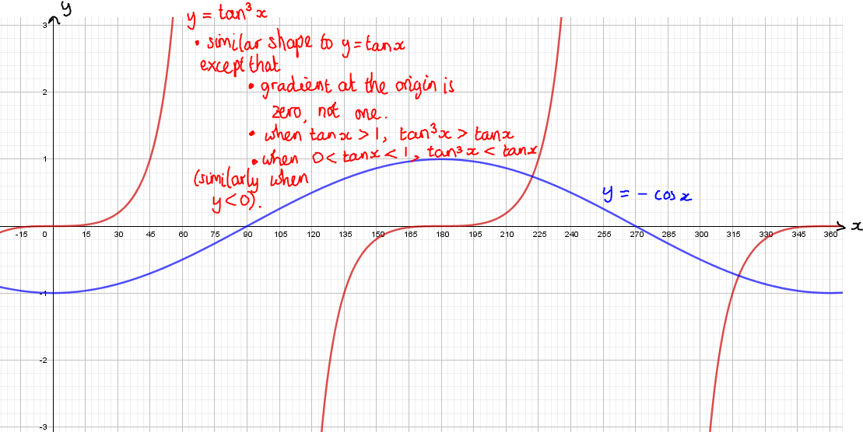  
     
   For $0°≤x<90°$, $-\cos{x}<0<\tan^{3}{x}$, and for $90°<x<180°$, $\tan^{3}{x}<0<-\cos{x}$. For $180°<x<270°$, $-\cos{x}$ and $\tan^{3}{x}$ are both positive, with $-\cos{x}$ decreasing and $\tan^{3}{x}$ increasing from zero towards infinity, meaning that the curves intersect precisely once.  
   For $270°<x<360°$, $-\cos{x}$ and $\tan^{3}{x}$ are both negative, with $-\cos{x}$ decreasing and $\tan^{3}{x}$ increasing from negative infinity to zero, meaning that the curves intersect precisely once.   
   For $x=90°, 180°, 270°$ and $360°$, either $\tan^{3}{x}$ is undefined, or it is but the graphs clearly do not intersect.  
   In total, there are two solutions on the interval $0°≤x≤360°$.

The answer is c).

1. $\cos^{2n}{x}={\left(\cos^{n}{x}\right)}^{2}≥0$. In a similar way, if $n$ is even then $\sin^{n}{x}≥0$ and $\cos^{2n}{x}+\sin^{n}{x}$ can never equal zero, since $\cos{x}$ and $\sin{x}$ never equal zero for the same value of $x$. This immediately rules out a), b), d) and e). The answer is c), simply by deduction that it cannot be any of the other answers!
2. For $90°≤x≤270°$, $225°≤x+135°≤405°$. A quick sketch of the graph of $y=\sin{x}$ shows that $-1≤\sin\left(x+135°\right)≤\frac{1}{\sqrt{2}}.$  
   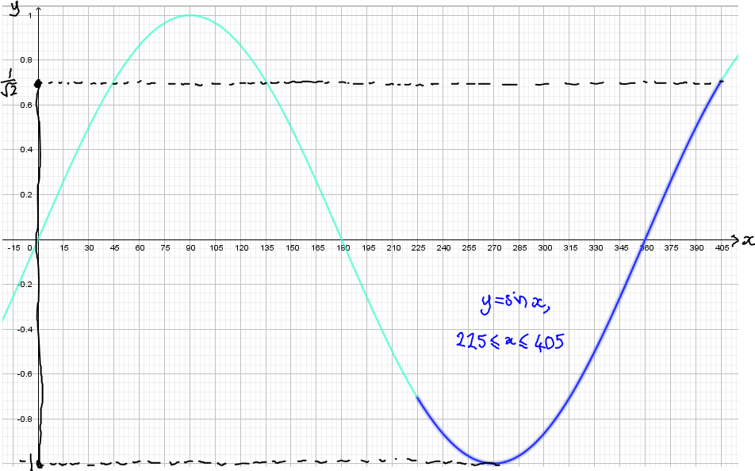  
     
   So $2-\frac{1}{\sqrt{2}}≤2-\sin\left(x+135°\right)≤3⇔\frac{1}{3}≤0≤\frac{1}{2-\sin\left(x+135°\right)}≤\frac{1}{2-\frac{1}{\sqrt{2}}}=\frac{\sqrt{2}}{2\sqrt{2}-1}×\frac{2\sqrt{2}+1}{2\sqrt{2}+1}=\frac{4+\sqrt{2}}{7}$.  
   It follows that $\frac{1}{9}≤{\left[\frac{1}{2-\sin\left(x+135°\right)}\right]}^{2}≤{\left(\frac{4+\sqrt{2}}{7}\right)}^{2}=\frac{16+8\sqrt{2}+2}{49}=\frac{18+8\sqrt{2}}{49}$.

The answer is d).

Here is another example that it is probably quicker to answer by simply eliminating the wrong answers. The most obvious triangle that satisfies $0<α≤β≤γ<90°$ is an equilateral triangle, with $α=β=γ=60°$. This is handy because $\sin{60°=\frac{\sqrt{3}}{2}}$ and $\cos{60°}=\frac{1}{2}$ are both common knowledge.  
  
If $α=β=γ=60°$:

$\sin{α}\sin{β}\sin{γ}=\frac{\sqrt{3}}{2}×\frac{\sqrt{3}}{2}×\frac{\sqrt{3}}{2}=\frac{3\sqrt{3}}{8}$. Since ${\left(\frac{3\sqrt{3}}{8}\right)}^{2}=\frac{27}{64}>\frac{16}{64}=\frac{1}{4}>0⇔\sqrt{\frac{27}{64}}=\frac{3\sqrt{3}}{8}>\sqrt{\frac{1}{4}}=\frac{1}{2}$. So $\sin{α}\sin{β}\sin{γ}=\frac{3\sqrt{3}}{8}>\frac{1}{2}$, and a) is not possible; $\sin{α}+\sin{β}+\sin{γ}=\frac{\sqrt{3}}{2}+\frac{\sqrt{3}}{2}+\frac{\sqrt{3}}{2}=\frac{3\sqrt{3}}{2}$ 
  
. Since ${\left(\frac{3\sqrt{3}}{2}\right)}^{2}=\frac{27}{4}>4>0⇔\sqrt{\frac{27}{4}}=\frac{3\sqrt{3}}{2}>\sqrt{4}=2$. So $\sin{α}\sin{β}\sin{γ}=\frac{3\sqrt{3}}{2}>2$, and b) is not possible; $\cos{α}+\cos{β}+\cos{γ}=\frac{1}{2}+\frac{1}{2}+\frac{1}{2}=\frac{3}{2}$ 
  
, so this eliminates both d) and e).  
  
The only possible answer is c).

The circle has centre $\left(1, 1\right)$ and radius $1$.  
The angle that $y=x$ makes with the $x$-axis is $45°$.  
This means that angle $XAC$ is $45°$ (since corresponding angles are equal) and angle $CXA$ is $45°$ (angles in triangle $ACX$ add up to $180°$).  
Therefore, angle $AXB$ is $135°$ (angles on a straight line add up to $180°$) and angles $XBA$ and $BAX$ both equal $\frac{180-135}{2}=22.5°$ (since $AX=XB=1$ so triangle $AXB$ is isosceles).  
Therefore angle $BAC$ is $45+22.5=67.5°$.

$AC=CX=\frac{\sqrt{2}}{2}$. (Let $AC=CX=p>0$; then, by Pythagoras’ Theorem, $p^{2}+p^{2}=1^{2}⇔p^{2}=\frac{1}{2}⇔p=\sqrt{\frac{1}{2}}×\frac{\sqrt{2}}{\sqrt{2}}=\frac{\sqrt{2}}{2}$).  
So $AC=\frac{\sqrt{2}}{2}$ and $CB=\frac{\sqrt{2}}{2}+1$, and $\tan{67.5°}=\frac{CB}{AC}=\frac{\left(\frac{\sqrt{2}}{2}+1\right)}{\left(\frac{\sqrt{2}}{2}\right)}×\frac{2}{2}=\frac{\sqrt{2}+2}{\sqrt{2}}×\frac{\sqrt{2}}{\sqrt{2}}=\frac{2+2\sqrt{2}}{2}=1+\sqrt{2}$. The answer is b).

**Chapter 10 Logic and proof**

**Try it out (page 118)**

$not\left(P or Q\right)$

|  |  |  |  |
| --- | --- | --- | --- |
| $$P$$ | $$Q$$ | $$P or Q$$ | $$not\left(P or Q\right)$$ |
| F | F | F | T |
| F | T | T | F |
| T | F | T | F |
| T | T | T | F |

|  |  |  |  |  |
| --- | --- | --- | --- | --- |
|  |  |  |  |  |
| F | F | T | T | T |
| F | T | T | F | F |
| T | F | F | T | F |
| T | T | F | F | F |

**Try it out (page 119)**

For $n≥2$, if $n$ is odd then $n$ is prime.

A counter example for this is $n=9$ since $9>2$ and $9=3^{2}$

**Try it out (page 120)**

$x^{2}>4 \overset{⇒}{ } x>2$

It is worth noting that this statement is false before you start.

Converse: $x>2\overset{⇒}{ }x^{2}>4$

This **is** true for all values of $x$ greater than $2$, squaring will give a value greater than $4$.

Contrapositive: $x≤2\overset{⇒}{ }x^{2}≤4$

This is false. The contrapositive is only true if and only if the original statement is true (the contrapositive can be used to prove a statement).

A counter example here is $x=-3$

Negation: $x^{2}>4$ does not imply $x>2$.

This is actually true as the original statement was false.

**Try it out (page 121)**

1. $x>2$ if $x>4$ is true there are no values greater than $4$ that are not also greater than $2$.
2. $x>2$ only if $x>4$ is false. There are values that are not greater than $4$ that are greater than $2$ e.g. $x=3$.
3. $S$ is a square if $S$ is a rectangle is false. It is possible for a rectangle not to be a square (if adjacent side lengths are not equal).
4. $S$ is a square only if $S$ is a rectangle is true. The definition of a rectangle is that it is a quadrilateral with four internal right-angles. A square has to have these.
5. $ab=ac$ if and only if $b=c$ is false. If $a=0$ then $b$ and $c$ could be anything. This could be made true by specifying that $a≠0$.
6. $x^{2}<x$ if $x<1$ is false. A counter example is $x=0$ which gives $x^{2}=x$. Think of some more counter examples.
7. $x^{2}<x$ only if $x<1$ is true. All of the values for which $x^{2}<x$ lie below $1$.
8. $x^{2}<x$ if and only if $x<1$ is false. A counter example is $x=-\frac{1}{2}$ for which $x^{2}=\frac{1}{4}$

**Exercise 1**

* + - 1. The statement does not say “behind every odd number there is a vowel” so turning the $3$ over would not prove anything conclusive.

The statement also does not say “behind every consonant there is an even number” so turning the B over would not prove anything conclusive.

Turning the A over would either show that the statement is false, if there is an even number on the back, or *provide evidence* (but not prove) that the statement is true.

Turning the $2$ over would either show that the statement is false, if there is a vowel on the other side, or *provide evidence* (but not prove) that the statement is true.

To prove that the statement is true, both the A and the 2 cards would have to be turned over.

The minimum number of cards is .

* + - 1. Let stand for Moves, $S$ for Salute and $P$ for Paint, We are told that $M\overset{⇒}{ }S$ and $not(M)\overset{⇒}{ }P$.

1. We are given $not(P)$. The contrapositive of $not(M)\overset{⇒}{ }P$ is $not(P)\overset{⇒}{ }M$. Since a conditional statement and its contrapositive are logically equivalent we have $not(P)$ is true and $not(P)\overset{⇒}{ }M$ (so $M$ is true) and finally $M\overset{⇒}{ }S$ so the recruit should salute it.
2. We are given $P$ is true but we cannot deduce $M$ or $S$ from this. If the object is not moving, the recruit should paint it again (just following orders). If the object is something e.g. a vehicle that was painted when it was stationary and has subsequently started moving then it should be saluted.
   * + 1. The part of the statement that says $\left(not dry\right) or \left(not warm\right)$ is equivalent to $not\left(dry and warm\right)$. Siân will go out if it is the negation of this i.e. it is dry and warm so Max will have convinced Siân by saying that it is dry and warm.
       2. It is possible for the car headlights to be on in the daytime even if it is not raining.

You can deduce nothing without additional information.

This may seem like a slightly pointless question but, in mathematics, it is important to be able to ascertain when you can make an inference and when you cannot.

* + - * 1. This is correct
        2. This could be false. It does not say that you can’t put up an umbrella when it isn’t raining.
        3. This is the sort of statement that can cause a great deal of argument! Even though the initial statement is not true, the logic is correct. It is possible to come to a false conclusion but correct logical argument if an initial statement is incorrect (as it is here).
        4. Other animals than cats purr. The statement is only made about cats and it does not say “all animals that purr are cats.” The purring animal could be something different. A quick internet search will show that mongeese, bears, badgers, foxes, hyaenas, rabbits, squirrels, guinea pigs, tapirs and ring-tailed lemurs also purr.
        5. We may choose not to ski even if it is not windy. The statement doesn’t say that we have to ski.

**Exercise 2**

To prove that for any positive integer $n$, if $2^{n}-1$ is prime then $n$ is prime.

Assume that $n$ is not prime, i.e. $n=pq$ where $p$ and $q$ are positive integers.

$2^{pq}-1={\left(2^{p}\right)}^{q}-1=\left(2^{q}-1\right)\left(2^{\left(p-1\right)q}+2^{\left(p-2\right)q}+2^{\left(p-3\right)q}+…+2^{q}+1\right)$

If $n$ is not prime (i.e. $n=pq$) then $2^{n}-1$ is divisible by $2^{q}$ and is therefore not prime so for $2^{n}-1$ to be prime, $n$ has to be prime.

The converse of this statement is

If a positive integer $n$ is prime then $2^{n}-1$ is prime.

This can be proved false by a counter example.

If $n=11$ then $2^{11}-1=2047$ which is divisible by $23$ and $89$ (as well as $1$ and $2047$)

If $a^{2}+b^{2}≠74$ then $a+b≠12$ or $ab≠35$

Using the contrapositive

Let statement A be $a+b=12$ and statement B be $ab=35$

$a+b≠12$ or $ab≠35$ is equivalent to $\left(not A\right) or \left(not B\right)$

$\left(not A\right) or \left(not B\right)$ is the same as $not\left(A and B\right)$

So the statement can be rewritten If $a^{2}+b^{2}≠74$ then $a+b=12$ and $ab=35$ are not true simultaneously.

The contrapositive is

if $a+b=12$ and $ab=35$ then $a^{2}+b^{2}=74$.

Proving the contrapositive will prove the initial result

If $a+b=12$ and $ab=35$

Let $a^{2}+b^{2}=74$

$a^{2}+b^{2}≡{\left(a+b\right)}^{2}-2ab$

${\left(a+b\right)}^{2}-2ab=74$

${12}^{2}-2×35=74$

So the statement is true for real numbers $a$ and $b$.

1. The contrapositive for this is

If $ab=35$ and $a^{2}+b^{2}=74$ then $a+b=12$

$a^{2}+b^{2}≡{\left(a+b\right)}^{2}-2ab$

${\left(a+b\right)}^{2}=a^{2}+b^{2}+2ab$

${\left(a+b\right)}^{2}=74+2×35$

${\left(a+b\right)}^{2}=144$

$a+b=±12$ since $a$ and $b$ are real numbers

This statement is not true as the contrapositive is not true. It is possible for $a+b$ to be equal to $-12$.

**Exercise 3**

**TMUA style questions**

* + - 1. A table of when Alice and Marcus are telling the truth and lying will help

|  |  |  |  |  |  |  |  |
| --- | --- | --- | --- | --- | --- | --- | --- |
|  | Mon | Tue | Wed | Thur | Fri | Sat | Sun |
| Alice | T | T | T | L | L | L | T |
| Marcus | L | L | L | T | T | T | T |

The possibilities are that

* 1. both are telling the truth
  2. Alice is telling the truth and Marcus is lying
  3. Alice is lying and Marcus is telling the truth
  4. both are lying
  5. Sunday is the only day where both tell the truth. If both are telling the truth then on Saturday both would be lying. This is not the case so it is not Sunday
  6. T/L occurs on Monday, Tuesday and Wednesday. If Alice is telling the truth and Marcus is lying then the previous day has to be L/T. None of these days has a previous day as L/T so it is not Monday, Tuesday or Wednesday.
  7. L/T occurs on Thursday, Friday and Saturday. If Alice is lying and Marcus is telling the truth then the previous day has to be T/L. The only day where this happens is Thursday (T/L on Wednesday)

It is Thursday.

The correct answer is D

* + - 1. A simple counter example can reduce the options

If $c=10$, $a=100$ and $b=1000$ then

$\log_{c}{a}=\log_{10}{100=2}$ and $\log_{c}{b}=\log_{10}{1000=3}$

$a^{\left(\log_{c}{b}\right)}={100}^{3}=1000000$

$b^{\left(\log_{c}{a}\right)}={1000}^{2}=1000000$

Here $a^{\left(\log_{c}{b}\right)}=b^{\left(\log_{c}{a}\right)}$ so A and B can be eliminated.

This suggests that $a^{\left(\log_{c}{b}\right)}=b^{\left(\log_{c}{a}\right)}$ but it needs to be confirmed for all cases

Let $\log_{c}{a}=x$ and $\log_{c}{b}=y$

This gives $a=c^{x}$ and $b=c^{y}$

$a^{\left(\log_{c}{b}\right)}={\left(c^{x}\right)}^{y}=c^{xy}$

$b^{\left(\log_{c}{a}\right)}={\left(c^{y}\right)}^{x}=c^{xy}$

The correct answer is C

* + - 1. If jar B is false then

B contains £2

B says that C contains £10 so C does not contain £10

C is true so C also does not contain £50

D is true so E contains £20

E is true so A contains £5

This leaves jars C and D with two options, either £10 or £50 but C does not contain either of these (as discussed above)

B must therefore not be false otherwise C would also have to be false and as precisely one jar is false, it cannot be B that is false. B must be true.

If jar C is false then jar C contains £50 however, as B is true and states that C contains £10, this means that C cannot be false without B being false. C must be true.

If jar D is false the D contains £2.

As B is true, C contains £10 and this confirms that C is true (it does not contain £50).

If jar D is false then jar E does not contain £20

If jar E is true then A contains £5

So far the information indicates that A contains £5, C contains £10 and D contains £2. The remaining amounts are £20 and £50. Since D is false and E does not contain £20, it follows that B contains £20 and the £50 must be in jar E.

It looks like the answer is E

As a final check, jar E can be assumed to be false in which case jar E contains £2.

Jar A does not contain £5.

Jar D is true and states that E contains £20 but A also states that jar E contains £2. Both A and D are true so E cannot be false.

The £50 is in jar E.

$a\left(b-c\right)=a(c-b)$

$a\left(b-c\right)=-a\left(b-c\right)$

$2a\left(b-c\right)=0$

Either $a=0$ or $b=c$

The only fully correct option is II so the answer is C

* + - 1. and are factors of $r$ $⟸\frac{p}{q}=r$ (*) is true. So $q$ and $r$ are factors of $r$ is a sufficient condition for (*).

However, $q$ and $r$ are factors of $r$ $⟹\frac{p}{q}=r$ is false (for example, 2 and 3 are factors of 12 but $\frac{12}{2}≠3.$ So $q$ and $r$ are factors of $r$ is not a necessary condition for (*).

The correct answer is B.

* + - 1. If then $\frac{1}{b}+\frac{1}{c}=0$.

Since $0<a≤b≤c$ then this is not possible. As $a$ is an integer, it follows that $a>1$

If $a=2$ then $\frac{1}{b}+\frac{1}{c}=\frac{1}{2}$

$b≠2$ in this case as $\frac{1}{c}≠0$

$b=3$ gives $c=6$

$b=4$ gives $c=4$

If $b>4$ then $c<b$ but $b≤c$

If $a=3$ then $\frac{1}{b}+\frac{1}{c}=\frac{2}{3}$

$b=3$ gives $c=3$

If $b>3$ then $c<b$ but $b≤c$

If $a=4$ then $\frac{1}{b}+\frac{1}{c}=\frac{3}{4}$

$b=4$ gives $c=2$ but $b≤c$ so this signals that no further options are possible.

The only possibilities for $\left(a, b, c\right)$ are $\left(2, 3, 6\right)$, $\left(2, 4, 4\right)$ and $\left(3, 3, 3\right)$

For I, the values $a=2$, $b=3$ and $b=6$ provide a counter example.

For II, in every case $b=3$ or $b=4$

For III, in every case $a>1$

The correct answer is G.

* + - 1. For I since, for $x>0$, $x^{2}$ is an increasing function then as $0<a<b<c$,

$0<a^{2}<b^{2}<c^{2}$

For II since $0<a<b<c$, $a<b+c$.

Let $b+c=a+δ$

$a\left(b+c\right)=a\left(a+δ\right)=a^{2}+aδ$

So $a^{2}+aδ>a^{2}$

For III $b^{2}<ac$ (since all are positive, multiplying by $ab$ will not change the inequality)

A suitable counter example is $a=0.1$, $b=0.11$, $c=0.12$

$b^{2}={0.11}^{2}=0.0121$

$ac=0.1×0.12=0.012$

For these values $b^{2}>ac$

I and II only.

The correct answer is E.

* + - 1. The solution does not appear to have any obvious mistakes.

From the final solutions, $x=-\frac{π}{8}$.

Substituting this into the left hand side of A gives

$\sqrt{2}\sin\left(-\frac{π}{8}\right)-2\sin\left(-\frac{π}{8}\right)=-1-\sqrt{2}$

The solution $x=-\frac{π}{8}$ is inconsistent with the first equation.

The correct answer is G.

**Chapter 11 Getting started with longer questions**

**Try it out (page 128)**

$x^{3}-3pqx+pq\left(p+q\right)=0$

$$x=\frac{pz+q}{z+1}$$

$${\left(\frac{pz+q}{z+1}\right)}^{3}-3pq\left(\frac{pz+q}{z+1}\right)+pq\left(p+q\right)=0$$

${\left(pz+q\right)}^{3}-3pq\left(pz+q\right){\left(z+1\right)}^{2}+pq\left(p+q\right){\left(z+1\right)}^{3}=0$

$z^{3}$ terms: $\left(p^{3}-3p^{2}q+p^{2}q+pq^{2}\right)z^{3}=\left(p^{3}-2p^{2}q+pq^{2}\right)z^{3}=p\left(p^{2}-2pq+q^{2}\right)z^{3}$

$=p{\left(p-q\right)}^{2}z^{3}$

$z^{2}$ terms: $\left(3p^{2}q-6p^{2}q-3pq^{2}+3p^{2}q+3pq^{2}\right)z^{2}=0z^{2}$

$z$ terms: $\left(3pq^{2}-3p^{2}q-6pq^{2}+3p^{2}q+3pq^{2}\right)z=0z$

Constant: $q^{3}-3pq^{2}+p^{2}q+pq^{2}=q^{3}-2pq^{2}+p^{2}q=q\left(p^{2}-2pq+q^{2}\right)=q{\left(p-q\right)}^{2}$

The equation becomes $p{\left(p-q\right)}^{2}z^{3}+q{\left(p-q\right)}^{2}=0$

$a=p{\left(p-q\right)}^{2}$ and $b=q{\left(p-q\right)}^{2}$

**A question to think about (page 128)**

$a{\left(x+by\right)}^{2}+c{\left(dx-3y-2\right)}^{2}+e$

Coefficients

$x^{2}:$ $a+cd^{2}$ $y^{2}:$ $ab^{2}+9c$ $x:$ $-4cd$ $y:$ $12c$

$xy:$ $2ab-6cd$ constant: $4c+e$

For $7x^{2}+14y^{2}-28xy-16x+24y$

$a+cd^{2}=7$ $ab^{2}+9c=14$ $-4cd=-16$ $12c=24$ $2ab-6cd=-28$

$d=2$ $c=2$

$a+8=7\overset{⇔}{ } a=-1$ $-2b-24=28\overset{⇔}{ }b=2$

Check $ab^{2}+9c=-4+18=14$

$4c+e=0\overset{⇔}{ }e=-4c$ so $e=-8$

$7x^{2}+14y^{2}-28xy-16x+24y≡-{\left(x+2y\right)}^{2}+2{\left(2x-3y-2\right)}^{2}-8$

$$a=-1, b=2, c=2, d=2, e=-8$$

For $-x^{2}+3y^{2}+24xy+8x-12y$

$a+cd^{2}=-1$ $ab^{2}+9c=3$ $-4cd=8$ $12c=-12$ $2ab-6cd=24$

$d=2$ $c=-1$

$a-4=-1\overset{⇔}{ } a=3$ $6b+12=24\overset{⇔}{ }b=2$

Check $ab^{2}+9c=12-9=3$

$4c+e=0\overset{⇔}{ }e=-4c$ so $e=4$

$$-x^{2}+3y^{2}+24xy+8x-12y≡3{\left(x+2y\right)}^{2}-{\left(2x-3y-2\right)}^{2}+4$$

$a=3, b=2, c=-1, d=2, e=4$

The equation $7x^{2}+14y^{2}-28xy-16x+24y=-1$ can be rewritten using the found identity as

$-{\left(x+2y\right)}^{2}+2{\left(2x-3y-2\right)}^{2}-8=-1$ so $-{\left(x+2y\right)}^{2}+2{\left(2x-3y-2\right)}^{2}=7$ A

The equation $x^{2}-3y^{2}-24xy-8x+12y=-63$ can be rewritten as

$-x^{2}+3y^{2}+24xy+8x-12y=63$

$$3{\left(x+2y\right)}^{2}-{\left(2x-3y-2\right)}^{2}+4=63$$

$3{\left(x+2y\right)}^{2}-{\left(2x-3y-2\right)}^{2}=59$ B

Let $X={\left(x+2y\right)}^{2}$ and $Y={\left(2x-3y-2\right)}^{2}$

A becomes $-X+2Y=7$

B becomes $-3X+Y=-59$

A – 2B gives $5X=125$ so $X=25$ and $Y=\frac{7+25}{2}=16$

${\left(x+2y\right)}^{2}=25$ and ${\left(2x-3y-2\right)}^{2}=16$

So $x+2y=±5$ and $2x-3y-2=±4$

There are four pairs of simultaneous equations, each giving a possible solution pair for $x$ and $y$

If $x+2y=5$ and $2x-3y-2=4$

$x+2y=5$ $×2$ $2x+4y=10$

$2x-3y=6$ $2x-3y=6$

Subtract $7y=4$ $y=\frac{4}{7}, x=5-\frac{8}{7}=\frac{27}{7}$

$x=\frac{27}{7}, y=\frac{4}{7}$ is one solution pair

If $x+2y=5$ and $2x-3y-2=-4$

$x+2y=5$ $×2$ $2x+4y=10$

$2x-3y=-2$ $2x-3y=-2$

Subtract $7y=12$ $y=\frac{12}{7}, x=5-\frac{24}{7}=\frac{11}{7}$

$x=\frac{11}{7}, y=\frac{12}{7}$ is another solution pair

If $x+2y=-5$ and $2x-3y-2=4$

$x+2y=-5$ $×2$ $2x+4y=-10$

$2x-3y=6$ $2x-3y=6$

Subtract $7y=-16$ $y=-\frac{16}{7}, x=-5+\frac{32}{7}=-\frac{3}{7}$

$x=-\frac{3}{7}, y=-\frac{16}{7}$ is another solution pair

If $x+2y=-5$ and $2x-3y-2=-4$

$x+2y=-5$ $×2$ $2x+4y=-10$

$2x-3y=-2$ $2x-3y=-2$

Subtract $7y=-8$ $y=-\frac{8}{7}, x=-5+\frac{16}{7}=-\frac{19}{7}$

$x=-\frac{19}{7}, y=-\frac{8}{7}$ is one solution pair

The four pairs of solutions are $\left(\frac{27}{7}, \frac{4}{7}\right)$, $\left(\frac{11}{7}, \frac{12}{7}\right)$, $\left(-\frac{3}{7}, -\frac{16}{7}\right)$ and $\left(-\frac{19}{7}, -\frac{8}{7}\right)$

**Try it out (page 129)**

$xy\left(x-y\right)-yz\left(y+z\right)+xz\left(x+z\right)$

Let $y=-z$

$-xz\left(z+z\right)-0+xz\left(x+z\right)=0$

So $\left(y+z\right)$ is also a factor

$xy\left(x-y\right)-yz\left(y+z\right)+xz\left(x+z\right)≡\left(x-y\right)\left(y+z\right)\left(x+z\right)$

Factorisation like this should be checked to ensure that each term has the correct sign.

**Try it out (page 130)**

$a{\left(bx-y+c\right)}^{2}-d{\left(x+y\right)}^{2}+e≡15x^{2}-y^{2}-18xy+12x-4y$

Equating coefficients of

$x^{2}$: $ab^{2}-d=15$

$y^{2}$: $a-d=-1$

$x$: $2abc=12 \overset{⇔}{ } abc=6$

$y$: $-2ac=-4 \overset{⇔}{ } ac=2$ so $b=3$ (using the coefficient of $x$)

$xy$: $-2ab-2d=-18 \overset{⇔}{ } ab+d=9$

Constants: $ac^{2}+e=0$

Using $b=3$ and the coefficients of $xy$ and $y^{2}$

$3a+d=9$, $a-d=-1$. Adding these equations gives $4a=8 \overset{⇔}{ } a=2$, $d=a+1=3$

Check using the coefficient of $x^{2}$: $ab^{2}-d=2×3^{2}-3=18-3=15$

$ac=2$ so $c=1$ (as $a=2$)

$ac^{2}+e=0$ gives $e=-2×1=-2$

$a=2, b=3, c=1, d=3, e=-2$

**Try it out (page 131)**

$x^{4}-y^{4}+4y^{3}z-6y^{2}z^{2}+4yz^{3}-z^{4}$

$≡\left(x^{2}-p\right)\left(x^{2}+p\right)$ where $p=f\left(y,z\right)$

$\left(x^{2}-p\right)\left(x^{2}+p\right)=x^{4}-p^{2}$

$p^{2}=y^{4}-4y^{3}z+6y^{2}z^{2}-4yz^{3}+z^{4}$

This is the binomial expansion ${\left(y-z\right)}^{4}$

$p^{2}={\left(y-z\right)}^{2}$

$x^{4}-y^{4}+4y^{3}z-6y^{2}z^{2}+4yz^{3}-z^{4}≡\left(x^{2}-{\left(y-z\right)}^{2}\right)\left(x^{2}+{\left(y-z\right)}^{2}\right)$

$\left(x^{2}-{\left(y-z\right)}^{2}\right)\left(x^{2}+{\left(y-z\right)}^{2}\right)=\left(x-\left(y-z\right)\right)\left(x+\left(y-z\right)\right)\left(x^{2}+{\left(y-z\right)}^{2}\right)$

$=\left(x-y+z\right)\left(x+y-z\right)\left(x^{2}+y^{2}+z^{2}-2yz\right)$

**Try it out (page 131)**

$a^{2}-b^{2}≡\left(a+b\right)\left(a-b\right)$

$p=n^{2}-1$ where $p$ is a prime number and n is a positive integer

$p=\left(n-1\right)\left(n+1\right)$

$n=1$, $p=0$ (not prime)

$n=2$, $p=3$

The only prime number that is one less than a square number is 3.

All subsequent values of $n$ will give the product of two values greater than one which would mean that p is not prime.

$p=n^{3}-1$

$p=\left(n-1\right)\left(n^{2}+n+1\right)$

Either $n-1=1 \overset{⇔}{ } n=2$

Or $n^{2}+n+1=1 \overset{⇔}{ } n^{2}+n=0 \overset{⇔}{ } n\left(n+1\right)=0$ so $n=0$ or $n=-1$ (but $n$

is a positive integer)

For $n=0$, $p=-1$

For $n=2$, $p=7$

The only prime number that is one less than a cube number is $7$.

$p=a^{n}-1=\left(a-1\right)\left(a^{n-1}+a^{n-2}+a^{n-3}+…+a+1\right)$

Either $a-1=1$ $\overset{⇔}{ } a=2$

or $a^{n-1}+a^{n-2}+a^{n-3}+…+a+1=1$

i.e. $a^{n-1}+a^{n-2}+a^{n-3}+…+a=0$

If $a$ is a positive number then $a^{n-1}+a^{n-2}+a^{n-3}+…+a≠0$

$p=2^{n}-1$

**Try it out (page 132)**

$\left(x+a\right)\left(x+b\right)\left(x+c\right)=x^{3}+\left(a+b+c\right)x^{2}+\left(ab+bc+ac\right)x+abc$

For $x^{3}+2px^{2}+6px+6pq+3x^{2}+3qx+qx^{2}+2pqx$

$x^{3}+\left(2p+q+3\right)x^{2}+\left(6p+3q+2pq\right)x+6pq$

$a+b+c≡2p+q+3$

$x^{3}+2px^{2}+6px+6pq+3x^{2}+3qx+qx^{2}+2pqx≡\left(x+2p\right)\left(x+q\right)\left(x+3\right)$

**Exercise 1**

$\left(x-α\right)\left(x-β\right)\left(x-γ\right)=x^{3}-\left(α+β+γ\right)x^{2}+\left(αβ+βγ+γα\right)x-αβγ$

$x^{3}+αx^{2}+αβx+βx^{2}+βγx+γx^{2}+γαx+αβγ$

$=x^{3}-\left(-α-β-γ\right)x^{2}+\left(αβ+βγ+γα\right)x-\left(-αβγ\right)$

$=\left(x+α\right)\left(x+β\right)\left(x+γ\right)$

$x^{3}+αx^{2}+αβx+βx^{2}-βγx-γx^{2}-γαx-αβγ$

$=x^{3}-\left(-α-β+γ\right)x^{2}+\left(αβ-βγ-γα\right)x-αβγ$

$=\left(x+α\right)\left(x+β\right)\left(x-γ\right)$

$x^{3}-αx^{2}-αβx+βx^{2}-βγx-γx^{2}+γαx+αβγ$

$=x^{3}-\left(α-β+γ\right)x^{2}+\left(-αβ-βγ+γα\right)x-\left(-αβγ\right)$

$=\left(x-α\right)\left(x+β\right)\left(x-γ\right)$

$x^{3}+\left(2α+β\right)x^{2}+α\left(α+2β\right)x+α^{2}β$

$=x^{3}-\left(-α-α-β\right)x^{2}+\left(α^{2}+αβ+αβ\right)x-\left(-α^{2}β\right)$

$=\left(x+α\right)\left(x+α\right)\left(x+β\right)={\left(x+α\right)}^{2}\left(x+β\right)$

$x^{3}-\left(α+β^{2}+γ\right)x^{2}+α\left(β^{2}+γ\right)x+β^{2}γx-αβ^{2}γ$

$=x^{3}-\left(α+β^{2}+γ\right)x^{2}+\left(αβ^{2}+β^{2}γ+γα\right)x-αβ^{2}γ$

$=\left(x-α\right)\left(x-β^{2}\right)\left(x-γ\right)$

$x^{3}+\left(\frac{α\left(β+γ\right)+1}{α}\right)x^{2}+\left(\frac{β+γ+αβγ}{α}\right)x+\frac{βγ}{α}$

$=x^{3}+\left(\frac{αβ}{α}+\frac{αγ}{α}+\frac{1}{α}\right)x^{2}+\left(\frac{β}{α}+\frac{αβγ}{α}+\frac{γ}{α}\right)x+\frac{βγ}{α}$

$=x^{3}-\left(-\frac{1}{α}-β-γ\right)x^{2}+\left(\frac{β}{α}+βγ+\frac{γ}{α}\right)x-\left(-\frac{βγ}{α}\right)$

$=\left(x+\frac{1}{α}\right)\left(x+β\right)\left(x+γ\right)$

$x^{3}-αβx^{2}+α^{2}βγx-βγx^{2}+αβ^{2}γx-αγx^{2}+αβγ^{2}x-{\left(αβγ\right)}^{2}$

$=x^{3}-\left(αβ+βγ+αγ\right)x^{2}+\left(α^{2}βγ+αβ^{2}γ+αβγ^{2}\right)x-\left(αβ×βγ×αγ\right)$

$=\left(x-αβ\right)\left(x-βγ\right)\left(x-αγ\right)$

$x^{3}+2\left(α+β+γ\right)x^{2}+\left({\left(α+β+γ\right)}^{2}+αβ+αγ+βγ\right)x$

$$+\left(αβ\left(α+β\right)+βγ\left(β+γ\right)+αγ\left(α+γ\right)+αβγ\right)$$

$$=x^{3}-\left(-\left(α+γ\right)-\left(α+β\right)-\left(β+γ\right)\right)x^{2}+\left(α^{2}+β^{2}+γ^{2}+3αβ+3βγ+3αγ\right)x$$

$$+\left(α^{2}β+αβ^{2}+α^{2}γ+αγ^{2}+β^{2}γ+βγ^{2}+αβγ\right)$$

$$=x^{3}-\left(-\left(α+β\right)-\left(α+γ\right)-\left(β+γ\right)\right)x^{2}+\left(\left(α+γ\right)\left(α+β\right)+\left(α+γ\right)\left(β+γ\right)+\left(α+β\right)\left(β+γ\right)\right)x-\left(-\left(α+β\right)\left(α+γ\right)\left(β+γ\right)\right)$$

$$=\left(x+\left(α+β\right)\right)\left(x+\left(α+γ\right)\right)\left(x+\left(β+γ\right)\right)$$

$\left(x-y\right)\left(y-z\right)\left(z-x\right)=x^{2}z-x^{2}y+xy^{2}-y^{2}z+yz^{2}-xz^{2}$

For each of the questions, it is important to have some sort of idea what the final factorisation will look like. It is usually useful to find the equivalent terms to the ones that cancel in the expansion above ($xyz-xyz$). For example seeing the terms $xyz$ and $\frac{1}{xyz}$ might indicate that the terms $x, y, z, \frac{1}{x}, \frac{1}{y}$ and $\frac{1}{z}$ will form part of the factorisation. If you are not sure what to look for, in the following examples, the key stage to identifying the correct factorisation is in manipulating the expression to give the line before the final factorisation. Look at each answer and try to link each one to $x^{2}z-x^{2}y+xy^{2}-y^{2}z+yz^{2}-xz^{2}$. It is not easy but once you have the idea you should be more confident in spotting these factorisations.

$2\left(x^{2}\left(2z-y\right)+y^{2}\left(2x-z\right)+z^{2}\left(2y-x\right)\right)-7xyz$

$=xyz-2x^{2}y-2xz^{2}+4x^{2}z-2y^{2}z+2xy^{2}+4yz^{2}-8xyz$

$=xyz-2x^{2}\left(y-2z\right)-2y^{2}\left(z-2x\right)-2z^{2}\left(x-2y\right)-8xyz$

$=\left(x-2y\right)\left(y-2z\right)\left(z-2x\right)$

$xyz\left(1-xyz\right)+x^{3}\left(z^{2}-y\right)+y^{3}\left(x^{2}-z\right)+z^{3}\left(y^{2}-x\right)$

$=xyz-x^{3}y-xz^{3}+x^{3}z^{2}-y^{3}z+x^{2}y^{3}+y^{2}z^{3}-x^{2}y^{2}z^{2}$

$=xyz+x^{3}\left(z^{2}-y\right)+y^{3}\left(x^{2}-z\right)+z^{3}\left(y^{2}-x\right)-x^{2}y^{2}z^{2}$

$=\left(x-y^{2}\right)\left(y-z^{2}\right)\left(z-x^{2}\right)$

1. c $xyz+x+y+z+\frac{1}{x}+\frac{1}{y}+\frac{1}{z}+\frac{1}{xyz}$

$=xyz+\frac{xz}{z}+\frac{xy}{x}+\frac{yz}{y}+\frac{y}{xy}+\frac{z}{yz}+\frac{x}{xz}+\frac{1}{xyz}$

$=xyz+\frac{x}{x}\left(y+\frac{1}{z}\right)+\frac{y}{y}\left(z+\frac{1}{x}\right)+\frac{z}{z}\left(x+\frac{1}{y}\right)+\frac{1}{xyz}$

$=\left(x+\frac{1}{y}\right)\left(y+\frac{1}{z}\right)\left(z+\frac{1}{x}\right)$

$xyz-x-y-z+\frac{1}{x}+\frac{1}{y}+\frac{1}{z}-\frac{1}{xyz}$

This could be done directly from (c) but, imagining that you had not seen the previous question, here is the full working:

$=xyz-\frac{xz}{z}-\frac{xy}{x}-\frac{yz}{y}+\frac{y}{xy}+\frac{z}{yz}+\frac{x}{xz}-\frac{1}{xyz}$

$=xyz-\frac{x}{x}\left(y-\frac{1}{z}\right)-\frac{y}{y}\left(z-\frac{1}{x}\right)-\frac{z}{z}\left(x-\frac{1}{y}\right)-\frac{1}{xyz}$

$=\left(x-\frac{1}{y}\right)\left(y-\frac{1}{z}\right)\left(z-\frac{1}{x}\right)$

As the question implies, you should be looking for the most efficient method you can come up with for each of these.



$x^{3}\left(y-z\right)+y^{3}\left(z-x\right)+z^{3}\left(x-y\right)$

This initially looks like it will be a cyclical factorisation but multiplying it out does not give the required form to enable it to be factorised by comparing to $\left(x-y\right)\left(y-z\right)\left(z-x\right)$. A different method has to be used.

Looking at the expression, substituting $y=z$, $x=y$ and $x=z$ into it should all result in the expression equating to $0$. This can be done mentally but here is the written method:

Let $y=z$: $x^{3}\left(z-z\right)+z^{3}\left(z-x\right)+z^{3}\left(x-z\right)=0+z^{3}\left(z-x\right)-z^{3}\left(z-x\right)=0$

$\left(y-z\right)$ is a factor.

Let $x=y$: $y^{3}\left(y-z\right)+y^{3}\left(z-y\right)+z^{3}\left(y-y\right)=y^{3}\left(y-z\right)-y^{3}\left(y-z\right)+0=0$

$\left(x-y\right)$ is a factor.

Let $x=z$: $z^{3}\left(y-z\right)+y^{3}\left(z-z\right)+z^{3}\left(z-y\right)=z^{3}\left(y-z\right)+0-z^{3}\left(y-z\right)=0$

$\left(z-x\right)$ is a factor.

Note that any of these factors could be written “the other way round” e.g. $y-z$ could be

$z-y$. At this stage, the best thing to do is to be consistent in the approach. The

factorisation will be checked by comparing coefficients later on and any problems with

signs can be dealt with at that stage.

So far the factorisation is $\left(x-y\right)\left(y-z\right)\left(z-x\right)$ but this is clearly not equal to the

original expression which will have terms such as $x^{3}y$ and $x^{3}z$ (ignoring signs for the

moment). The factorisation so far has terms $x^{2}y$ and $x^{2}z$ so it needs to be multiplied by

$x$. In the similar vein there needs to be a multiplication by $y$ to give the ${xy}^{3}$ and $y^{3}z$

terms and a multiplication by $z$ to give the ${xz}^{3}$ and $yz^{3}$ terms.

At this stage the factorisation seems to be based on $\left(x-y\right)\left(y-z\right)\left(z-x\right)\left(x+y+z\right)$.

At this stage the coefficients of terms should be compared to correct any places where

sign changes need to be made.

The coefficient of $x^{3}y$ should be $1$ and is currently $-1$.

The coefficient of $x^{3}z$ should be $-1$ and is currently $1$.

The coefficient of $xy^{3}$ should be $-1$ and is currently $1$.

The coefficient of $y^{3}z$ should be $1$ and is currently $-1$.

The coefficient of $xz^{3}$ should be $1$ and is currently $-1$.

The coefficient of $yz^{3}$ should be $-1$ and is currently $1$.

All of these signs can be corrected by “swapping” the terms in the first three factors

giving the factorisation $\left(y-x\right)\left(z-y\right)\left(x-z\right)\left(x+y+z\right)$

The final stage is to check that no additional terms are introduced by the result you have

reached.

That seems like a long process when each stage is written out but a lot of it can be done

mentally.

$1-4x+6x^{2}-4x^{3}+x^{4}$

This should be recognised as the binomial expansion of ${\left(1-x\right)}^{4}$

$8+12x+6x^{2}+x^{3}$

The first check should be to see if this is a binomial expansion.

The first term is $2^{3}$.

Taking a factor of $2^{3}$ from the first term, $2^{2}$ from the second term and $2$ from the third gives $2^{3}×1+2^{2}×3x+2×3x^{2}+1×x^{3}$

The binomial coefficients $1 3 3 1$ indicate that this is the expansion of ${\left(2+x\right)}^{3}$

$x^{3}-x^{2}-xy^{2}+y^{2}$

Using the factor theorem, $\left(x-1\right)$, $\left(x-y\right)$ and $\left(x+y\right)$ must be factors as substituting

$x=1$, $x=y$ and $x=-y$ into the expression all result in $0$.

Try $\left(x-1\right)\left(x-y\right)\left(x+y\right)$ and compare coefficients

The coefficients of $x^{3}$ and $y^{2}$ should both be $1$ and are $1$.

The coefficients of $x^{2}$ and $xy^{2}$ should both be $-1$ and are $-1$.

No additional terms are introduced by $\left(x-1\right)\left(x-y\right)\left(x+y\right)$

The correct factorisation is $\left(x-1\right)\left(x-y\right)\left(x+y\right)$

Note that this could be written $\left(1-x\right)\left(y-x\right)\left(x+y\right)$

$81-72x+24x^{2}-\frac{32}{9}x^{3}+\frac{16}{81}x^{4}$

Taking out a factor of $\frac{1}{81}$ gives $\frac{1}{81}\left({81}^{2}-81×72x+81×24x^{2}-9×32x^{3}+16x^{4}\right)$

Writing the powers of 81 in terms of 9 (indicated by $9×32x^{3}$) gives

$\frac{1}{81}\left(9^{4}-9^{2}×72x+9^{2}×24x^{2}-9×32x^{3}+16x^{4}\right)$

Writing $16$ as $2^{4}$, $32$ as $2^{3}×4$, $24$ as $2^{2}×6$ and $72$ as $9×2×4$ gives

$\frac{1}{81}\left(9^{4}-9^{3}×4×2x+9^{2}×6×2^{2}x^{2}-9×4×2^{3}x^{3}+2^{4}x^{4}\right)$

This is the binomial expansion for $\frac{1}{81}{\left(9-2x\right)}^{4}$

Note: since ${\left(-1\right)}^{4}=1$, this could also be written as $\frac{1}{81}{\left(2x-9\right)}^{4}$

$xy\left(x+y\right)+yz\left(y+z\right)+xz\left(x+z\right)-\left(x^{3}+y^{3}+z^{3}\right)-2xyz$

This appears to be based on $\left(x-y\right)\left(y-z\right)\left(z-x\right)$ but a little more evidence is needed.

By considering the terms the expression can be written as

$x^{2}\left(y+z-x\right)+y^{2}\left(x+z-y\right)+z^{2}\left(y+x-z\right)-2xyz$

From the idea that it might be based on $\left(x-y\right)\left(y-z\right)\left(z-x\right)$ and the form that has just

been found, $x+y-z$ should be a factor of the final result (so should $x+z-y$ and

$y+z-x$). This is by no means obvious but can be tested.

$=z^{2}\left(y+x-z\right)+x^{2}y+x^{2}z-x^{3}+y^{2}x+y^{2}z-y^{3}-2xyz$

Working with the $-x^{3}$ and $+x^{2}z$ and taking out a factor of $-x^{2}$ gives $-x^{2}\left(x-z\right)$ an

additional $-x^{2}y$ term is needed to make this $-x^{2}\left(x+y-z\right)$ but this is not present in

the expression. It can be added to the expression provided a “balancing” $+x^{2}y$ is also

included.

$=z^{2}\left(y+x-z\right)-x^{2}\left(x+y-z\right)+x^{2}y+x^{2}y+y^{2}x+y^{2}z-y^{3}-2xyz$

$=z^{2}\left(y+x-z\right)-x^{2}\left(x+y-z\right)+2x^{2}y+y^{2}x+y^{2}z-y^{3}-2xyz$

The same thing can be done with the $-y^{3}$ and $+y^{2}x$ terms

$=z^{2}\left(y+x-z\right)-x^{2}\left(x+y-z\right)-y^{2}\left(x+y-z\right)+y^{2}x+2x^{2}y+y^{2}x-2xyz$

$=z^{2}\left(y+x-z\right)-x^{2}\left(x+y-z\right)-y^{2}\left(x+y-z\right)+2x^{2}y+2y^{2}x-2xyz$

The next part is slightly more obvious

$=z^{2}\left(y+x-z\right)-x^{2}\left(x+y-z\right)-y^{2}\left(x+y-z\right)+2xy\left(x+y-z\right)$

$=\left(y+x-z\right)\left(z^{2}-x^{2}-y^{2}+2xy\right)$

The final part of the factorisation can be done by realising that $x+z-y$ and $y+z-x$

should also be factors and that $\left(x+z-y\right)\left( y+z-x\right)≡z^{2}-x^{2}-y^{2}+2xy$

The complete factorisation is

$\left(x+y-z\right)\left(y+z-x\right)\left(x+z-y\right)$

Note: this is by no means obvious. A great deal of thought has to be put into difficult

expressions like this. It helps to have a suspicion about the form of the final result.

**Exercise 2**

**MAT style questions**

(i) $x^{3}+ax^{2}+bx+c=0$

$a=-\left(α+β+γ\right)$, $b=αβ+βγ+γα$, $c=-αβγ$

$\frac{b}{c}=\frac{αβ+βγ+γα}{-αβγ}=-\left(\frac{1}{α}+\frac{1}{β}+\frac{1}{γ}\right)$

(ii) For $x^{3}+px^{2}-x+1=0$, the product of the roots $αβγ=-1$.

If $α$ and $β$ are distinct integer values then $αβ$ is an integer and $γ=-\frac{1}{αβ}$ will not be an integer.

(iii) For $x^{3}+px^{2}+10x-3=0$

From (i) $\frac{b}{c}=-\left(\frac{1}{α}+\frac{1}{β}+\frac{1}{γ}\right)$. For this equation $\frac{10}{-3}=-\left(\frac{1}{α}+\frac{1}{β}+\frac{1}{γ}\right)$ i.e. $\frac{10}{3}=\frac{1}{α}+\frac{1}{β}+\frac{1}{γ}$

If $α$, $β$ and $γ$ are all positive integers then $\frac{1}{α}≤1$, $\frac{1}{β}≤1$ and $\frac{1}{γ}≤1$ giving $\frac{1}{α}+\frac{1}{β}+\frac{1}{γ}≤3$

Since $\frac{10}{3}>3$ the equation cannot have three positive integer solutions

(iv) For $x^{3}+px^{2}-qx+q=0$

$\frac{-q}{q}=-\left(\frac{1}{α}+\frac{1}{β}+\frac{1}{γ}\right)$ so $\frac{1}{α}+\frac{1}{β}+\frac{1}{γ}=1$

Without loss of generality let $0<α≤β≤γ$

If $α=1$, $\frac{1}{β}+\frac{1}{γ}=0$ which is not possible as $β,γ>0$ so $\frac{1}{β},\frac{1}{γ}>0$

If $α=2$, $\frac{1}{β}+\frac{1}{γ}=\frac{1}{2}$ so the two possibilities are $β=3, γ=6$ and $β=4, γ=4$

(increasing $β$ further would give $β>γ$)

If $α=3$, $\frac{1}{β}+\frac{1}{γ}=\frac{1}{3}$ giving only one possibility $β=3, γ=3$

(increasing $β$ further gives $β>γ$)

If $α=4$, $\frac{1}{β}+\frac{1}{γ}=\frac{3}{4}$ but this means that $α$ must be greater than one of $β$ or $γ$

The only possibilities are

$α=2$, $β=3$, $γ=6$ giving $x^{3}-11x^{2}+36x-36=0$ i.e. $p=-11$ and $q=-36$

$α=2$, $β=4$, $γ=4$ giving $x^{3}-10x^{2}+32x-32=0$ i.e. $p=-10$ and $q=-32$

$α=3$, $β=3$, $γ=3$ giving $x^{3}-9x^{2}+27x-27=0$ i.e. $p=-9$ and $q=-27$

(v) For $x^{4}+px^{3}+qx^{2}-rx+r=0$

$p=-\left(α+β+γ+δ\right)$

$q=αβ+αγ+αδ+βγ+βδ+γδ$

$-r=-\left(αβγ+αβδ+αγδ+βγδ\right)$

$r=αβγδ$

$\frac{r}{r}=\frac{αβγ+αβδ+αγδ+βγδ}{αβγδ}$

$$\frac{1}{α}+\frac{1}{β}+\frac{1}{γ}+\frac{1}{δ}=1$$

There are limited possibilities for this (but more than for part (iii))

Without loss of generality let $0<α≤β≤γ≤δ$

$$α=2, β=3$$

$γ=7, δ=42$

$γ=8, δ=24$

$γ=9, δ=18$

$γ=10, δ=15$

$γ=12, δ=12$

$$α=2, β=4$$

$γ=5, δ=20$

$γ=6, δ=12$

$γ=8, δ=8$

$α=2, β=5$

$γ=5, δ=10$

$α=2, β=6$

$γ=6, δ=6$

$α=3, β=3$

$γ=4, δ=12$

$γ=6, δ=6$

$α=3, β=4$

$γ=4, δ=6$

Each of these are the roots of a distinct equation so there are 13 distinct equations with four positive integer solutions.

(i) Multiplying out the brackets (carefully) gives

$x^{6}$

$+\left(a+b+c\right)x^{5}$

$+\left(ab+ac+bc+3k\right)x^{4}$

$+\left(abx+2ak+2bk+2ck\right)x^{3}$

$+\left(abk+ack+bck+3k^{2}\right)x^{2}$

$+\left(ak^{2}+bk^{2}+ck^{2}\right)x$

$+k^{3}$

(ii) The coefficients of $x^{5}$, $x^{4}$, $x^{2}$ and $x$ must be equal to $0$.

$a+b+c=0$ is one condition (from $x^{5}$)

$ab+ac+bc+3k=0$ gives the other condition (from $x^{4}$)

$abk+ack+bck+3k^{2}$ from $x^{2}$ gives the same condition as that from $x^{4}$

$ak^{2}+bk^{2}+ck^{2}$ from $x$ gives the same condition as that from $x^{5}$

$A=abc+2k\left(a+b+c\right)=abc$ as $a+b+c=0$

$B=k^{3}$

(iii) $\left(x^{2}-2x+4\right)\left(x^{4}+px^{3}+qx^{2}+rx+s\right)≡x^{6}+16x^{3}+64+\left(Px+Q\right)$

Equating coefficients of

$x^{5}$: $p-2=0 \overset{⇔}{ } p=2$

$x^{4}$: $q-2p+4=0 \overset{⇔}{ } q=0$

$x^{3}$: $r-2q+4p=16 \overset{⇔}{ } r=8$

$x^{2}$: $s-2r+4q=0 \overset{⇔}{ } s=16$

$x$: $-2s+4r=P \overset{⇔}{ } P=0$

Const: $4s=Q+64 \overset{⇔}{ } Q=0$

$\left(x^{2}-2x+4\right)\left(x^{4}+2x^{3}+8x+16\right)≡x^{6}+16x^{3}+64$

So $\left(x^{2}-2x+4\right)$ is a factor of $x^{6}+16x^{3}+64$

(iv) Assuming that the other two quadratic factors are $\left(x^{2}+bx+4\right)$ and $\left(x^{2}+cx+4\right)$

$\left(x^{2}+bx+4\right)\left(x^{2}+cx+4\right)≡x^{4}+2x^{3}+8x+16$

Equating coefficients of

$x^{3}$: $b+c=2$

$x^{2}$: $bc+4+4=0 \overset{⇔}{ } bc=-8$

$c=2-b$

$b\left(2-b\right)=-8$

$2b-b^{2}=-8$

$b^{2}-2b-8=0$

$\left(b-4\right)\left(b+2\right)=0$

$b=4$ or $b=-2$

$b=4$ gives $c=-2$ and $b=-2$ gives $c=4$

Hence the other two factors are $\left(x^{2}-2x+4\right)$ and $\left(x^{2}+4x+4\right)$

$x^{6}+16x^{3}+64=\left(x^{2}+4x+4\right){\left(x^{2}-2x+4\right)}^{2}$

(v) $x^{6}+16x^{3}+64=0$

$\left(x^{2}+4x+4\right){\left(x^{2}-2x+4\right)}^{2}=0$

$x^{2}+4x+4=0$ $x^{2}-2x+4=0$

${\left(x+2\right)}^{2}=0$ ${\left(x-1\right)}^{2}+4-1=0$

$x=-2$ ${\left(x-1\right)}^{2}=-3$

The only real solution is $x=-2$

(i) The first part of this question is covered in the earlier “try it out” section.

The answer found was

$p{\left(p-q\right)}^{2}z^{3}+q{\left(p-q\right)}^{2}=0$

$a=p{\left(p-q\right)}^{2}$ and $b=q{\left(p-q\right)}^{2}$

(ii) For this to be the case

$c=pq$ A

$d=pq\left(p+q\right)$ B

From A $q=\frac{c}{p}$ substituting into B gives $d=c\left(p+\frac{c}{p}\right)$

$d=cp+\frac{c^{2}}{p}$

$$pd=cp^{2}+c^{2}$$

$$p^{2}c-pd+c^{2}=0$$

This is quadratic in $p$ and has real roots when $d^{2}-4c^{3}>0$ i.e. $d^{2}>4c^{3}$ as required

(iii) $x^{3}+6x-2=0$

For this equation, $c=-2$ and $d=-2$

$d^{2}>4c^{3}$ for these values so the substitution for (i) can be used

$$-2p^{2}+2p+4=0$$

$$p^{2}-p-2=0$$

$$\left(p-2\right)\left(p+1\right)=0$$

When $p=2$, $q=\frac{c}{p}=\frac{-2}{2}=-1$

When $p=-1$, $q=\frac{-2}{-1}=2$

For $p=2$, $q=-1$:

$a=p{\left(p-q\right)}^{2}=2{\left(2+1\right)}^{2}=18$ and $b=q{\left(p-q\right)}^{2}=-1{\left(2+1\right)}^{2}=-9$

For $p=-1$, $q=2$:

$a=p{\left(p-q\right)}^{2}=-1{\left(-1-2\right)}^{2}=-9$ and $b=q{\left(p-q\right)}^{2}=2{\left(-1-2\right)}^{2}=18$

Using $a=18$ and $b=-9$

The equation $az^{3}+b=0$ becomes $18z^{3}-9=0$

$z^{3}=\frac{1}{2}$

$$z=2^{-\frac{1}{3}}$$

$$x=\frac{pz+q}{z+1}=\frac{2×2^{-\frac{1}{3}}-1}{2^{-\frac{1}{3}}+1}=\frac{2^{\frac{2}{3}}-1}{2^{-\frac{1}{3}}+1}=\frac{2^{\frac{1}{3}}\left(2^{\frac{2}{3}}-1\right)}{2^{\frac{1}{3}}\left(2^{-\frac{1}{3}}+1\right)}=\frac{2^{\frac{1}{3}}\left(2^{\frac{2}{3}}-1\right)}{1+2^{\frac{1}{3}}}=\frac{2^{\frac{1}{3}}\left(2^{\frac{1}{3}}-1\right)\left(2^{\frac{1}{3}}+1\right)}{1+2^{\frac{1}{3}}}$$

$x=2^{\frac{1}{3}}\left(2^{\frac{1}{3}}-1\right)=2^{\frac{2}{3}}-2^{\frac{1}{3}}$

Using $a=-9$ and $b=18$ giving $-9z^{3}+18=0$ results in $z^{3}=2$ so $z=2^{\frac{1}{3}}$

$x=\frac{pz+q}{z+1}=\frac{-2^{\frac{1}{3}}+2}{2^{\frac{1}{3}}+1}=\frac{2-2^{\frac{1}{3}}}{2^{\frac{1}{3}}+1}=\frac{2^{\frac{1}{3}}\left(2^{\frac{2}{3}}-1\right)}{2^{\frac{1}{3}}+1}$

and the same result follows.

(iv) For $d^{2}=4c^{3}$

$$x^{3}-3p^{2}x+2p^{3}=0$$

Using the factor theorem, $\left(x-p\right)$ is a factor

$$\left(x-p\right)\left(x^{2}+kx-2p^{2}\right)≡x^{3}-3p^{2}x+2p^{3}$$

Equating coefficients of $x^{2}$: $k-p=0$ so $k=p$

$$\left(x-p\right)\left(x^{2}+px-2p^{2}\right)=0$$

$$\left(x-p\right)\left(x-p\right)\left(x+2p\right)=0$$

Giving $x=p$ (a repeated root) or $x=-2p$

For $x^{3}-3cx+d=0$, let $c=p^{2}$ and $d=2p^{3}$

Hence $p=\frac{d}{2c}$ and the roots are $x=\frac{d}{2c}$ (repeated) and $x=-\frac{d}{c}$

Note: this is question 5 in the book but I have asked for the current question 4 to be removed as it does not work.

(i) $α$ satisfies both equations so

$α^{2}+a α+b=0$ A

$α^{2}+c α+d=0$ B

A – B gives $\left(a-c\right)α+\left(b-d\right)=0$

$α=-\frac{b-d}{a-c}$ provided $a≠c$

Substituting this into A gives ${\left(\frac{b-d}{a-c}\right)}^{2}-a\left(\frac{b-d}{a-c}\right)+b=0$

Multiplying throughout by ${\left(a-c\right)}^{2}$ gives

${\left(b-d\right)}^{2}-a\left(b-d\right)\left(a-c\right)+b{\left(a-c\right)}^{2}=0$ (*)

Care is needed for this step. “If and only if” is used. Simply showing that substituting $α$ into B gives an equivalent expression is not enough. You need to show that substituting $α$ into the left hand side of B gives $0$.

Substituting $α=-\frac{b-d}{a-c}$ into the LHS of B gives ${\left(\frac{b-d}{a-c}\right)}^{2}-c\left(\frac{b-d}{a-c}\right)+d$

Using a common denominator of ${\left(a-c\right)}^{2}$ gives

$\frac{{\left(b-d\right)}^{2}-c\left(b-d\right)\left(a-c\right)+d{\left(a-c\right)}^{2}}{{\left(a-c\right)}^{2}}$

$\frac{{\left(b-d\right)}^{2}-c\left(ab-bc-ad+cd\right)+d\left(a^{2}-2ac+c^{2}\right)}{{\left(a-c\right)}^{2}}$

$\frac{{\left(b-d\right)}^{2}-abc+bc^{2}+acd-c^{2}d+a^{2}d-2adc+c^{2}d}{{\left(a-c\right)}^{2}}$

$\frac{{\left(b-d\right)}^{2}-abc+bc^{2}-acd+a^{2}d}{{\left(a-c\right)}^{2}}$

$\frac{{\left(b-d\right)}^{2}+abc-2abc+a^{2}d-acd+bc^{2}+a^{2}b-a^{2}b}{{\left(a-c\right)}^{2}}$

$\frac{{\left(b-d\right)}^{2}-a^{2}b +abc+a^{2}d-acd+a^{2}b-2abc+bc^{2}}{{\left(a-c\right)}^{2}}$

$\frac{{\left(b-d\right)}^{2}-a\left(ab-abc-ad+cd\right)+b\left(a^{2}-2ac+c^{2}\right)}{{\left(a-c\right)}^{2}}$

$\frac{{\left(b-d\right)}^{2}-a\left(b-d\right)\left(a-c\right)+b{\left(a-c\right)}^{2}}{{\left(a-c\right)}^{2}}$

As ${\left(b-d\right)}^{2}-a\left(b-d\right)\left(a-c\right)+b{\left(a-c\right)}^{2}=0$ from (*), this is equal to $0$.

$\frac{{\left(b-d\right)}^{2}-a\left(b-d\right)\left(a-c\right)+b{\left(a-c\right)}^{2}}{{\left(a-c\right)}^{2}}=0$

There will be a common root if and only if ${\left(b-d\right)}^{2}-a\left(b-d\right)\left(a-c\right)+b{\left(a-c\right)}^{2}=0$

If $a=c$ and the equations have common roots then for a common root $α$

$α^{2}+a α+b=0$ C

$α^{2}+a α+d=0$ D

From C $α^{2}+a α=-b$ in D $-b+d=0$ so $b=d$

Both roots are common.

Is ${\left(b-d\right)}^{2}-a\left(b-d\right)\left(a-c\right)+b{\left(a-c\right)}^{2}=0$ consistent with this?

If $a=c$ it becomes ${\left(b-d\right)}^{2}-a\left(b-d\right)\left(a-a\right)+b{\left(a-a\right)}^{2}=0$ giving ${\left(b-d\right)}^{2}=0$

so $b=d$

The condition ${\left(b-d\right)}^{2}-a\left(b-d\right)\left(a-c\right)+b{\left(a-c\right)}^{2}=0$ still holds but if $a=c$, both roots will be the same.

(ii) Let the common root be $β$

So

$β^{2}+aβ+b=0$ E

$β^{3}+\left(a+1\right)β^{2}+qβ+r=0$ F

E $×β$: $β^{3}+aβ^{2}+bβ=0$ G

F – G: $\left(a+1-a\right)β^{2}+\left(q-b\right)β+r=0$

$β^{2}+\left(q-b\right)β+r=0$ H

Using part (i) if $β$ is a common root then E and H will have a common root

$β^{2}+aβ+b=0$: $a=a$, $b=b$

$β^{2}+\left(q-b\right)β+r=0$: $c=q-b$, $d=r$

${\left(b-d\right)}^{2}-a\left(b-d\right)\left(a-c\right)+b{\left(a-c\right)}^{2}=0$

${\left(b-r\right)}^{2}-a\left(b-r\right)\left(a-q+b\right)+b{\left(a-q+b\right)}^{2}=0$

${\left(b-r\right)}^{2}-a\left(b-r\right)\left(a+b-q\right)+b{\left(a+b-q\right)}^{2}=0$

as required. Since $β$ E + H gives the cubic F, it follows that F is satisfied too.

$2x^{2}+5x+2b=0$ $\overset{⇔}{ } x^{2}+\frac{5}{2}x+b=0$

$2x^{3}+7x^{2}+5x+1=0$ $\overset{⇔}{ } x^{3}+\frac{7}{2}x^{2}+\frac{5}{2}x+\frac{1}{2}=0$

$a=\frac{5}{2}, b=b, \frac{7}{2}=\frac{5}{2}+1, q=\frac{5}{2}$ and $r=\frac{1}{2}$

For a common root

${\left(b-r\right)}^{2}-a\left(b-r\right)\left(a+b-q\right)+b{\left(a+b-q\right)}^{2}=0$

${\left(b-\frac{1}{2}\right)}^{2}-\frac{5}{2}\left(b-\frac{1}{2}\right)\left(\frac{5}{2}+b-\frac{5}{2}\right)+b{\left(\frac{5}{2}+b-\frac{5}{2}\right)}^{2}=0$

${\left(b-\frac{1}{2}\right)}^{2}-\frac{5}{2}b\left(b-\frac{1}{2}\right)+b^{3}=0$

$b^{3}+b^{2}-b+\frac{1}{4}-\frac{5}{2}b^{2}+\frac{5}{4}b=0$

$4b^{3}+4b^{2}-4b-10b^{2}+5b+1=0$

$4b^{3}-6b^{2}+b+1=0$

$b-1$ is a factor since $4-6+1+1=0$

$\left(b-1\right)\left(4b^{2}+kb-1\right)≡4b^{3}-6b^{2}+b+1$

Equating coefficients of $b^{2}$: $k-4=-6 \overset{⇔}{ } k=-2$

$\left(b-1\right)\left(4b^{2}-2b-1\right)=0$

$b=1$ or $4b^{2}-2b-1=0$

$b^{2}-\frac{1}{2}b-\frac{1}{4}=0$

${\left(b-\frac{1}{4}\right)}^{2}-\frac{1}{4}-\frac{1}{16}=0$

${\left(b-\frac{1}{4}\right)}^{2}=\frac{5}{16}$

$b=\frac{1}{4}±\frac{\sqrt{5}}{4}$

$b=1$, $b=\frac{1-\sqrt{5}}{4}$ or $b=\frac{1+\sqrt{5}}{4}$

**Chapter 12 Number Theory and Combinatorics**

**Try it out (page 136)**

$x$ has to be a positive integer.  
If $x=1$ then $7y=14$ so $y=2$.  
If $x=2$ then $7y=9$ and $y$ is not an integer.  
If $x≥3$ then $7y≤4$ and $y$ cannot be a positive integer.  
  
It follows that $x=1$ and $y=2$ is the only solution.

$x$ has to be a negative integer.  
If $x=-1$ then $3y=-16$ and $y$ is not an integer.  
If $x=-2$ then $3y=-14$ and $y$ is not an integer.  
If $x=-3$ then $3y=-12$ so $y=-4$.  
If $x=-4$ then $3y=-10$ and $y$ is not an integer.  
If $x=-5$ then $3y=-8$ and $y$ is not an integer.  
If $x=-6$ then $3y=-6$ so $y=-2$.  
If $x=-7$ then $3y=-4$ and $y$ is not an integer.  
If $x≤-8$ then $3y≥-2$ and $y$ cannot be a negative integer.  
  
It follows that there are two solutions, $x=-3$ and $y=-4$, and $x=-6$ and $y=-2$.

It helps to think of the line with equation $x+ay=b⟺y=-\frac{1}{a}x+\frac{b}{a}$ if $a≠0$, and $x=b$ if $a=0$. The problem stated above is equivalent to asking for what real numbers $a$ and $b$ does the line travel infinitely far in the top-right quadrant of the co-ordinate axes ( $x>0$ and $y>0$). This happens precisely when the line has negative gradient, when the line is horizontal and with a non-positive y-intercept, or when the line is vertical and with non-positive $x$-intercept.  
  
If $a≠0$, the gradient of the line is $-\frac{1}{a}$: $-\frac{1}{a}<0⟺\frac{1}{a}>0⟺a>0$. Also, since $x+ay=b$ includes an $x$ term for any values of $a$ and $b$, it follows that no horizontal line, $y=c$ for some real number, $c$, can be written in this form. However, $a=0$ gives the vertical line $x=b$, which has non-negative $x$-intercept when $b≤0$.  
  
It follows that the equation $x+ay=b$ has finitely many positive integer solutions precisely when either $a>0$ or $a=0$ and $b≤0$.

Since $\frac{12}{2a+b}$ is an integer and $a$ and $b$ are positive integers, $2a+b$ must be a factor of $12$. Also, $2a+b≥2×1+1=3$. $2a+b=3$ 
  
: if $a=1$ then $b=1$. This is the only positive integer solution. $2a+b=4$ 
: if $a=1$ then $b=2$. This is the only positive integer solution, since $a=2$ would lead to $b=0$. $2a+b=6$ 
: if $a=1$ then $b=4$ and if $a=2$ then $b=2$. These are the only positive integer solutions, since $a=3$ would lead to $b=0$. $2a+b=12$ 
: if $a=1$ then $b=10$, if $a=2$ then $b=8$, if $a=3$ then $b=6$, if $a=4$ then $b=4$ and if $a=5$ then $b=2$. These are the only positive integer solutions, since $a=6$ would lead to $b=0$.  
  
There are nine solutions in total, namely $\left(a, b\right)=\left(1, 1\right), \left(1, 2\right), \left(1, 4\right), \left(2, 2\right), \left(1, 10\right), \left(2, 8\right), \left(3, 6\right)$ and $\left(4, 4\right)$.

1. The great thing about powers is that they get large very quickly! $5^{4}>270$ and $3^{6}>270$. However, $2^{9}>270$ so a pause before starting this question would help you realise that there are up to $4×6×9=216$ separate cases to check. Just in case you need convincing that you cannot afford the time to check each case separately, I did exactly that… and it took a long time! See the unnecessarily long table at the end of this solution!  
     
   As well as checking cases systematically, you need to think of ways to cut down the number of cases that you need to check. One way would be to think of last digits. The number $270$ has last digit $0$ and every positive integer power of $5$ has last digit $5$. Therefore, for the sum to work, $2^{a}+3^{b}$ has to have last digit $5$. The last digits of $2^{a}$ are $2, 4, 8$ and $6$, and the last digits of $3^{b}$ are $3, 9, 7$ and $1$.  
     
   The following are the only ways for $2^{a}+3^{b}$ to end in last digit $5$ and be less than $270$. In each case, you just need to subtract $2^{a}+3^{b}$ from $270$ and see if you are left with a power of $5, 5^{c}$.  
     
   … $2+$… $3$: $2+3=5$ 
     
    but $265$ is not a power of $5$. $2+243=245$ 
    and $25$ is a power of 5. This gives a solution: $a=1, b=5$ and $c=2$. $32+3=35$ 
    but $235$ is not a power of $5$.  
     
   … $4+$… $1$: $4+81=85$ 
     
    but $185$ is not a power of $5$. $64+81=145$ 
    and $125$ is a power of $5$. This gives a solution: $a=6, b=4$ and $c=3$.  
     
   … $8+$ (power of $3$) will not end in a $5$.  
     
   … $6+$… $9$: $16+9=25$ 
     
    but $245$ is not a power of $5$. $256+9=265$ 
    and $5$ is a power of $5$. This gives a solution: $a=8, b=2$ and $c=1$.  
     
   So there are exactly three solutions, the three found above, and this conclusion is reached after only needing to check $7$ cases, as opposed to blindly going through over $200$ cases!
2. $a=2, b=3, c=4$: $8p+27q+64r≥8+27+64=99$ (since $p, q$ and $r$ are positive integers). There is another $150-99=51$ to be made up from any number of $8$ s and $27$ s ( $64$ is too large). $8$ is not a factor of $51$ so there needs to be at least and, in fact, exactly one $27$. This leaves $24$ which is $3×8$. So $4×2^{3}+2×3^{3}+1×4^{3}=150$. $a=2, b=3, c=5$ 
     
   : $8p+27q+125r≥8+27+125=160>150$, so no solutions are possible.  
     
   Any further cases would involve at least one of $a, b$ and $c$ increasing by one, and therefore they would also always lead to a sum greater than $150$.  
     
   There is just the one solution, $a=2, b=3, c=4, p=4, q=2$ and $r=1$.

**Try it out (page 137)**

The solutions of $1+\frac{3}{y}=\frac{7}{x}+\frac{16}{xy}$ are the same as the solutions of $xy+3x=7y+16⇔xy+3x-7y=16⇔\left(x-7\right)\left(y+3\right)+21=16⇔\left(x-7\right)\left(y+3\right)=-5$. Since $y+3$ is a positive integer and $x-7$ is an integer (possibly negative), the only possibilities are: $y+3=5$ 
  
 and $x-7=-1$, giving $y=2$ and $x=6$; $y+3=1$ 
 and $x-7=-5$, giving $y=-2$ and $x=2$, but this not allowed since $y$ must be a positive integer.  
  
The only positive integer solution is $y=2$ and $x=6$.

**Try it out (page 138)**

Let $n$ be a positive integer that is not an $r^{th}$ power. Suppose that $\sqrt[r]{n}$ is rational, so that $\sqrt[r]{n}=\frac{a}{b}$ where $a$ and $b$ are integers and $b≠0$. Raising each side to the power of $r$ gives $n=\frac{a^{r}}{b^{r}}$ and from this $nb^{r}=a^{r}$.

Now, the trick is to spot that, since ${\left(p_{1}p_{2}p_{3}⋯p_{q}\right)}^{r}={p_{1}}^{r}{p_{2}}^{r}{p_{3}}^{r}⋯{p_{q}}^{r}$, $r^{th}$ powers are precisely those numbers in the prime factorisation of which every prime is raised to an power that is a multiple of $r$. Therefore the prime factorisations of $a^{r}$ and $b^{r}$ consists of only prime numbers raised to powers that are multiples of $r$, whereas at least one prime number in the prime factorisation of $n$ is raised to a power that is not a multiple of $r$ (since $n$ is not an $r^{th}$ power). Pick one of those primes and call it $P$. Then $P$ is raised to a power that is not a multiple of $r$ in $nb^{r}$ but is raised to a power that is a multiple of $r$ in $a^{r}$. Two numbers are equal if and only if their prime factorisations are the same. Therefore $nb^{r}$ and $a^{r}$ cannot be equal and the initial assumption, that $\sqrt[r]{n}$ is rational, cannot be true; therefore, $\sqrt[r]{n}$ must be irrational.

**Exercise 1**

1. $ma$ Let $m=\frac{c}{d}$ for integers $c$ and $d≠0$. Suppose that $ma$ is rational, so that $ma=\frac{e}{f}$ for integers $e$ and $f≠0$. Then $\frac{c}{d}a=\frac{e}{f}$. So long as $m≠0$, $a=\frac{de}{cf}$, which is rational, contradicting the fact that $a$ is irrational. If $m=0$ then $ma=0$ which is also rational, giving the same contradiction.  
   Therefore, $ma$ cannot be rational; it must be irrational.
2. $ab$ $ab$ could be rational; for example, $a=\sqrt{2}$ and $b=2\sqrt{2}$ (which is irrational, thanks to part a)) gives $ab=\sqrt{2}×2\sqrt{2}=4$, which is rational.  
   However, $ab$ could also be irrational; for example, $a=\sqrt{2}$ and $b=\sqrt{3}$ gives $ab=\sqrt{2}×\sqrt{3}=\sqrt{6}$, which is irrational.
3. $m+a$ Let $m=\frac{c}{d}$ for integers $c$ and $d≠0$. Suppose that $m+a$ is rational, so that $m+a=\frac{e}{f}$ for integers $e$ and $f≠0$. Then $\frac{c}{d}+a=\frac{e}{f}$, giving $a=\frac{e}{f}-\frac{c}{d}=\frac{de-cf}{df}$, which is rational ( $d≠0$ and the numerator and denominator are integers), contradicting the fact that $a$ is irrational. Therefore, $m+a$ cannot be rational; it must be irrational.
4. $a+b$ $a+b$ could be rational; for example, $a=\sqrt{2}$ and $b=-\sqrt{2}$ (which is irrational, thanks to part a)) gives $a+b=\sqrt{2}-2\sqrt{2}=0$, which is rational.  
   However, $a+b$ could also be irrational; for example, $a=\sqrt{2}$ and $b=2\sqrt{2}$ gives $a+b=\sqrt{2}+2\sqrt{2}=3\sqrt{2}$, which is irrational (thanks to part a) applied several times).
5. $a^{2}$ $a^{2}$ could be rational; for example, $a=\sqrt{2}$ gives $a^{2}={\left(\sqrt{2}\right)}^{2}=2$, which is rational.  
   However, $a^{2}$ could also be irrational; for example, $a=\sqrt[4]{2}$ gives $ab={\left(\sqrt[4]{2}\right)}^{2}=\sqrt{2}$, which is irrational.

1. Squaring both sides gives $x-2\sqrt{19x}+19=y⇔x-y+19=2\sqrt{19x}$.  
   Squaring both sides again gives $x^{2}+y^{2}+361-2xy+38x-38y=4×19x⇔x^{2}-38x+y^{2}-38y+361-2xy=0⇔{\left(x-y\right)}^{2}-38\left(x+y\right)+361=0⇔\frac{{\left(x-y\right)}^{2}+361}{38}=x+y$, or $\frac{{\left(x-y\right)}^{2}+{19}^{2}}{2×19}=x+y$. Since $x+y$ must be a positive integer, the same must be true of $\frac{{\left(x-y\right)}^{2}+{19}^{2}}{2×19}$, meaning that the numerator, which is always positive, must be divisible by both $2$ and $19$; this happens precisely when $x-y$ is an odd multiple of $19$. Let $x-y=19\left(2n-1\right)$, where $n$ can be any positive integer. Then $x+y=\frac{{{19}^{2}\left(2n-1\right)}^{2}+{19}^{2}}{2×19}=19×\frac{{\left(2n-1\right)}^{2}+1}{2}=19×\frac{4n^{2}-4n+2}{2}=19\left(2n^{2}-2n+1\right)$. Adding the two equations gives $2x=19\left(2n-1+2n^{2}-2n+1\right)=19\left(2n^{2}\right)$, so $x=19n^{2}$. Substituting this into the first equation gives $19n^{2}-y=19\left(2n-1\right)⇔19\left(n^{2}-\left(2n-1\right)\right)=y$, so $y=19\left(n^{2}-2n+1\right)=19{\left(n-1\right)}^{2}$.  
   So $x=19n^{2}$ and $y=19{\left(n-1\right)}^{2}$. These are both positive integers whenever $n≥2$. This gives an infinite family of potential solutions.   
   Checking that these satisfy the original equation, $\sqrt{y}=\sqrt{19{\left(n-1\right)}^{2}}=\left(n-1\right)\sqrt{19}$ and $\sqrt{x}-\sqrt{19}=\sqrt{19n^{2}}-\sqrt{19}=n\sqrt{19}-\sqrt{19}=\left(n-1\right)\sqrt{19}=\sqrt{y}$, so all the solutions we found, that is infinitely many, satisfy the original equation.  
   The answer is E.
2. Squaring both sides gives $\sqrt{x}-a=x-2\sqrt{x}+1⇔3\sqrt{x}=x+a+1$.  
   Squaring both sides again gives $9x=x^{2}+a^{2}+1^{2}+2ax+2x+2a⇔0=x^{2}+\left(2a-7\right)x+a^{2}+2a+1⇔0={\left(x+\left(a-\frac{7}{2}\right)\right)}^{2}+9a-\frac{45}{4}=0⇔x+a-\frac{7}{2}=±\sqrt{\frac{45}{4}-9a}⇔x=\frac{7}{2}-a±\sqrt{\frac{45}{4}-9a}=-a+\frac{1}{2}\left(7±\sqrt{45-36a}\right)$. This is an integer precisely when $\sqrt{45-36a}$ is an odd number, so that $45-36a$ is the square of an odd number. In the interval $-3≤a≤33$, $45-36a$ is only positive for $-3≤a≤1$, so there are only five cases to check. $a=1$ 
     
   : $45-36a=9$, which is the square of an odd number. This leads to the solution $x=-1+\frac{1}{2}\left(7±\sqrt{9}\right)=-1+5$ or $-1+2=4$ or $1$. $a=0$ 
   : $45-36a=45$, which is not the square of an odd number. $a=-1$ 
   : $45-36a=81$, which is the square of an odd number. This leads to the solution $x=1+\frac{1}{2}\left(7±\sqrt{81}\right)=1+8$ or $1-1=9$ or $0$. Eliminate $x=0$ since $x$ has to be a positive integer. $a=-2$ 
   : $45-36a=117$, which is not the square of an odd number. $a=-3$ 
   : $45-36a=153$, which is not the square of an odd number.  
     
   So the only possible positive integer solutions are $x=4$ with $a=1$, $x=1$ with $a=1$ and $x=9$ with $a=-1$. It needs to be checked that they satisfy the original equation. $a=1$ 
     
   , $x=4$: $\sqrt{\sqrt{x}-a}=\sqrt{\sqrt{4}-1}=1$ and $\sqrt{x}-1=\sqrt{4}-1=1=\sqrt{\sqrt{x}-a}$. $a=1$, $x=1$: $\sqrt{\sqrt{x}-a}=\sqrt{\sqrt{1}-1}=0$ and $\sqrt{x}-1=\sqrt{1}-1=0=\sqrt{\sqrt{x}-a}$. $a=-1$ 
   , $x=9$: $\sqrt{\sqrt{x}-a}=\sqrt{\sqrt{9}+1}=2$ and $\sqrt{x}-1=\sqrt{9}-1=2=\sqrt{\sqrt{x}-a}$.  
   So all of the possible integer solutions do also satisfy the original equation.
3. Let $x=10a+b$ where $a≠0$ and $b$ are the digits of $x$. Reversing the digits forms $y=10b+a$. Since $y$ is also a two-digit number it follows that $b≠0$ must be true.  
   Then $x-4y=10a+b-4\left(10b+a\right)=6a-39b=3\left(2a-13b\right)$ is a multiple of $3$. This is also a multiple of $6$ precisely if $2a-13b$ is even, and this in turn is true precisely if $-13b$ is odd, and, therefore, if $b$ is odd.
4. Let $x=10a+b$ where $a≠0$ and $b$ are the digits of $x$. Reversing the digits forms $y=10b+a$. Since $y$ is also a two-digit number it follows that $b≠0$ must be true. Squaring the first number gives ${\left(10a+b\right)}^{2}=100a^{2}+20ab+b^{2}$ and squaring the second number gives ${\left(10b+a\right)}^{2}=100b^{2}+20ab+a^{2}$. The difference between these two numbers is $\left|100a^{2}+20ab+b^{2}-\left(100b^{2}+20ab+a^{2}\right)\right|=\left|99a^{2}-99b^{2}\right|=99\left|a^{2}-b^{2}\right|$. Since $\left|a^{2}-b^{2}\right|$ is an integer, the difference must always be a multiple of $99$. If the difference is not a multiple of $198$ then $\left|a^{2}-b^{2}\right|$ must be an odd integer. This happens precisely when either $a$ is even and $b$ is odd, or when $a$ is odd and $b$ is even.
5. Let $x=100a+10b+c$, where $a, b$ and $c$ are digits with $a≠0$. Then $y=100c+10a+b$, which would mean that $c≠0$ is necessary for this to also be a three-digit number. Therefore, $\left|x-y\right|=\left|100a+10b+c-\left(100c+10a+b\right)\right|=\left|90a+9b-99c\right|=9\left|10a+b-11c\right|$. Since $\left|10a+b-11c\right|$ is an integer then $9\left|10a+b-11c\right|$ always a multiple of $9$. It is also a multiple of $99$ precisely when $\left|10a+b-11c\right|$ is a multiple of $11$, and this in turn happens precisely when $\left|10a+b\right|=10a+b$ is a multiple of $11$. This is equivalent to the necessary and sufficient condition that $a=b≠0$.
6. Suppose that $1≤a<b<c$ are three digits such that $a+b+c=14$. The six two-digit numbers that can be formed by concatenating two of the three integers are $‘ab’=10a+b,{}_{}^{'}ac^{'}=10a+c,{}_{}^{'}ba^{'}=10b+a,{}_{}^{'}bc^{'}=10b+c,{}_{}^{'}ca^{'}=10c+a$ and $'cb^{'}=10c+b$. The sum of these six integers is $10a+b+10a+c+10b+a+10b+c+10c+a+10c+b=20a+20b+20c+2a+2b+2c=22\left(a+b+c\right)=22×14=308$.
7. Any four-digit number can be expressed as $1000a+100b+10c+d$, where $a, b, c$ and $d$ are digits with $a≠0$. Then the number formed by reversing the digits can be expressed as $1000d+100c+10b+a$. Adding these two numbers gives $1000a+100b+10c+d+1000d+100c+10b+a=1001a+110b+110c+1001d$. Since $1001=990+11=90×11+11=91×11$, it follows that $1001a+110b+110c+1001d=11\left(91a+10b+10c+91d\right)$, which, since $91a+10b+10c+91d$ is an integer, must be a multiple of $11$. It is also a multiple of $110$ precisely when $91a+10b+10c+91d=10\left(9a+b+c+9d\right)+a+b$ is a multiple of $10$ and this happens precisely when $a+b$ is a multiple of $10$. Since $a$ and $b$ are integers with $a≠0$, the only way this is possible is if $a+b=10$; this is a necessary and suffucient for the sum of the two numbers to be a multiple of $110$.
8. Suppose that $x$ is an $n$-digit number. Let $x=10a+b$ where $b$, the last digit, is any integer from $0$ to $9$ inclusive, but $a$ is a positive integer consisting of $\left(n-1\right)$ digits. Then $y=a-5$ and $10y=10a-50b$, so $x=10a+b-\left(10a-50b\right)=51b$, which is a multiple of $17$. Therefore $10y$ is a multiple of $17$ if and only if $x$ is. (1)  
   If $10y$ is a multiple of $17$ then $10y=17m$ for some integer $m$. The prime factorisation of each side must include at least $2, 5$ and $7$. Since $2$ and $5$ are not factors of $17$, they must each be a factor of $m$, meaning that $y=17×\frac{m}{10}$, where $\frac{m}{10}$ is an integer. Also, if $y$ is a multiple of $17$, say $y=17n$ for some integer $n$, then $10y=17×10n$, where $10n$ is an integer. Therefore $y$ is a multiple of $17$ if and only if $10y$ is. (2)  
   Putting (1) and (2) together gives the desired result, that $y$ is a multiple of $17$ if and only if $x$ is a multiple of $17$.

**Try it out (page 142)**

* + - 1. Conditioning on the highest value coin, there 4 ways to make £1.50 using £1:

(£1, 50p), (£1, 20p, 20p, 10p), (£1, 20p, 10p,10p,10p), (£1, 10p, 10p, 10p, 10p, 10p)

Notice how the final two ways are obtained from the second one by replacing a 20p piece with two 10p pieces each time. We could encode this as (£1, 50), (£1, 20, 20, 10)+2 meaning that there are two further solutions obtained from (£1, 20p, 20p, 10p).

Continuing in this way you obtain:

(50, 50, 50), (50, 50, 20, 20, 10)+2, (50, 20, 20, 20, 20, 20)+5, and (20, 20, 20, 20, 20, 20, 20, 10)+7

Giving $1+3+1+3+6+8=22$ ways in total.

Saranya needs to make exactly £1.50 using only 50p, 20p and 10p coins so her successful combinations must be a subset of the 22 ways already listed. With the extra restrictions, Saranya’s only solution involves choosing two 50p coins, two 20p coins and a 10p coin in any order. You can work out the probability of success directly by taking the product of the probability of a successful sequence, e.g. (50, 50, 20, 20, 10), and the number of ways this can occur. If all the coins were distinguishable, the number of permutations of 5 coins is 5! But each sequence includes two 50p and two 20p coins you need to divide this number by $2!×2!$. So the required probability is $\left(\frac{2}{10}×\frac{1}{9}×\frac{4}{8}×\frac{3}{7}×\frac{4}{6}\right)×\frac{5!}{2!×2!}=\frac{2}{21}$.



$\left(\begin{matrix}n \\ m\end{matrix}\right)\left(\begin{matrix}m \\ k\end{matrix}\right)=\frac{n!}{m!\left(n-m\right)!}×\frac{m!}{k!\left(m-k\right)!}=\frac{n!}{\left(n-m\right)!k!\left(m-k\right)!}$

$\left(\begin{matrix}n \\ k\end{matrix}\right)\left(\begin{matrix}n-k \\ m-k\end{matrix}\right)=\frac{n!}{k!\left(n-k\right)!}×\frac{\left(n-k\right)!}{\left(m-k\right)!\left(n-k-\left(m-k\right)\right)!}=\frac{n!}{k!\left(n-k\right)!}×\frac{\left(n-k\right)!}{\left(m-k\right)!\left(n-m\right)!}=\frac{n!}{\left(n-m\right)!k!\left(m-k\right)!}$.

Following the hint, a squad of size m can be chosen from n players in $\left(\begin{matrix}n \\ m\end{matrix}\right)$ ways. For each of these ways there are then $\left(\begin{matrix}m \\ k\end{matrix}\right)$ ways to choose a team of size k. So there are $\left(\begin{matrix}n \\ m\end{matrix}\right)\left(\begin{matrix}m \\ k\end{matrix}\right)$ ways to choose a squad of size m and then a team of size k. Alternatively, you can choose the team first in $\left(\begin{matrix}n \\ k\end{matrix}\right)$ and then, in each case, choose the remaining squad players in $\left(\begin{matrix}n-k \\ m-k\end{matrix}\right)$ ways giving $\left(\begin{matrix}n \\ k\end{matrix}\right)\left(\begin{matrix}n-k \\ m-k\end{matrix}\right)$ ways in total.

$\left(\begin{matrix}n \\ k\end{matrix}\right)=\left(\begin{matrix}n-1 \\ k\end{matrix}\right)+\left(\begin{matrix}n-1 \\ k-1\end{matrix}\right)=\left(\begin{matrix}n-1 \\ k\end{matrix}\right)+\left(\begin{matrix}n-2 \\ k-1\end{matrix}\right)+\left(\begin{matrix}n-2 \\ k-2\end{matrix}\right)=\left(\begin{matrix}n-1 \\ k\end{matrix}\right)+\left(\begin{matrix}n-2 \\ k-1\end{matrix}\right)+\left(\begin{matrix}n-3 \\ k-2\end{matrix}\right)+\left(\begin{matrix}n-3 \\ k-3\end{matrix}\right)=⋯=\left(\begin{matrix}n-1 \\ k\end{matrix}\right)+\left(\begin{matrix}n-2 \\ k-1\end{matrix}\right)+\left(\begin{matrix}n-3 \\ k-2\end{matrix}\right)+⋯+\left(\begin{matrix}n-k \\ 1\end{matrix}\right)+\left(\begin{matrix}n-k-1 \\ 0\end{matrix}\right)$

Let the $n$-set be $S=\{1,2,…,n\}$. Conditioning on the elements $1,2, …, k$:

There are $\left(\begin{matrix}n-1 \\ k\end{matrix}\right)$ subsets of $S$ that do not contain 1.

There are $\left(\begin{matrix}n-2 \\ k-1\end{matrix}\right)$ subsets of $S$ that contain 1 but not 2.

There are $\left(\begin{matrix}n-3 \\ k-2\end{matrix}\right)$ subsets of $S$ that contain 1 and 2 but not 3.

…

There are $\left(\begin{matrix}n-k-1 \\ 0\end{matrix}\right)$ subsets of $S$ that contain $1,2,…, k$ (note that this is just the set $\{1,2,…,k\}$).

Since this counts each possible subset of size $k$ exactly once, the sum of these terms is $\left(\begin{matrix}n \\ k\end{matrix}\right)$.

**Try it out (page 144)**

1. The only motif patterns of lengths 1 and 2 are 1, 11, and 12 so $M(1)=1$ and $M(2)=2$.
2. Listing the motifs in “numerical order” gives:

1111 1112 1121 1122 1123 1211 1212 1213 1221 1222 1223 1231 1232 1233 1234

Hence $M(4)=15$.

1. Using part (ii): $N(4,1)=1, N(4,2)=7, N(4,3)=6, N(4,4)=1$.
2. $N(l,1)=N(l,l)=1$ for all $l$ (the sequences are $11…1$, and $12…l$ respectively).
3. Each pattern of length 5 that uses 3 symbols is either formed by appending 3 to the end of a pattern of length 4 that uses 2 symbols (in $N(4,2)$ ways) or by appending any of 1,2,3 to the end of a pattern of length 4 that uses 3 symbols (in $3×N(4,3)$ ways). Since these patterns are all distinct, $N\left(5,3\right)=N\left(4,2\right)+3×N\left(4,3\right)=7+3×6=25$.

$M\left(8\right)=N\left(8,1\right)+N\left(8,2\right)+N\left(8,3\right)+⋯+N(8,8)$

To calculate N(8,2) generalise the idea used in part (v) to obtain: $N\left(8,2\right)=2N\left(7,2\right)+N\left(7,1\right);$ $N(7,2)=2N(6,2)+N(6,1)$; $N(6,2)=2N(5,2)+N(5,1)$ and $N(5,2)=2N(4,2)+N(4,1).$ Using parts (iii) and (iv) gives

$$N\left(5,2\right)=2×7+1=15$$

$$N\left(6,2\right)=2×15+1=31$$

$$N\left(7,2\right)=2×31+1=63$$

$N\left(8,2\right)=2×63+1=127$.

Similar calculations give $N\left(8,3\right)=966$, $N\left(8,4\right)=1701$, $N\left(8,5\right)=1050$, $N\left(8,6\right)=266$ and $N\left(8,7\right)=28$. Finally, $N\left(8,1\right)=N\left(8,8\right)=1$ and adding these terms gives $M\left(8\right)=4140$.

**Exercise 2**

Letting $n=abcd$ denote a 4-digit number, there are 2 choices for $a$ ( $a$ must be 5 or 6 so that $n>5000$), then 4 choices for $b$, 3 for $c$ and 2 for $d$. So there are $2×4×3×2=48$ 4-digit numbers greater than 5000. Any 5-digit number is greater than 5000 and there are $4×4×3×2×1=96$ of these (note that $a≠0$), hence there are 144 such numbers in total.

A number is divisible by 3 if and only if the sum of its digits is divisible by 3. Since $0+3+4+5+6=18$, all of the 5-digit numbers are divisible by 3. The 4-digit numbers divisible by 3 are those that do not contain a 4 or a 5. Considering choices for the digits of $n=abcd$, there are $2×3×2×1=12$ numbers that do not contain a 4 and $1×3×2×1=6$ numbers that do not contain a $5$. So there are $18$ numbers out of $144$ that are not divisible by 3, hence the probability that a randomly chosen number is divisible by 3 is $\frac{126}{144}=\frac{7}{8}$.

Notice that if 1 is not in the first position then it is immediately preceded by a number greater than itself. You should find there are 4 sequences with the 1 in position 2; 6 sequences with the 1 in position 3; 4 sequences with the 1 in position 4 and just 1 sequence with the 1 in position 5. So there are 15 such sequences with the 1 not in position 1. If the sequence has a 1 in position 1 then the remaining sequence of 4 must contain exactly 1 descent. These can be listed systematically as follows:

12354 12435 12453 12534 13245 13425 13452 14235 14325 14523 15234

So there are 26 sequences of length 5 with one descent.

It is possible to generalise the previous argument to obtain a recurrence relation for sequences of length $n$. However, there is a more elegant approach which is to observe that if the set $\{1,2,…,n\}$ is partitioned into two subsets, of size $k$ and $n-k$ say, with the numbers in each subset ordered numerically and then joined to form a sequence of length $n$, then this sequence will have exactly descent (with the number in position $k+1$ less than that in position $k$) unless the partition happens to be { $1,2,…,k\}$ and $\{k+1,…,n\}$. For example with $n=5$ and $k=2$, the partition $\{2,5\}, \{1,3,4\}$ generates the sequence 25134 whereas the partition $\{1,2\}, \{3,4,5\}$ generates 12345 which is not valid. Therefore the number of valid sequences with the number in position $k+1$ less than that in position $k$ is $\left(\begin{matrix}n \\ k\end{matrix}\right)-1$. Summing over all possible $k$ gives:

$$\left(\begin{matrix}n \\ 1\end{matrix}\right)+\left(\begin{matrix}n \\ 2\end{matrix}\right)+⋯+\left(\begin{matrix}n \\ n-1\end{matrix}\right)-\left(n-1\right)$$

Using the fact that $\left(\begin{matrix}n \\ 0\end{matrix}\right)+\left(\begin{matrix}n \\ 1\end{matrix}\right)+\left(\begin{matrix}n \\ 2\end{matrix}\right)+⋯+\left(\begin{matrix}n \\ n-1\end{matrix}\right)+\left(\begin{matrix}n \\ n\end{matrix}\right)=2^{n}$ gives the formula for the total number of sequences of length $n>1$ with exactly one descent to be .

* + - 1. You need the number of non-negative integer pairs $(C,I)$ such that $C+I≤20$ and $3C-2I≥42$. Conditioning on $I$: $I=0⟹C≥\left\lceil \frac{42}{3}\right\rceil =14$ and similarly $I=1⟹C≥\left\lceil \frac{44}{3}\right\rceil =15$, $I=2⟹C≥\left\lceil \frac{46}{3}\right\rceil =16$, $I=3⟹C≥\left\lceil \frac{48}{3}\right\rceil =16$. No more solutions are possible because $I=4⟹C≥\left\lceil \frac{50}{3}\right\rceil =17$ but we require $C+I≤20$. Each of the possibilities leads to multiple solutions, for example with $I=0, C≥14$ you obtain $(14,0), (15,0), … (20,0$). Continuing in this way, there are $7+6+5+5+4=27$ passing combinations.

For $n=50$ questions, a similar consideration of cases gives that for $I=0, 1, 2, 3, 4, 5, 6, 7, 8$ and 9, $C≥35, 36, 37, 37, 38, 39, 39, 40, 41$ and 41 respectively. This gives a total of 115 passing combinations.

* + - 1. Without considering rotations and reflections, the number of distinct arrangements corresponds to the number of ways of choosing two of the nine smaller triangles in which to place the counters. This number is given by $\left(\begin{matrix}9 \\ 2\end{matrix}\right)=36$.

If rotations and reflections are considered equivalent then these 36 arrangements are partitioned into subsets where any two are related by a rotation or reflection. There are 9 such subsets (three of size 6 and six of size 3) which can be found by taking an arrangement and generating the other arrangements obtained by rotating or reflecting. The subsets of size 3 correspond the arrangements where a rotation is also a reflection.

* + - 1. Let to denote the items of clothing (where $L$ and $R$ stand for left and right, and $S, B, g, G$ stand for sock, boot, inner glove and outer glove respectively).

(a) You require the number of permutations of these 8 items such that $L_{S}<L_{B}, R_{S}<R_{B}, L_{g}<L_{G}, R_{g}<R_{G}$ (where $X<Y$ means that $X$ occurs to the left of $Y$). There are $\left(\begin{matrix}8 \\ 2\end{matrix}\right)$ positions for $\left\{L_{S},L_{B}\right\}$ but having chosen these you must have $L_{S}<L_{B}$. For each of these there are $\left(\begin{matrix}6 \\ 2\end{matrix}\right)$ positions for $\left\{R_{S},R_{B}\right\}$ but having chosen these you must have $R_{S}<R_{B}$, similarly there are $\left(\begin{matrix}4 \\ 2\end{matrix}\right)$ positions for $\left\{L_{g},L_{G}\right\}$ and then $\left\{R_{g},R_{G}\right\}$ must fill the final two positions (with $R_{g}<R_{G}$). Therefore the total number of ways for Pogo to dress himself correctly is:

$$\left(\begin{matrix}8 \\ 2\end{matrix}\right)×\left(\begin{matrix}6 \\ 2\end{matrix}\right)×\left(\begin{matrix}4 \\ 2\end{matrix}\right)=2520$$

(b) You now require that the final two positions are $\left\{L_{G},R_{G}\right\}$ (in either order). The number of positions for Pogo’s socks and boots (which must occur in the first 6 positions) is now $\left(\begin{matrix}6 \\ 2\end{matrix}\right)×\left(\begin{matrix}4 \\ 2\end{matrix}\right)=90$. The inner gloves must be placed in the remaining two places (in either order). Once all the other items have been put on, the two outer-gloves must be put on (in either order). So the total number of ways is now $90×2×2=360$.

**Exercise 3**

**A MAT Style question**

* + - * 1. is the number of ways of dividing a triangle into 1 triangle using 0 diagonals – this is clearly just 1.

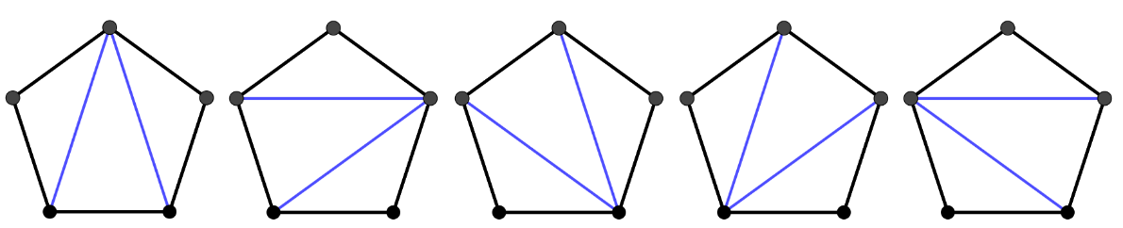

* + - * 1. There are four triangles that can be removed $\left(1,2,3\right)$, $\left(1,2,4\right)$, $\left(1,2,5\right)$ and $\left(1,2,6\right)$

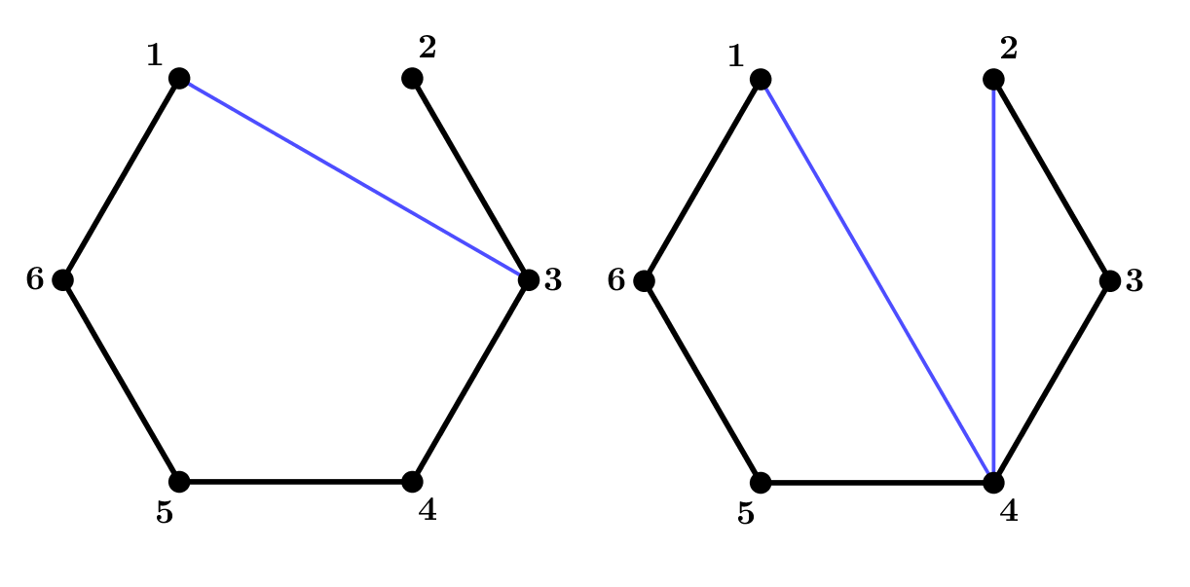

Removing $\left(1,2,3\right)$ leaves a pentagon which has $T_{3}$ possible triangle arrangements and a space which has $T_{0}$ possible arrangements (considering $T_{0}$ to be 1). This is $T_{3}×T_{0}$ arrangements in total.

Removing $\left(1,2,4\right)$ leaves a quadrilateral with $T_{2}$ arrangements and a triangle with $T_{1}$ arrangements. This is $T_{2}×T_{1}$ arrangements in total.

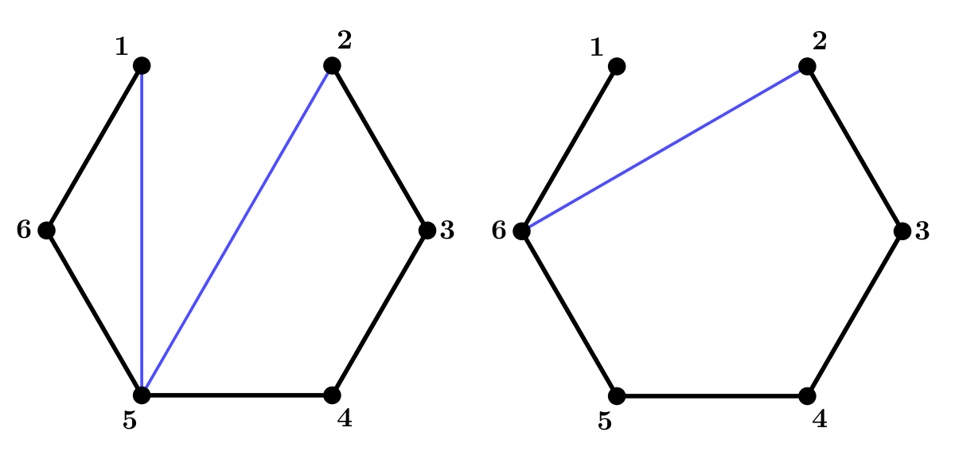

Removing $\left(1,2,5\right)$ leaves a triangle with $T_{1}$ arrangements and a quadrilateral with $T_{2}$ arrangements. This is $T_{1}×T_{2}$ arrangements in total.

Removing $\left(1,2,6\right)$ leaves a space which has $T_{0}$ arrangements and a pentagon which has $T_{3}$ arrangements. This is $T_{0}×T_{3}$ arrangements in total.

Hence $T_{4}=T_{3}×T_{0}+T_{2}×T_{1}+T_{1}×T_{2}+T_{0}×T_{3}=2\left(T_{3}×T_{0}+T_{2}×T_{1}\right)$

1. $T_{2}$ is needed. This is the number of ways of splitting a quadrilateral up into triangles using one diagonal. This is $2$ as there are only two distinct diagonal lines that can be drawn.

$T_{4}=2\left(5×1+2×1\right)=14$

1. For a polygon with $n+2$ sides, and vertices numbered in order $1$ to $n+2$ there are $n$ points for which the removal of side $\left(1,2\right)$ will make a triangle. Removing the triangle that joins $\left(1,2\right)$ to point 3 leaves a space and an $n+1$ sided polygon. This will give $T_{0}×T_{n-1}$ arrangements. Removing the triangle that joins $\left(1,2\right)$ to point 4 will leave a triangle and an $n$ sided polygon. This will give $T_{1}×T_{n-2}$ arrangements. This pattern will repeat giving $T_{r-1}×T_{n-r}$ until $r=\frac{n}{2}$ for $n$ even or $r=\frac{n+1}{2}$ for $n$ odd (i.e. the “half-way mark”) after which arrangements will reduce in the same pattern i.e. $T_{n-r}×T_{r-1}, …T_{n-3}×T_{2}$, $T_{n-2}×T_{1}, T_{n-1}×T_{0}$.

This gives the number of arrangements for $T_{n}$ as

$T_{0}×T_{n-1}+T_{1}×T_{n-2}+T_{2}×T_{n-3}+…+T_{n-3}×T_{2}+T_{n-2}×T_{1}+T_{n-1}×T_{0}$

Hence

$$T_{n}=\sum_{r=1}^{n}{T_{r-1}T_{n-r}}$$

1. For an octagon, $n+2=8$ so $n=6$

$T_{6}=T_{0}×T_{5}+T_{1}×T_{4}+T_{2}×T_{3}+T_{3}×T_{2}+T_{2}×T_{1}+T_{1}×T_{0}$

$T_{5}=T_{0}×T_{4}+T_{1}×T_{3}+T_{2}×T_{2}+T_{3}×T_{1}+T_{4}×T_{0}$

$T_{4}=14$ from part (iv)

$T_{3}=5$, $T_{2}=2$, $T_{1}=1$, $T_{0}=1$

$$T_{5}=1×14+1×5+2×2+5×1+14×1=42$$

$$T_{6}=1×42+1×14+2×5+5×2+14×1+42×1=132$$