Answers

1 Business context part 1: sections 1.1–1.6

Recall activities

Term |  | Description
Private sector |  | This consists of non-profit-making organisations.
Voluntary sector |  | This part of the economy is organised and controlled by the government.
Public sector |  | Organisations within the economy that are owned by individuals or groups of individuals.
Charity |  | An organisation that benefits the public but does not make any profits.
Non-Governmental organisations (NGOs) |  | An organisation that maximises profits to provide social value.
Charity commission |  | A government body that regulates and registers charities in England and Wales.
Social enterprise |  | Organisations that are separate from the government and which are not commercial or profit-making.

Private sector | Public sector | Voluntary sector
Center Parcs UK | Environmental Agency | Royal British Legion
Co-op | Office for National Statistics
Arsenal FC | The National Lottery
Marks and Spencer PLC | NHS
Thames Water

Term |  | Description
Private sector |  | To address an issue/need and to provide goods/services that may have been neglected by other sectors.
Public sector |  | To generate a profit, to grow and to survive.
Voluntary sector |  | To provide for the benefit of the community, overcome a market failure and achieve environmental goals.

- Product Promotion Physical evidence
Price People
Place Process

Term |  | Description
Specific |  | If the specific outcome is capable of being met.
Measurable |  | If the target can be achieved within a specific frame.
Achievable |  | When key statements are made relevant to an individual’s performance.
Relevant |  | When appropriate targets are set by the employer.
Timebound |  | When the key aspects of performance must be quantified.
- There are several different roles within a business that have different functions and various responsibilities. A management board will consist of an executive and non-executive director. The executive team will set the strategic direction for the business, as well as set the priorities. The senior leadership team will be responsible for the operational and strategic planning, as well as the performance management of the business. It will delegate responsibility to specific teams with managers within the business and then oversee the business operations.

Short-answer exam-style practice questions
- D
- D
- B
- A
- C
- D
- B
- A
- Corporate social responsibility
- Senior management
- Economic decisions are made partly by the government and the rest through the market.
- Communication can become distorted through the different layers of the structure.
- This is when individuals are placed in an equal position. They are treated equally and given equal rights.
- Multinational corporations
- Companies House is responsible for keeping the official records of businesses that are registered on a central register of companies within England, Wales, Scotland and Northern Ireland.
- A vision statement outlines the future plans for the business [1], which incorporates the mission statement [1].
- The ability to communicate with others to set up, maintain [1] and use contacts for the benefit of the business [1].
- The circular economy includes consumption and production [1] that guarantee sustainable growth over a given time period [1].
- When the owners of a business are personally liable [1] for all of the business's debts [1] if the business unfortunately has insufficient money to repay the debts [1].
- One mark each for:
- generate a profit
- to grow
- survive.
- One mark each for:
- economic responsibilities
- legal responsibilities
- ethical responsibilities
- philanthropic responsibilities.
- One mark for naming a document and one mark for the explanation:
- The Memorandum of Association [1], which will detail the overall purpose of the business and the members involved [1].
- The Articles of Association [1], which details the internal rules of the business [1].

Long-answer exam-style practice questions
- Mark scheme:
Answer | Marks | Guidance
Answers need to relate to the question and highlight:  - matrix structure  - new project  - team working.  Demonstrate knowledge of the features of a matrix structure:  - Teams are brought in for specific projects.  - A mixture of skills and knowledge is required from each team member.  - The matrix structure lasts for the length of the project.  - Managed by dual reporting to the functional head and head of project.  Advantages of matrix structure could include:  - Teams are able to be formed and disbanded when required.  - Helps with communication and sharing of detailed knowledge related to the project.  - Flexible and can support a business's growth.  - It is a team approach that can integrate both functional product areas.  All must be related to the tendering process and justified.  Responses should be related to the context of the question. | 12 | Level 4: 10–12 marks  - A detailed explanation.  - Understanding of a matrix structure and how it can be beneficial to a business that has recently won a tender is appropriate for the context.  - Relevant discussion on features of a matrix structure.  - Detailed advantages of a matrix structure related to the context.  - Coherent and a well-structured answer.  Level 3: 7–9 marks  - A good explanation that shows an understanding of matrix structures.  - Suitable advantages and features are described, demonstrating knowledge of matrix structures that are relevant to the context.  - Makes relevant points that are developed for an evaluation.  Level 2: 4–6 marks  - Adequate explanations given related to matrix structures.  - A sound understanding of the features and advantages of this structure.  - Made some relevant points, some of which are developed.  Level 1: 1–3 marks  - A basic discussion.  - Some features and advantages of matrix structures are discussed but maybe one or more were not relevant. All need developing.  - Lacks detail in general.
- See sample answer in workbook.
- Mark scheme:
Answer | Marks | Guidance
Answers need to relate to the impact of negative publicity which could include:  - loss of sales  - loss of revenue  - costs from repairing the damage of reputation.  Explanation of each of the impacts such as:  - Loss of sales and revenue as customers turn away from buying their products or services.  - Greater turnover of staff as people leave the organisation, feeling that ethical issues such as equality, diversity, health and safety or pollution are not being dealt with by management.  - Costs increase as the business has to manage a damaged reputation, which could include legal battles or paying out for fines.  - Directors could be removed by legal action or dissatisfaction from the shareholders.  Responses should be related to the context of Zebra Products and the ethical element of the business. | 6 | Level 3: 5–6 marks  - Detailed explanation.  - Clear understanding of business ethics.  - Understanding of the impacts related to the business Zebra Products.  - Coherent and well-structured.  Level 2: 3–4 marks  - An adequate explanation showing sound knowledge related to the context.  - Reference to business ethics.  - Make relevant points, some of which are developed.  Level 1: 1–2 marks  - A basic explanation.  - Brief understanding of business ethics.  - Some appropriate points made that need developing.  - Lacks detail.
- Sample answer: Key performance indicators are targets that are set by a business and can be used to measure success [1]. Strategies are the goals [1] and actions [1] that a business sets in order to achieve its goals [1]. A business will set itself its aims or visions that it wants to achieve [1], which will then be converted into a strategy [1] in the form of objectives. This will explain the steps [1] that the business needs to take in order to achieve its aims. The KPIs will provide the evidence that the business needs to assess the progress it is making with the objectives [1]. KPIs can be set for individuals [1], which will complement the business's strategies. The heads of the departments in the newly expanded business will be responsible for agreeing these KPIs with their teams. It will be important to review the KPIs, as they can provide a warning [1] to the team or individuals if problems start to occur. This could mean that the progress of the work could be limited [1]. In this case, the business would be advised to review the methods that are being used and, if necessary, change these [1].
- Sample answer: Risk management is a key part of audits [1]. Audits enable a business to focus on how they manage their operations [1], ensuring that they are efficient and comply with the required standards and legislation [1]. In large businesses, an audit committee (governance) will be established to monitor the financial statements of the organisation and make judgements [1] on the business’s performance. In order to manage risk, a key responsibility of management will be to determine how much risk they are willing to take to avoid damaging the overall performance of the business [1]. Internally, these can be controlled but external influences, such as the pandemic, cannot be predicted. An internal audit will provide an evaluation of the business [1] and assurances to bodies outside of the organisation in the form of external auditors. The main role of an external auditor is to detect fraud in the financial reporting of a business [1]. This is to protect the investments of shareholders and potential investors into the business. Auditors will scrutinise the business's accounts, ask many questions and report their findings [1]. Using both internal and external audits will enable a business to monitor its ongoing progress and any findings can be reported back to directors, management and shareholders [1] (depending on the type of business).

2 Business context part 2: sections 1.7–1.11

Recall activities

- 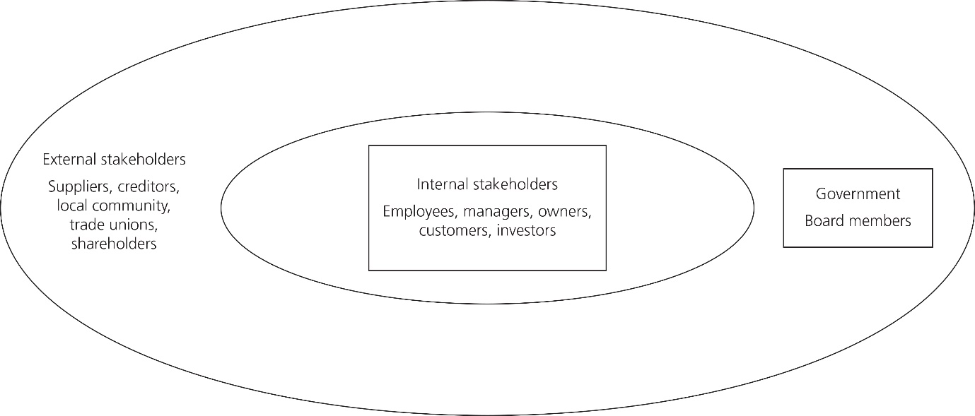
- 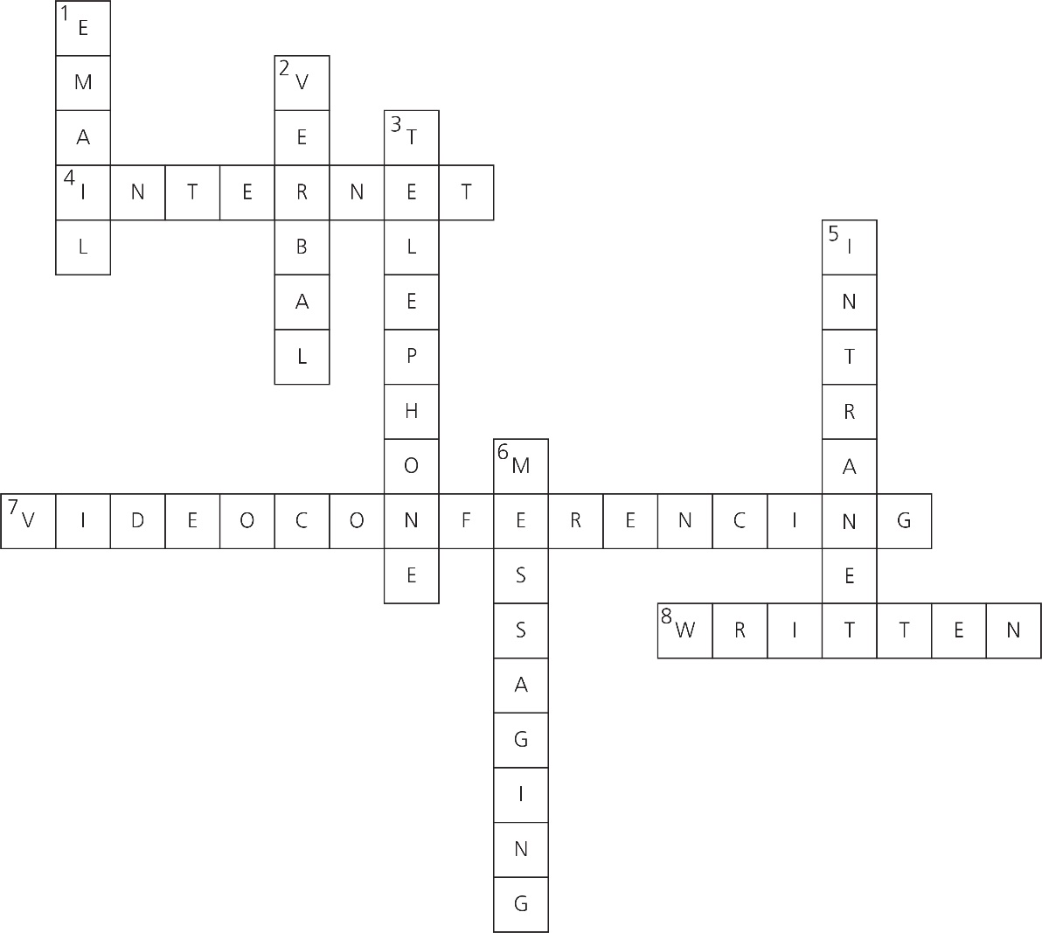

Framework | Regulatory body
Health and Safety at Work etc. Act 1974 | Information Commissioner's Office
Anti-competitive regulations | Health and Safety Executive
Consumer protection legislation | Crown Prosecution Service
General Data Protection Regulation (GDPR) | Equality Advisory Support Service
Equality Act 2010 | Equality and Human Rights Commission

Short-answer exam-style practice questions
- One of the following: training, cost or process changes.
- General Data Protection Regulation.
- One of the following: respect, attitudes, perceptions.
- One of the following: appointed board, cooperative or membership.
- One of the following: managers, employees, owners, customers, investors.
- One of the following: email signatures, types of communication, branding, tone of messages, format of communications.
- One of the following: face-to-face meetings or video conferencing interactions.
- Virtual reality is a digital environment that appears to make objects and scenery real to the user.
- When a business operates differently through new business designs using technology.
- One of the following: risk registers, audits, policies, procedures or processes.
- Two of the following: subscribing to blogs, attending webinars, attending events or seminars on the emerging technologies.
- A mission statement describes the purpose of the business [1] and details the vision for the future [1].
- Two of the following: who will have access, an increase in cyber threats, users having awareness of issues.
- The business could change its internal branding to integrate its culture and values within this [1] or reinforce and update its expected employee conduct and behaviour that would then be presented to all employees [1].
- When a person works for an organisation [1] that then decides to tell others outside of the organisation, such as the media, about the negative culture and behaviours that are displayed in the business [1].
- Direct discrimination is when a person is treated less favourably compared to others [1]. Indirect discrimination occurs when a policy or practice is applied to everyone in the business, but it has a worse effect on individuals who have protected characteristic, such as length of service [1].
- Big data is related to the large and diverse sets of information [1] that continue to grow for businesses and that the business needs to understand and review [1].
- The manners and etiquette that are expected to be used when using the internet for business purposes.
- Formal communications will be established within the business and follow particular processes and procedures [1]. Formal documents will be completed before, during and after the meeting, which will then be circulated. For example, management meetings that take place monthly to discuss the progress of the business [1].
Informal communications will often not be scheduled and occur on an ad hoc or last-minute basis when people are available [1]. No formal documentation will be completed. For example, an urgent change to a project needs to be communicated to the team, so a last minute meeting is planned for the afternoon with individuals taking their own notes/actions [1].
- Maximum of four marks: Communities and environmental campaigners are examples of external stakeholders [1]. Communities can influence a business as they will want to ensure that their local community is not disrupted by a business in terms of noise and pollution [1]. If a bakery business was to be set up, the local community would not be happy if deliveries were to happen in the early morning, as this could cause noise pollution as well as added traffic, creating pollution [1]. These may be similar concerns for environmental campaigners. If it was a problem, the local community and environmental campaigners could speak to the business about their concerns and potentially change how they operate [1]. However, a new business will give the local community employment opportunities [1]. They will want to ensure that the business is paying at least the minimum wage and, in the example of a bakery business, the local community will be able to purchase their products, which will be positive for the local economy [1].
- See sample answer in workbook.
- See sample answer in workbook.
- The National Cyber Security Centre aims to protect businesses, organisations and individuals from the risks of cyber-attacks [1] and provides assistance in response to these attacks [1]. It categorises attacks as untargeted (phishing, water holing, ransomware, scanning) or targeted (spear-phishing, deploying a botnet or subverting the supply chain) [1]. Systems can be vulnerable to attacks because of poor design or user errors, such as weak passwords [1]. The Security Centre is therefore vital in our digital world.
- When writing a professional email, it is important to know if it is to be addressed to one person or several [1]. You should avoid using jargon that the user may not understand and use a spell checker [1]. Always reread emails before you send them to ensure they make sense [1], answer any questions that may have been asked and that the email is clear [1]. This way your email will remain professional.
- Digitisation related to the information [1]; digitalisation involves the process for the business [1]; and digital transformation when the business adapts to the changes [1].
- AI means artificial intelligence [1]. For a business, this means that machines are used to interpret and carry out tasks on the data [1]. A supermarket could use robots to pick and pack customer orders for home delivery, especially if the robots are quicker to complete this than humans [1], as this would be more time efficient for the business [1].
- External branding is how a business is able to create an external image of itself [1], for example through communication methods, uniform, language [1], etc. Internal branding, however, is concerned with the behaviours of its employees related to the brand [1] and the business culture that it has created [1].

Long-answer exam-style practice questions
- Mark scheme:
Answer | Marks | Guidance
Answers need to relate to the question and highlight culture and values.  Definition of Culture: organisational culture is the expectations and practices that guide and inform the actions of the individuals who work for a business.  Demonstrate knowledge of the features of culture:  - organisational structure  - control systems  - symbols  - stories  - power structure  - rituals and routines  (referred to The Cultural Web).  Definition of values: the main core beliefs of a business that are demonstrated within the purpose it has, the direction that it follows and the tone for it held by an organisation.  Reference to suitable internal stakeholders related to culture and values include:  - managers  - employees (workforce)  Reference to suitable external stakeholders related to culture and values include:  - customers  - suppliers  - shareholders  - creditors  Impacts of culture and values:  - Culture and values of organisations are often integral to the business’s success.  - Organisations with a strong culture of shared beliefs and values will often see the workforce showing greater commitment and loyalty to the organisation, as there is a common sense of purpose.  - Organisations with a weak culture have staff who are likely to be divided and have little sense of belonging.  - Organisations could have a high staff turnover and limited commitment and loyalty if the culture and values are negative.  All must be related to the values and cultures and justified.  Responses should be related to the context of the question. | 12 | Level 4: 10–12 marks  - A detailed explanation.  - Demonstrates an understanding of the importance of culture and values, referring to The Cultural Web, and how it can be beneficial to an organisation and be reinforced to particular stakeholders.  - Relevant discussion on impacts of culture and values on suitable internal and external stakeholders that have been identified.  - Coherent and a well-structured answer.  Level 3: 7–9 marks  - A good explanation that shows an understanding of cultures and values in an organisation. There is some reference to The Cultural Web.  - Suitable benefits made referring to the reinforcement of stakeholders that are relevant to the context.  - Made relevant points that all are developed for an evaluation.  Level 2: 4–6 marks  - Adequate explanations given related to understanding of cultures and values in an organisation. There is limited reference to The Cultural Web.  - A sound understanding of culture and values related to stakeholder(s).  - Made some relevant points, some of which are developed.  Level 1: 1–3 marks  - A basic discussion.  - Some features of culture and values have been explained but maybe one or more were not relevant. All need developing.  - Limited reference to stakeholders and lacks detail in general related to the context.
- See sample answer in workbook.
- Sample answer: Frameworks are the main legislation that businesses need to abide by [1]. The frameworks cover all areas of legislation from health and safety at work through to the Equality Act and GDPR [1]. The legislation is there to protect the employers, employees, consumers and other companies involved [1] in the business. All UK legislation must be implemented [1] into the business model and adhered to at all times [1]. Businesses will need to produce processes and policies that staff will need to abide by to ensure that the business is adhering to the various frameworks [1]. Businesses will also need to have risk registers, risk management and audits in place to ensure that they comply with the frameworks [1]. If they do not comply then there could be financial, legal and reputational risks, which could affect the future workings of the business. Penalties could be imposed on businesses [1], which could damage the reputation of the organisation, resulting in a loss of customers through bad publicity [1]. Therefore, it is very important that frameworks are taken seriously and implemented into the business once it starts.
- Mark scheme:
Answer | Marks | Guidance
Answers need to relate to the context provided.  Suitable methods of digital communications need to be selected which could include:  - email  - instant messaging  - video conferencing.  They must all be digital forms to gain the marks.  Discussion on each method must be included such as:  - Email is cheap, efficient, fast, sent to multiple users, sent as high priority but some emails can be lost due to amounts sent/received each day.  - Instant messaging is instant, several people can be informed of updates at the same time, they can be read at the convenience of the user, not too formal. Messages can get lost if they are not read frequently.  - Video conferencing can be accessed remotely. Documents can be shared online with the meeting being recorded, which can be shared with people who could not attend. If cameras are not used, then participation could be limited.  A relevant recommendation must be made in the answer with clear justification.  Responses need to be related to the business. | 12 | Level 4: 10–12 marks  - A detailed explanation.  - Demonstrates an understanding of different forms of digital communications that are appropriate for the context.  - Relevant discussion on the methods.  - Recommendations that are justified.  - They must all be digital forms to gain the marks.  - Coherent and well-structured answer.  Level 3: 7–9 marks  - A good explanation that shows an understanding of digital communications.  - Suitable digital communications are discussed that are relevant to the context.  - Made relevant points that are all developed with a recommendation given.  Level 2: 4–6 marks  - Adequate explanations given related to digital communications.  - A sound understanding of the methods.  - Made some relevant points, some of which are developed.  Level 1: 1–3 marks  - A basic discussion.  - Some digital methods discussed but maybe one or more were not digital. All need developing.  - Lacks detail in general.

3 People

Recall activities

Maslow’s needs
Physiological
Security
Belongingness
Esteem
Self-actualisation
Examples of what the employer could provide
Job security.
A friendly and encouraging team so staff feel they belong.
Salary, food/drinks and sometimes accommodation.
Challenges and new opportunities for employees.
Acknowledgement of successes and opportunities to succeed.

Mentoring | Coaching
Mentoring is a long-term process where good working relationships can be formed. | Helps employees to be able to solve issues/problems in different ways.
Being able to see an individual grow from the mentoring process can enable career aspirations to be fulfilled. | Improves productivity for the business as the individual being coached can implement the new knowledge into their work.
Staff who receive this form of training often learn more quickly meaning that they can be working at the required pace faster. | Increases the confidence of the individual who is being coached to complete the job role.
Becoming a mentor is a form of training for the individual as they will have to really look at the tasks that they complete, to be able to explain these to the mentored so that they can learn. Being a mentor can be added to the individual's CPD record. | As with becoming a mentor, being a coach is a specific role within a business which can be added to the individual's CPD record.

- 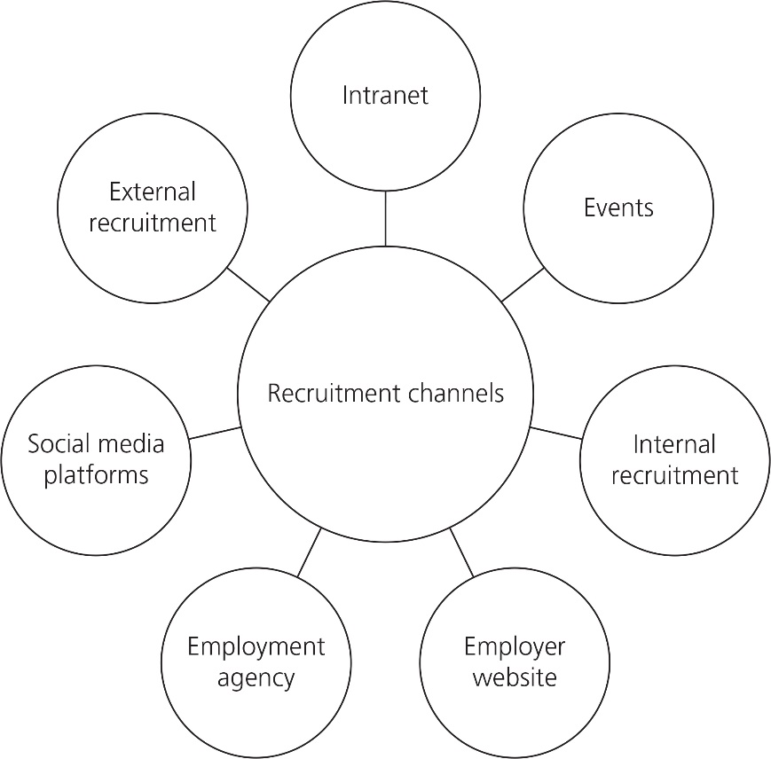

Term |  | Description
Value |  | All individuals are equal in opportunities, rights or status.
Equality |  | When individuals are from a range of social and ethnic backgrounds, genders, beliefs and sexual orientations.
Benefit |  | The advantages to a business.
Diversity |  | How important a particular element of a business is to the company.

- Hierarchical structure
- Flat structure
- Matrix structure

Short-answer exam-style practice questions
- Belbin’s team roles.
- It would be important for the business to make sure that the employee is OK and suggest that they go home [1]. The business will then implement the disciplinary procedure which, depending on the severity of the incident, could result in dismissal [1].
- One of following: job description, person specification, job advertisement.
- A business could provide exercise classes, mindfulness workshops or a healthier working environment for its employees.
- Management styles are the different approaches that an individual will have for managing people [1] compared to leadership styles, which involve the different ways that a person will manage people [1].
- Two of the following: action plans, project plans or progress reports.
- Two of the following: full time, part time, fixed term or temporary contracts.
- Two of the following: A business could have set questions that would be asked to all candidates [1], have an application form that all candidates have to complete [1] or suggest they send a CV with a covering letter related to their experiences [1]. This will make the process fair, transparent and consistent [1].
- Any two of the following should be identified and written about:
- A contract of employment must be issued within two months of starting a new job and signed by both the employer and the employee.
- Employees are entitled to daily and weekly rest breaks, for example a 20-minute break for people who work over six hours.
- Parental leave includes a provision for antenatal care, up to 52 weeks of maternity leave and a minimum of one week for paternity leave.
- Long service ensures employees who have worked for the same employer for an extended period of time are entitled to more benefits at work, which could include flexible working, parental leave, etc.
- Redundancy payments relate to employees whose job is no longer needed within the organisation, provided they have worked for two years or more for the business.
- No individual is allowed to work more than 48 hours in a week [1]. There are exceptions if your role is within the armed forces, emergency services or police, if you work within security and surveillance, if a job role involves 24-hour staffing, if you are a domestic servant in a private household, if your job role is as a seafarer, sea-fisherman or worker on vessels on inland waterways (different legislation applies), if your working time is not specifically measured as you are a managing executive of your own business so are in control of your personal decisions [1].
- One mark for a reason, one mark for the explanation:
Disciplinary action may be taken if an employer has cause to be concerned about the work that an individual is doing [1], their conduct when in work [1] or absence rates [1]. If any of these occur, the employer may want to raise these matters in an informal or formal way. If the situation does not improve, then they may decide to impose the official disciplinary action process [1].
- Two of the following: notice board, newsletter, website, intranet, direct communication.
- Conflict means a work disagreement or argument [1] that can affect or impact how individuals or teams work together [1].
- Four of the following: age, disability, gender reassignment, marriage or civil partnership (in employment only), pregnancy and maternity, race, religion or belief and sex.
- Like the name suggests, the style of management involves participation from others [1], so the manager may encourage ideas from the team so that they work together to make important decisions [1]. A participative management style will want group work to gain ideas [1], make decisions from the ideas and then implement the decision [1].
- See sample answer in workbook.
- The onboarding process is when new employees are trained in the required knowledge and skills to complete their roles [1]. They are then able to be part of the business’s culture and ensure that they work hard for the business and are hopefully successful in their role [1]. This is crucial to make sure that the employees are effective and fulfilled within their role [1] so they want to stay and progress their careers [1].
- One mark for the personality group and one for the explanation:
- Action orientated [1]: individuals who like to get on with tasks and see projects completed in full [1].
- People orientated [1]: individuals in this category understand the impact of their direct actions on others and generally have good communication skills [1].
- Cerebral [1]: individuals who do not get affected by emotions that may be displayed and will totally understand the requirements of the task that need to be completed [1].
- One of the following approaches needs to be explained:
- Ethnocentric [1]: this is when a business recruits individuals from a parent company [1]. This can do this by relocating an existing employee from the parent country or hiring a new person from the parent country [1]. This method is often used when opening a new branch of the business in a new country [1].
- Polycentric [1]: this is simply recruiting new employees in the country where the new business is based [1]. This can be done by advertising [1] locally or nationally, or with a recruitment agency [1], to gain the right staff to complete the roles [1].
- Regiocentric [1]: this is when a business employs or transfers individuals from within the same region. This could be a group of countries [1] and it could be within a certain area, such as Scandinavian countries. It could enable the business to transfer a member of the team from Denmark to Sweden, as this is within the region, although they are different countries [1]. It could be a promotion for an individual who is looking for a new challenge in a new country [1].
- Geocentric [1]: this is when a business wants to recruit the best individuals who have the skills and knowledge no matter where they are from or live [1]. This means the business needs to have a global outlook in the recruitment process [1] and therefore may need different forms of advertising to attract the right potential candidates for an interview [1].

Long-answer exam-style practice questions
- See sample answer in workbook.
- Mark scheme:
Answer | Marks | Guidance
Answers need to relate to team working and the benefits of it.  Suitable benefits could include:  - Boosting team morale: working with others, give confidence to make decisions, learn from others, improve social and esteem needs, as well as motivation.  - Development needs: working in a team can lead to further opportunities, new knowledge can be learnt, learn how to troubleshoot and deal with situations.  - Accountability: objectives will be set and agreed with roles being approved so that accountability is clear, being able to take responsibility and manage the accountability.  - Support: understanding strengths/weaknesses of the team, ensure a good working environment which is supportive and motivating, with individuals who want to produce high quality work.  Reponses need to be related to the business. | 12 | Level 4: 10–12 marks  - A detailed explanation.  - Understanding of what team building is and the benefits of it on an organisation.  - Relevant discussion on each of the methods selected and how this can help the business.  - Coherent and a well-structured answer.  Level 3: 7–9 marks  - Good and relevant explanations that show an understanding of team working.  - Related to the benefits of team working.  - Made relevant points which all are developed.  Level 2: 4–6 marks  - Adequate explanations given related to team working.  - A sound understanding of the benefits of team working.  - Made some relevant points, some of which are developed.  Level 1: 1–3 marks  - A basic discussion.  - Very few relevant benefits of team working are described but need developing.  - Lacks detail in general.
- Sample answer: It is important for an induction programme to include all of the required information that a manager [1] will need to know in order to manage a sandwich shop. An induction programme should include an introduction to the key members of staff [1], such as the deputy managers and team. This will help the individual get to know everyone and their job role [1]. They will also need to know who their manager is and how they can be contacted if required. This will then establish the chain of command [1] and the span of control [1] within the business. The induction programme should also include how the business is organised, the functional areas and a basic history of the company [1]. The business policies, for example, health and safety, will need to be shared and the manager will need to know where to access all the policies and procedures [1]. Key expectations of employees and the employer will need to be shared [1]. Key areas of the business should be shown to the new managers. If it is appropriate the allocation of a mentor [1] should be provided and both parties given the opportunity to meet up. If all these elements are provided, then the induction programme should be a success and the new managers should settle into their new roles quickly.

4 Quality and compliance

Recall activities

- International Organization for Standardization
- European Foundation for Quality Management
- British Standards Institution
- Plan, Do, Study, Act
- General Medical Council

Short-answer exam-style practice questions
- A process or system that is followed by a business to ensure that the quality of services or products is being maintained and meets the quality standards, so customers are satisfied.
- Quality standards can be set by different sectors, or national or international organisations.
- Maximum of two of the following reasons: Quality audits are completed at an organisation's premises where the quality system can be accessed by the experts [1]. The system will be inspected or examined to make sure that it meets the requirements that are set [1]. An audit can also take into account the safety or risk documentation that the business uses [1].
- Customer satisfaction measures how much a business’s products/service meet the expectations of the customers [1]. If customer satisfaction is high, then the customer is more likely to return to the business or recommend them, which could generate more sales [1].
- Total Quality Management
- A business that improves and maintains quality standards should receive fewer customer complaints about the products and services that they provide [1]. With fewer complaints and more customer satisfaction, the business should receive repeat customers, which will be good for the business [1].
- A business that improves its processes and procedures regarding the quality standards will often have a reduction in customer complaints about quality of products/services [1]. This means the business will not have to spend money recalling products that do not meet its standards and replacing returned products. This means that its overall costs will be reduced in terms of the time that it takes to sort out issues that occur [1].
- Accountability is when an individual takes responsibility for the work activities that they complete [1] with regard to maintaining and improving the quality in their functional area [1].
- Any complaints that come into a business will be analysed from the information provided within the complaints handling process [1]. The business will be able to identify the issues and then take the necessary steps to prevent the issues reoccurring in the future [1]. The complaints handling process is another way of improving the quality within a business [1].
- A trade association is a voluntary organisation that is specific to a particular sector [1]. They will campaign and present the views of the members as a whole [1].
- Quality improvement is when a specific process or system is changed for the better to enhance the quality of products and/or services which will improve customer satisfaction [1]. It will involve every member of the team adopting this new process or system to ensure that the quality of the work meets the new process or systems that have been integrated into the business [1].
- The time limitation within which an activity is expected to be completed by a business.
- See sample answer in workbook.
- Investors in People is a form of a people-based accreditation that businesses can demonstrate within their work [1]. It is a well-known standard that improves the overall performance of an organisation through the management and development of its workforce [1]. A business needs to demonstrate three areas to be successful – leading, supporting and improving. They will do this through a range of different methods within their business [1]. This will form the evidence for the application process and, if successful, they will be able to state that they are an Investors in People business which could attract individuals to the business [1].
- The purpose of this model was originally to improve the quality [1] through the competitiveness of the European economy [1]. The model provides support to businesses that want to improve performance or manage change within their organisations [1]. There are three different focuses which are direction, execution and results [1].
- One method must be described:
- First-party [1] is when a business completes an audit on its own methods of working [1], the processes it has in place using externally produced quality standards that it uses [1], to identify its strengths and weaknesses [1].
- Second-party [1] is completed on an organisation by or on behalf of a customer [1] to ensure that it meets the required standards [1]. These will be set by the customer [1].
- Third-party audit [1] is completed by an independent auditor who has nothing to do with the business [1]. They will have no interest in the potential outcomes of the audit [1]. Regulators can use this type of audit to ensure compliance with laws and regulations and industry bodies’ standards [1]. If issues are identified, potential fines or criminal proceedings could be instigated [1].
- A monopoly is an organisation that has control over a specific sector [1]. This means that there is no other business like it, so it dominates the market as there are no alternatives [1].
- A business has had many complaints about a newly launched shower gel as, after a short time period, the shower gel gains an unpleasant scent [1]. The business which produces the product will analyse the different complaints that it has [1] and review the quality of the different elements used in the shower gel [1]. These will be reviewed and adjusted to improve the product, which will contribute to the process improvements and hopefully a better product that does not have an unpleasant scent [1].
- A business may receive complaints, so it is important that individuals follow the same process to resolve the situation. A complaints handling procedure will specify what information needs to be requested from the customer [1], how the complaint will be resolved [1], the timeframes, and the official documentation that the business is required to complete that will be filled in by the person dealing with the complaint [1]. If there is no procedure in place, vital information could be missed, meaning that the complaint might not be resolved [1] and the issues may continue to be a problem for the business [1].

Long-answer exam-style practice questions
- See sample answer in workbook.
- Sample answer: Obtaining a quality accreditation can bring several benefits to an organisation. This will mean that they potentially could have more opportunities [1] within their sector because of gaining a new quality accreditation [1]. Benefits to the organisation will be that the rigorous process [1] of accreditation means that the quality of their products and services will be increased [1], which means that their standards will be higher than those who have not achieved the accreditation [1]. For an organisation that has gained a quality accreditation, it could have a competitive advantage [1] over other businesses that do not. This is because many customers and clients prefer accredited businesses [1], as they demonstrate the standard of quality, giving the accredited organisation a broader customer base and potentially increased market share [1]. A business which gains an accreditation will often have to continuously improve and self-assess its methods [1]. This culture of continuous improvement ensures that the organisation stays relevant with best practices, evolving technologies and changing market demands [1]. If this organisation does apply for a quality accreditation, it will have many benefits, as it will enhance its credibility [1], improving the quality of services and providing a competitive advantage. I would therefore encourage this organisation to look at the process of applying and what provisions will need to be made in order to successfully meet the quality accreditation standards [1].
- Sample answer: Non-compliance with regulatory authorities can have significant implications on businesses, which may vary depending on the nature of the violation, the industry and the specific regulations involved. The main implications for a UK business could be financial [1]. Regulatory authorities can impose fines [1] on businesses that fail to comply with regulations. These fines can be substantial and could have a significant impact on a company's financial health [1]. Prohibition notices could be issued by inspectors if the actions of the business could cause, or risk causing, personal injury [1]. The business in this case would be shut with immediate effect [1] and the risk would have to be resolved. The business would need to prove to an inspector that the risk has been eliminated before it could start to trade again [1]. Finally, in extreme cases, closure notices can be issued with a business having to shut immediately, giving authorities time to investigate the business further and decide if the issues can be resolved or if the business will be forced to close [1]. To mitigate these risks, businesses should invest in robust compliance systems [1], stay informed about relevant regulations [1], conduct regular internal audits [1] and maintain open communication with regulatory authorities [1]. Compliance should be viewed not just as a legal obligation but as a fundamental aspect of responsible and sustainable business practices [1].
- Mark scheme:
Answer | Marks | Guidance
Answers need to relate to:  - the quality standards of products/service that are produced each day for customers.  Discussion on the improvements which could include:  - Customer satisfaction could result in repeat business.  - Efficiency due to streamlining to include operational efficiency.  - Innovation due to quality standards.  - The positive influence and impact of quality on the long-term success of the business.  Reponses need to be related to the business. | 12 | Level 4: 10–12 marks  - A detailed explanation.  - Understanding of the impact of quality standards.  - Relevant discussion on the improvements to be made to a business.  - Coherent and well-structured answer.  Level 3: 7–9 marks  - A good explanation which shows an understanding of quality standards.  - Related to improvements for the business.  - Made relevant points which are all developed.  Level 2: 4–6 marks  - Adequate explanations given related to quality standards.  - A sound understanding of improvements to the business.  - Made some relevant points, some of which are developed.  Level 1: 1–3 marks  - A basic discussion.  - Very few quality standards and improvements are identified but need developing.  - Lacks detail in general.

5 Finance

Recall activities

Term |  | Description
Sales turnover |  | The level of output at which total costs equal total revenue. This is the point at which a business makes no profit or no loss.
Accounting period |  | The total amount of money received for all goods and/or services that a business has sold in a given time period, e.g. a year.
Break-even point |  | Tax that is set by government on the net profit of a limited company.
Corporation tax |  | Details the revenue (the money) that comes into a business from the sales of products or services, as well as expenses that the business has used.
Retained profit |  | The time period (annual, quarterly or monthly) covered by a report or set of accounts produced by a business.
Income statement |  | This is a financial statement that details the organisation’s financial position, including what the organisation owns and what it owes other organisations and individuals.
Balance sheet |  | Tax that a government puts on its working population on the salary/wages that employees earn.
Income tax |  | An amount of the net profit that a business has left to keep in its accounts after all other costs and payments have been paid.
- Financial reporting is important to the business. This is because its customers, suppliers and the government need to know the financial elements of the business. A business will need to track, analyse and report on its financial activities. It also needs to comply with the law in the UK and other countries regarding the requirement of financial reporting. If it does not obey, a business may face financial penalties and, in extreme cases, imprisonment for non-compliance with the law. Accurate financial reports will be looked at by investors, employees or customers of the business so that they are aware of the performance of the business. By reporting the health of the business, this helps to create a comparison with other market leaders, giving a snapshot of its metrics. This means that the business can measure itself by tracking its progress to judge its performance against the metrics. Businesses often will use reporting as an opportunity to drive the business forward.
- 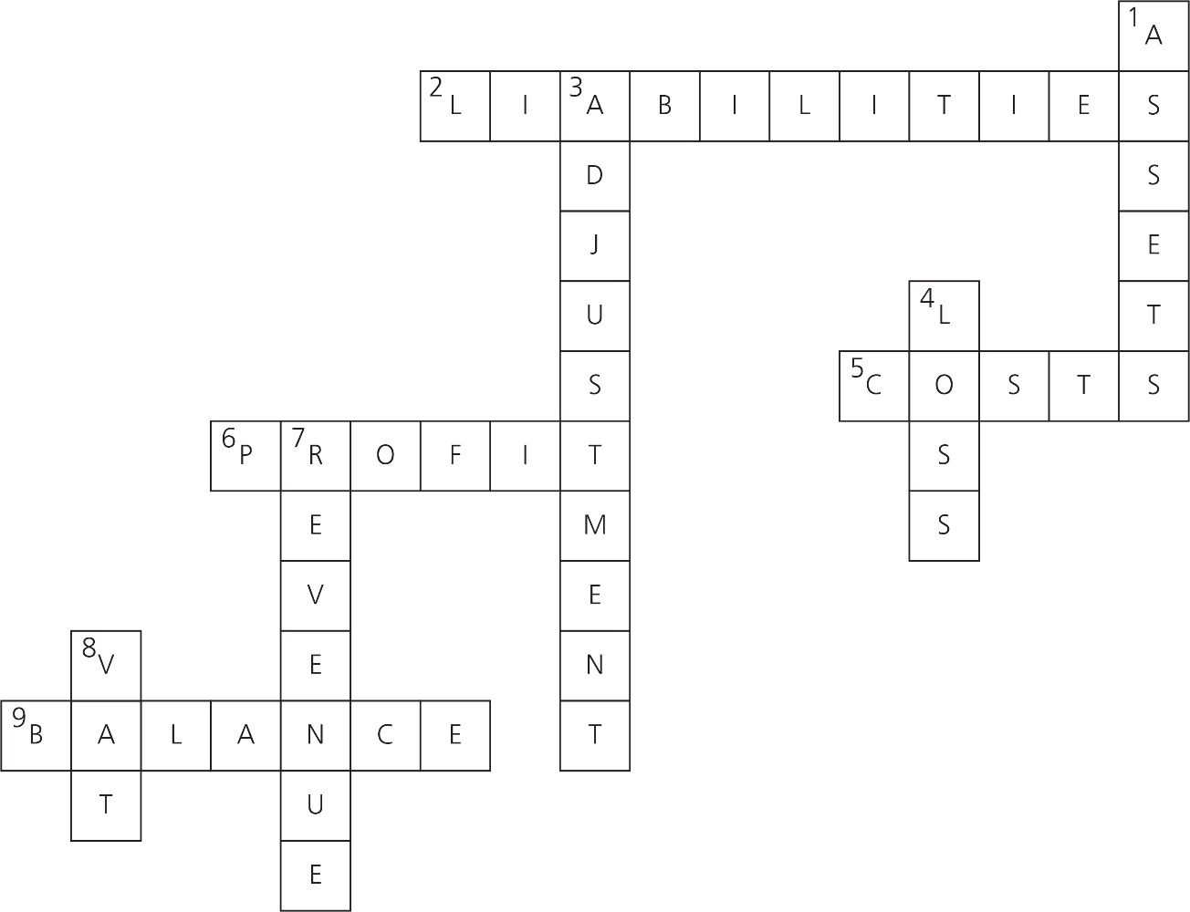
- Sales revenue – cost of sales = gross profit
- Net profit is a calculation of how the business is doing. It considers the costs that the business incurs. It is calculated as the following:
Sales revenue – (cost of goods sold + expenses) = net profit.

Short-answer exam-style practice questions
- A fixed cost does not change with the amount of products/service produced.
- Break-even point (in units) = Fixed costs
Selling price per unit – variable cost per unit
- Two of the following: owner’s capital, savings, retained profit, selling assets.
- Two of the following: electricity, gas, water and internet.
- One of the following: machinery, transportation such as vehicles and vans, ICT equipment, etc.
- A variable cost is one that changes according to the usage of the business [1]. For example, the consumption of electricity will change throughout the year so the charges made to the business will reflect the amount of electricity that the business has used [1].
- Two of the following: bank loans, credit cards, overdrafts, crowdfunding, investor funding, leasing and hire purchase.
- Variance is the payment to buy goods or services [1]. The payment is recorded at the time the purchase is made and can be made as a cash or credit purchase [1].
- Two of the following: statutory sick pay, state pensions and unemployment benefits.
- If a business uses hire purchase as a method of funding, it will be able to use the item it has hired from when it has made the first payment [1]. The item it has hired will be owned by the business once the final payment has been made [1], with the business having the ability to pay it off in smaller instalments [1].
- It relies on the internet, using online platforms as a form of communication so that it reaches the maximum sized audience.
- When a business asset reduces in value over time, such as a company van.
- Two of the following: value added tax (VAT), corporation tax, income tax, national insurance, business rates.
- The account holder will have an agreement with a bank [1] to pay out money for a pre-agreed amount that exceed the amount that is actually held in the business’s account [1].
- Four of the following: an overview of the business, directors’ report from each section of the business, balance sheet, income statement (profit and loss), clarification of documents, auditor’s report, strategic report, corporate governance statement detailing the controls and risk management systems relating to finance.
- An audit is an examination of a business’s financial records [1] and confirmation of their accuracy, which can be completed both internally and externally [1]. Internal audits are conducted internally (inside the business). The results are only to be used within the organisation, so external sources do not get involved [1]. External audits are carried out by a third-party, such as a chartered accountant. The individuals involved will be independent from the business. This enables the external auditors to provide an unbiased opinion and report any errors that may be discovered in the financial accounts [1]. Government departments, such as HMRC, ensure that the financial accounts of a business (including small businesses and self-employed people) are accurate and they check they are paying the correct amount of tax.
- See sample answer in workbook.

Income Statement for Drinks Cart
£ £
Sales revenue 156,400
Less costs of sales 80,200
Gross profit 76,200

Less expenses
Rent 20,000
Advertising 7,000
Equipment 150
Uniforms 100
General expenses 7000
Computers 300
34550

Net profit 41650

Mark scheme:
Answer | Marks | Guidance
Answers need to relate to the figures that are given in the question.  1 mark is awarded for the correct calculation of the gross profit:  156,000 – 80,200 = 76,200  1 mark is awarded for the correct calculation of the expenses:  Rent 20,000  Advertising 7,000  Equipment 150  Uniforms 100  General expenses 7000  Computers 300  Total = 34,550  1 mark is awarded for the correct calculation of the net profit:  76,200 – 34,550 = 41,650  1 mark is awarded for the correct layout.  Reponses need to be related to figures from the business. | 4 | 4 marks:  - A fully correct answer with the correct layout.  - A well-structured answer.  3 marks:  - A good answer which may be laid out slightly incorrectly but has the correct answers for gross and net profits.  2 marks:  - Some errors within the answer that could be the structure or errors within the expenses/gross/net profit figures.  1 mark:  - Several errors that do not show an understanding of an income statement.  - One calculation is correct.

- A spend authorisation is a request [1] to make a purchase for the business by a director, manager or employer [1]. Spend authorisation requests are important as they can help to prevent fraud [1] and maintain a healthy cash flow position within the organisation [1].
- Assets, equity, expenses, liabilities and revenue.
- Reputational risk happens when an organisation loses customer, stakeholder and shareholder confidence [1]. If customers lose confidence, they may go elsewhere, telling other customers their reasons, which may then influence them to follow [1]. Shareholders may not invest any further money and could withdraw their support in the business [1]. Stakeholders can include the staff of the business and suppliers [1]. The staff could become demotivated and therefore unproductive, which is not good for the business [1]. Suppliers may not want to be associated with the business and refuse to supply products or services to save their reputation [1].
- Two of the following:
- Operating activities are the main sources of income that the business receives and are the inflows of the business [1]. There are also outflows of the business which are wages, tax, rent etc [1].
- Investing activities [1] are the buying and selling of long-term assets that the business has, such as premises, large machinery etc [1].
- Finance activities [1] are the assets given to the business by the owners, meaning that they will then have a larger share of the equity of the business [1].
- Using owner’s capital can be a disadvantage to fund a new project, as the owner may not have enough capital for the duration of the project [1], which would leave the owner and the business vulnerable [1]. The owner may have limited capital [1] and their investment might not be replaced by the business if the project fails [1].
- Four of the following: annual budget, budget for the year to date, income, expenditure and surplus/deficit.
- Internal risks can include poor cash flow, bad investments, competitors, staffing issues, errors made by staff, the introduction of new products/service, equipment malfunctions.
External risks can include changes to legislation, exchange rate fluctuations, government changes, changes to industry standards, economic downturn.

Long-answer exam-style practice questions
- Sample answer: In order for this successful Midlands-based business to expand into other areas of the country it requires some finance. It is considering two methods. The first is a bank loan that will be provided by a financial institution [1]. It will want to see evidence that the business can repay the bank loan amount in full [1]. Loans are usually repaid over a period of 3–10 years [1]. In return for lending the money, the lending institution charges interest [1]. This will need to be repaid along with the amount of money borrowed. Sometimes the business will need to provide security or collateral in case the business cannot repay the debt [1]. The second option is an angel investor, also known as a business angel. They will be a wealthy entrepreneur [1] who provides a business owner with a substantial sum of money in order to expand their business [1]. In return for financing their business, the owner agrees to give the business angel a proportion of the business’s profits [1]. A business angel takes a considerable personal risk [1] by investing in the new business. However, if the business is successful, the business angel will receive a sizeable return on their investment [1]. I would advise the business to take out a bank loan [1], as this is a very secure way of obtaining money and it can be paid back on the agreed terms [1].
- See sample answer in workbook.
- Sample answer: The two types of finance options that Balance could consider are hire purchase [1] or a bank loan [1]. Hire purchase is when the business pays a deposit on the assets [1] it needs. For Balance, this will be the gym equipment that it wants to hire [1]. The remainder is paid off over an agreed time, normally at an agreed amount and rate [1], with the business having the option to purchase the equipment at the end of the term [1]. If some gym equipment is not used much by customers, it then may choose not to purchase it at the end of the finance term [1]. Equally if some equipment is very popular, the business could then invest in more of the same [1]. A bank loan means that the business would be loaned an agreed sum of money to purchase all the gym equipment that they would need to run a successful gym [1]. The business would need to demonstrate that they have the funds to pay off the loan during the duration of the loan [1]. The business would pay off the loan each month, with the financial institution charging interest on the loan to the business [1]. I would advise Balance to use the hire purchase option, as this way it can hire the equipment, paying the hire fee each month, and see which equipment is the most popular with the customers [1]. For the least popular equipment that is not used, it can be returned after the term has finished and the rest can be purchased. This is a good option, as the business can benefit from having the most up-to-date equipment and have the option of returning it without it costing too much to the business.
- 4000 [1]
(15 – 5 = 10) [1]

4000
10 [1]
= 400 boxes to break even [1]

The figures show that Ollie will need to sell 400 boxes a year to break even. That would be eight boxes a week [1]. If he can get regular orders, then this delivery service of veg/fruit boxes would be a good addition to his business [1], providing he can run this alongside his market stall [1]. I would therefore advise Ollie to start offering this to customers [1] and over time this should be another success for his business [1].

6 Policies and procedures

Recall activities

Term |  | Description
RAG rating |  | Formal guidance that explains why tasks have to be completed in a certain way.
Metrics |  | A set of rules that employees are expected to follow while at work.
Code of conducts |  | Traffic light system that demonstrates a level of concern for a business.
RIDDOR |  | Quantitative information that a business can use to measure the progress against its overall objectives.
Policy |  | Reporting of Injuries, Diseases and Dangerous Occurrences Regulations.
- 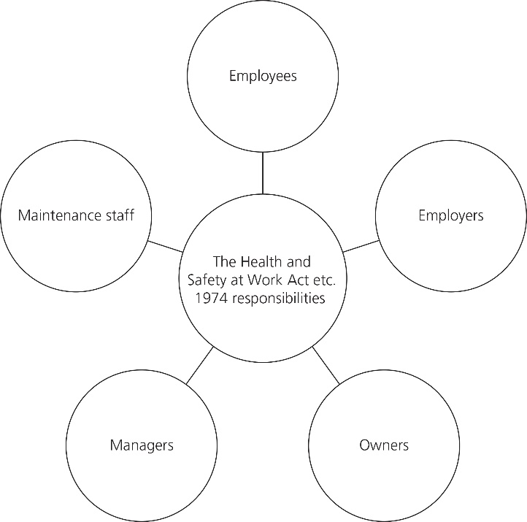

Age | Pregnancy and maternity
Disability | Race
Sex | Religion or belief
Gender reassignment | Sexual orientation
Marriage and civil partnership

Short-answer exam-style practice questions
- Sickness policy, recruitment policy and training and development policy.
- Mandatory policies and procedures are ones that have to legally be completed within a business [1]. A non-mandatory policy and procedure is one that the business may choose or not choose to complete, so it is not a legal requirement [1].
- Businesses use KPIs to measure the strategic success against the set objectives [1], the financial elements of the business and the operational work taken by managers, teams and individuals in all areas of the business [1].
- Red alerts the business to a serious issue that will need to be addressed urgently [1]. Amber means that there is a potential issue so it will need to be investigated [1]. Green means that there are no issues as the teams are meeting their targets successfully [1].
- A process will set out what activities need to be completed, whereas a procedure will state how an activity or task has to be completed.
- A manager of the Human Resources department will create a policy related to sickness in a large organisation.
- Health and Safety policy and procedure.
- Each policy or procedure must be subject to version control, which means that when changes are made, it is clear when/where the changes are saved [1]. Often drafts are labelled as V0.1 and, once changes are made, the document will be saved as V0.2. This way a business can track the changes within these important documents [1].
- A method that a business can use to analyse quantitative data [1] and to measure the outcomes against its goals/objectives [1].
- Website traffic, sales income or profit margins.
- See sample answer in workbook.
- Every policy and procedure that is written within a business will be for a reason. They are written so that the business can work well with the resources that it has [1]. Some policies and procedures are mandatory; they will have been written so that they are abiding by the law [1]. The policies and procedures enable the business to operate well as all tasks will have instructions on the process [1] and how the different stages have to be completed to ensure that quality products and services are sold to customers [1].
- A flexible policy will be reviewed and adjusted when it is required by the person who wrote the policy [1]. Adjustments may be made if an issue occurs, with clear statements made on who can make the changes and the tolerance levels of changes [1]. Inflexible policies cannot be changed [1] and implications will be instigated if the policy is not adhered to [1].
- Two of the following: an identified starting point, an identified end point, an explanation of how to complete a task related to work, an identification of the person/group who should complete the work, the action which the individual/group must take in order to complete the task.
- It is important for a business to be efficient and effective when using resources so that the wastage rates are kept low [1]. Policies and procedures are the framework which helps to ensure that tasks are carried out accurately [1] and in a timely manner so that there are no delays [1]. Management can monitor the progress in line with the policies and procedures to ensure that orders are fulfilled within the required timescales [1].
- A new policy will mean that the staff will be more efficient with the work that they complete [1], providing that the new policy is clearly understood by the staff [1].
- Strategic KPIs measure the business's success against the objectives that have been set [1]. These will be reviewed at specific points during the year as determined by the policy [1]. Financial KPIs are different as they measure the success of the organisation related to the financial side of the business [1], which would include a review of the gross profit/net profit and comparing this to previous years to set realistic targets for future years [1].
- Performance monitoring is when a manager reviews the performance of individuals within their team [1]. Employees will have their performance discussed at annual meetings when successes will be discussed [1], as well as identifying any issues that may have occurred and any training that may be needed or wanted [1]. Performance monitoring also enables the business to monitor how the processes and procedures it has implemented are performing against the targets set [1].

Long-answer exam-style practice questions
- See sample answer in workbook.
- Sample answer: Performance monitoring refers to the human resource process [1] of monitoring its employees, often in the form of annual reviews [1]. Within these annual reviews, set targets from the previous year will be reviewed in terms of success, with achievements being celebrated [1]. Within the review training, requirements will also be discussed for the future and new targets set in the form of KPIs [1]. Performance management can also refer to how the business is achieving the targets that have been set organisation-wide [1]. Each functional area can be assessed in terms of its achievements that have been set [1] and any areas struggling can be investigated [1]. If required, and the business has the means, more resources could be deployed in the form of investment or individuals [1]. Using these individual, functional areas and business-wide approaches to the performance monitoring process, the business should know how it is performing [1].
- Sample answer: It is important for an organisation to have policies and procedures in place so that all staff know the expectations [1] of them. By having policies and procedures that are established within a business, this will ensure that no regulations or laws will be broken [1] and that all employees can adhere to them [1]. When new staff start within a business, they will make themselves familiar with the policies and procedures so that they can understand how the business operates and the expectations of employees [1]. If any changes do occur to these policies and procedures, all staff will need to be informed [1]. Changes can potentially cause negative feelings within the business, as staff get used to completing tasks in a particular way, so changes could cause issues within the organisation [1]. Change will often involve training for the staff affected [1], which will cost the business in terms of time and money [1]. When training staff, this could delay the production of products/services for customers while the staff get used to the new ways [1]. Mistakes also may be made more frequently in the early days of a new policy or procedure being introduced, which could be demoralising for staff [1], as well as costly to the business [1]. The business may also need to invest in new resources [1], which could include equipment. If any slight changes need to be made, the business needs to be confident that the staff are informed and understand the policies and procedures so that they perform to the standard needed to work effectively and efficiently.
- Mark scheme:
Answer | Marks | Guidance
Answers need to identify what KPIs are (key performance indicators) and the relationship to the aims and objectives.  Learners should relate the KPIs to annual performance review meetings due to the question referring to KPIs cascading to staff.  Answers could be specific to certain areas of the business that can be rewarded for application, e.g. the relationship of KPIs to customer awareness of products related to a marketing KPI.  Answers may also relate to targets and how senior management can communicate these to staff, diagrams/charts to show the close relationship to functional areas that may have strategic objectives.  Responses need to be related to the business and the focus/direction of it. | 12 | Level 4: 10–12 marks  - A detailed explanation.  - Understanding of what KPIs are.  - Relevant discussion on the relationship to aims/objectives.  - Answers should relate to APRs and focus on the cascading of KPIs. Could also focus on a functional area.  - Coherent and a well-structured answer.  Level 3: 7–9 marks  - Good and relevant explanations that show an understanding of KPIs.  - Related to aims/objectives and cascading.  - Made relevant points which all are developed.  Level 2: 4–6 marks  - Adequate explanations given related to KPIs.  - A sound understanding of KPIs and staff.  - Made some relevant points, some of which are developed.  Level 1: 1–3 marks  - A basic discussion.  - Very little understanding of KPIs related to the question.  - Lacks detail in general.

7 Project and change management

Recall activities
- Political, Economic, Social, Technological, Legal, Environmental

Term |  | Description
PRINCE2 project management methodology |  | The process is known as the 8 Step Model of Change.
ADKAR model |  | This theory looks at the science behind persuading individuals to make the right decision without them realising.
Kübler-Ross theory |  | This model Illustrated the three processes of change using the concept of changing the shape of a block of ice.
McKinsey 7S model |  | This model explores seven different phases of improving performance or managing change within a business by dividing the elements into two different categories (hard and soft elements).
Nudge theory |  | Awareness, desire, knowledge, ability and reinforcement are all elements of the five stages of change.
Lewin’s Change Management Model |  | Denial, anger, bargaining, depression and acceptance are all the emotions that individuals go through when change is considered and during the introduction phase, the implementation and finally the new normal.
Six Sigma |  | This is a common business methodology that aims to improve the different processes a business uses, reduce waste and errors, and increase customer satisfaction throughout the business. It is predominately based on data and statistical analysis.
Kotter change management theory |  | This involves projects in controlled environments. The main principles of the methodology focus on the management of resources and risks within a business by dividing projects into different stages with clearly defined roles and responsibilities for the individuals involved.
SCRUM |  | Focuses on the project lifecycle by breaking down large projects into smaller chunks, meaning that teams can produce work faster to optimise their workflow and focus on continuous improvements to reduce errors.
Agile project management |  | It encourages individuals to think in a particular way in order to get work completed. The thinking concerns continuously improving and adjusting to the fluctuations in various factors.
- Businesses do not stay still. It is important for them to keep moving forward. A business will do this so that it can remain competitive and continue to improve, which could involve being innovative. Continuous improvements mean that a business looks at its current provision and seeks to improve what it is doing in terms of products/services and processes. This is important so that a business does not get left behind or become irrelevant and therefore have to close due to lack of sales and profits. As well as making continuous improvements, a business will want to look at how innovation could improve aspects of the business. Innovation could be a product, a service, a strategy or a business model that is useful to the business, and is often unique to the area of business it operates in. Innovation could involve a new technological aspect that enhances the business’s operations. Innovation enables a business to adapt its operations, encourages growth and, if the innovation is unique, it could mean that it makes its business stand out from other competitors. Innovation can help a business to improve efficiency and productivity, increase profit, potentially gain new customers, increase customer retention and improve the quality of products and services.
- 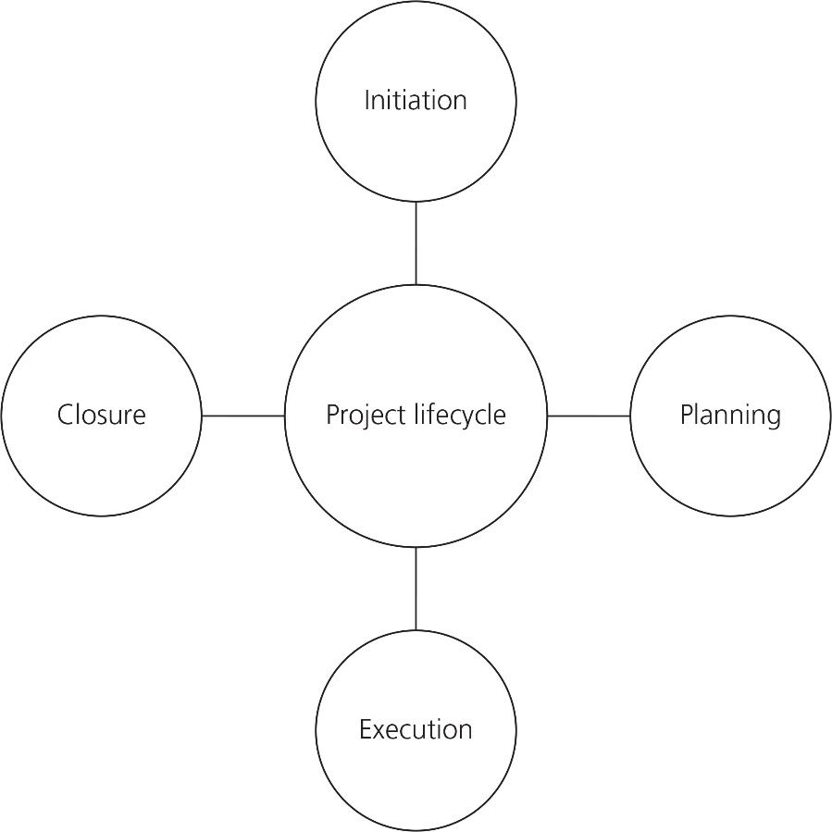

Short-answer exam-style practice questions
- The process of planning, organising, monitoring and applying resources to achieve an agreed end goal.
- Program Evaluation and Review Technique
- Helps to guide the team involved in the project in terms of tone, context, expectations and potential constraints.
- Any two of: What is the problem to solve? What is the overall project about? What are the business goals? How will success be determined? What metrics will be used?
- Research, evidence and evaluation.
- Continuous improvements mean that a business looks at its current provision and seeks to improve what it is doing in terms of products or services and processes [1]. This is important so that a business does not get left behind or become irrelevant [1].
- Businesses need to continually develop and evolve to remain competitive and relevant to the business world.
- Qualitative data is information about people’s opinions and views that is gained by interviewing a customer, for example [1]. Quantitative data is factual information that is collected often in the form of numbers, for example about customers’ ages [1]. Quantitative data is useful for statistical analysis [1], whereas qualitative information gives a business a much more in-depth understanding of key issues [1].
- When the project is viewed in terms of its success or failure related to meeting the business’s goals [1]. A project post-mortem can be a meeting or a report [1].
- A business environment that is constantly changing, so a business has to respond with ideas that may lead to vigorous marketplace activity, new or evolving products, expansion into different markets, development of the business’s technology and rapid change to its operations.
- Models often are a simplified process [1], so more of a scaled-down version of a theory that can be used in a range of different settings [1].
- Change is not always welcomed by everyone in the business. There may be apprehension about something new [1], a lack of understanding about why the change is required [1], as well as a fear of losing a job role if there is a reorganisation of the business due to changes [1].
- Two of the following: initiation, planning, execution or closing.
- Resource management is when managers know how much capacity their team has over a period of time [1], as well as the physical project resources and finances related to project management [1].
- Two of the following: physical resources, IT resources or financial resources.
- Web analytics are the methods that a business is able to use in order to collect, measure, analyse and report [1] the web data from the business’s online presence [1].
- A business would complete a field trial to record how it performs [1], enabling it to make changes before launching to a wider audience [1].
- A conclusion is a summary of the key points that have been discovered as a result of completing the specific research or project evaluation [1]. It enables a business to give final thoughts on the most important aspects [1]. This will aid decision-making about what will happen next [1].
- See sample answer in workbook.
- A Gantt chart [1] is a visual document that displays the schedule and progress for a project [1]. It is an action plan that shows the various activities that need to be completed [1] and by whom, within specific timeframes known as milestones [1]. Other examples could be Six Sigma, PRINCE, flow charts, Critical Path Analysis, PERT.
- Plan-on-a-page is a short and simple plan that should fit on a page. It can be used in many different ways, which means there is no formal layout to be used. However, it should be kept simple and short [1]. For it to work, the user must firstly define the purpose and ambition followed by the financial and non-financial objectives [1].
- A conclusion is a summary of the key points that have been discovered as a result of completing the specific research or project evaluation [1]. It enables a business to give final thoughts on the most important aspects [1]. This will aid decision-making about what is to happen next [1]. A project post-mortem as a form of evaluation is when the project is viewed in terms of its success or failure at meeting the business’s goals [1]. A project post-mortem can be a meeting or a report [1].
- A project management tool is an aid that is used to assist an individual or team [1] to effectively manage a range of tasks effectively to complete a project [1]. A project management approach is the way that a project manager will complete a project [1] using a particular method that suits their management style [1].
- A PESTLE analysis can help a business to make informed decisions [1] regarding the direction of the changes [1] that they may want to implement [1]. It will enable them to focus on the six key areas of political, economic, social, technological, legal and environmental aspects [1].
- The different advantages of the Pareto principle are that it gives the project team focus on the identified tasks that will have the greatest impact on the project in the order of importance [1]. The Pareto principle is a simple and visual format for displaying data [1], which can be used to compare before and after analyses [1] to verify any process that had to change to reach the finish point [1].
- Projects need to be evaluated at various stages because it will help to identify areas to be improved [1], highlights whether outcomes and goals were met [1], can help to determine if there have been any changes as a result of the project [1], and finally identify lessons learnt and how these can be used in future projects [1].
- The advantage of having a dashboard as a form of project management means that the project manager can keep track of the process of the project clearly with the clear display [1] and any updates are highlighted [1].
- Flow charts contain information on the tasks, the decisions and outcomes within the overall planning process, as well as documents, processes and data storage related to projects [1]. Flow charts show boxes linked with specific arrows, which are known as flow lines [1]. A different shape is used when key decisions need to be made [1]. No timescales are shown in terms of how long a task will take or when it needs to be completed, or information on resources that will be needed [1]. Flow charts are a simplistic diagram. They can be completed on paper or on a computer and are a good way to visualise a project. They can also be used for workflows and can identify any issues, such as improvements that may need to be made.

Long-answer exam-style practice questions
- See sample answer in workbook.
- Sample answer: A business could use surveys [1] as they are a good method to gain evaluation material, as often these are circulated to those who have been involved in the project [1]. Asking a range of questions will enable the participants to state their views on the project, as well as identify any issues that may or may not have occurred and the reasons for this [1]. This will give more insight [1] into the process. A range of quantitative and qualitative questions could be asked [1] such as: were pre-defined success metrics achieved, yes or no? This is an example of a quantitative question. How well do you think that the task expectations were defined and communicated? This is an example of a qualitative question. Another method that a business could use would be a validity check [1]. This could involve using a range of different questions which would be aimed at the products and services that they currently offer [1]. The question could be: is the information reliable? Is the information free from bias? Is the information relevant? Does the information’s intended use affect its suitability? Is information complex and up to date? Is the information sufficient and does it have the correct amount of data? [1] Either of these methods would be suitable for the business but it would depend on the time that they have available to complete the evaluation of their portfolio of products/services [1]. Other options that could be evaluated for the answer could be a focus group, group discussion or look at other businesses in the form of a case study to analyse their current provision.
- Mark scheme:
Answer | Marks | Guidance
Answers should relate to CFA as a tool.  The answers need to focus on:  - the mapping of tasks  - the sequencing  - the relationship between activities, time and dependency  - the presentation of the tool in circles and nodes and the reasons for this  - why it helps the team: making them focus on the activities, timings and deadlines  - CFL does not assign tasks to individuals.  Responses need to show an understanding of CFA. | 12 | Level 4: 10–12 marks  - A detailed explanation.  - Understanding of the impact of CFA on a team.  - Relevant discussion on the various elements of the tool.  - Coherent and a well-structured answer.  Level 3: 7–9 marks  - A good explanation that shows an understanding of CFA.  - Relates to improvements for the team within the business.  - Made relevant points that are all developed.  Level 2: 4–6 marks  - Adequate explanations given related to CFA.  - A sound understanding of the elements of CFA and of the business.  - Made some relevant points, some of which are developed.  Level 1: 1–3 marks  - A basic discussion.  - Very limited knowledge of CFA but needs developing.  - Lacks detail in general.
- Sample answer: This change management model focuses on reflecting how an individual travels through the process of change, so concentrates on the employees [1]. It is a supportive process [1] and emphasises the need for clarity and time for reflection [1]. There are five different stages. The first stage is awareness, so making an individual aware of the need for change [1]. Desire is the second stage and involves creating a desire for the change based on the benefits to the individual [1]. The third stage is knowledge, which will involve the employee understanding how that change will happen, informing the individual of the process and the training that may be involved [1]. The fourth stage is ability and ensuring that employees have the necessary skills, competencies and confidence to achieve the change [1]. The final stage is reinforcement and it will happen after the change has occurred [1]. It will often include rewarding and recognising what has been achieved that will sustain the implemented change and keep it in place within the business [1]. The ADKAR model focuses on achieving a positive outcome [1] and it can be used to check the progress of change of an individual and measure success of the change [1]. I therefore think that this will be a good model for the managing director to use, as it will give the employees an understanding of the need to return to the office and the benefits to them, as well as the business of working together in the office again [1].

8 Business behaviours

Recall activities

Verbal | Non-verbal
Tone | Posture
Voice projection | Gestures
Clarity of voice | Eye contact
 | Facial expressions
- Active listening is a form of communication when an individual is engaged in a conversation with another individual in a positive way. It involves listening to another person, paraphrasing or reflecting back what they say, making sure that you remain neutral with your responses so that the individual will continue to share their thoughts. Active listening works well within social, home and work situations.
- 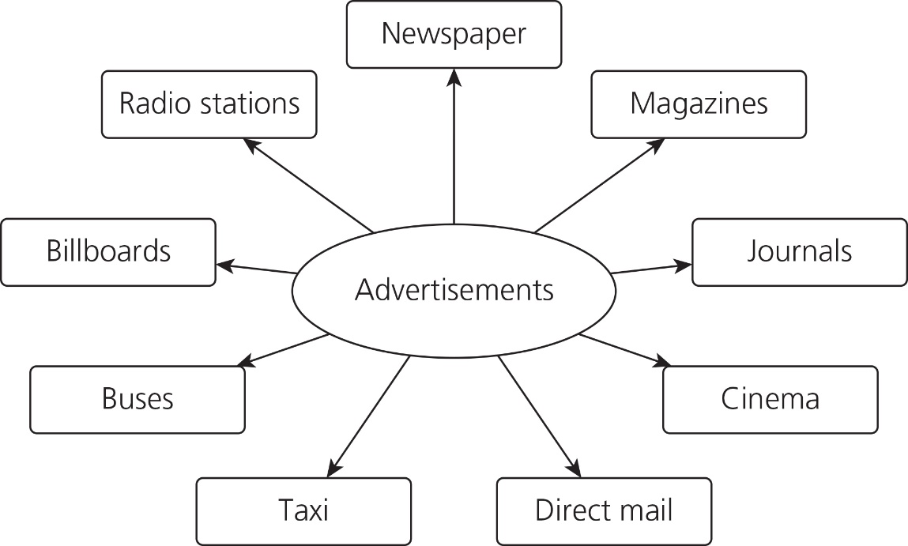

Term |  | Description
Form |  | This enables businesses to attach a range of different documents which the receiver will then be able to access when it is convenient for them. It enables stakeholders to communicate with each other worldwide without having to consider any time differences.
Report |  | This form of communication gives businesses the opportunity to sell their products or services to customers. Some forms of communication are purely for the users to gain information about a particular topic that they are interested in.
Memo |  | The user of this communication can share videos, photos and view things that interest them. Businesses can promote themselves using this communication method by sharing and linking posts to their business.
Website |  | Businesses may require employees to complete a document which is written or online, requiring the user to provide information which could be personal.
Email |  | Within a business organisation, specific areas will need to provide a progress update on different tasks. This could be in the form of project updates, functional area updates, employees’ performance reports, financial documents etc.
Social media |  | This form of communication is a short document that is prepared and sent to internal employees of an organisation.

- 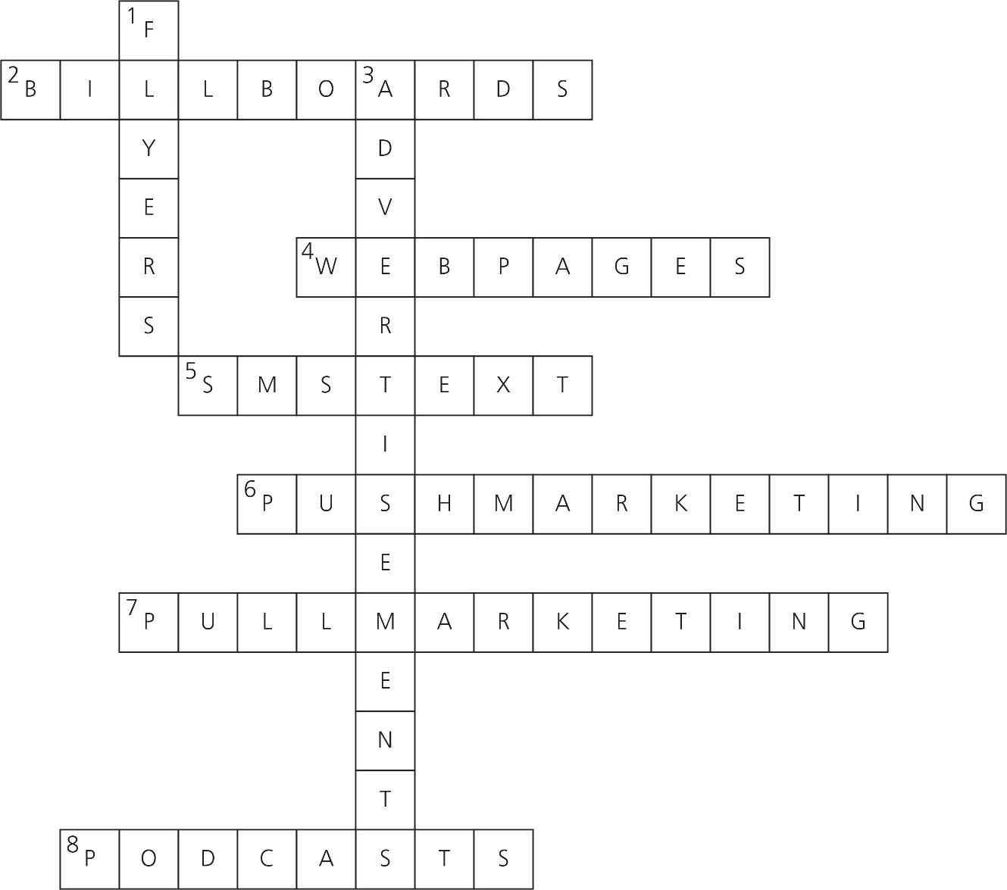

Integrity | Trust
Honesty | Being reliable
Showing commitment | Openness
Strong moral principles | Honest communication
Dependable

Short-answer exam-style practice questions
- Visual
- Five
- Continuing Professional Development
- Adaptability is when an individual is able to adjust their behaviour or actions to a situation, even if the situation is uncomfortable [1]. The individual is able to cope and still appear to be in control. Being flexible means that an individual is able to work around a situation in order to complete the task well [1].
- One of the following:
- The ABC method, which means an individual can prioritise A tasks as the most important through to C tasks which are the least important.
- The 4 Ds mean that the task can either be completed by one individual or delegated to another person. The 4 Ds are do, defer, delegate or drop.
- Positive comments, constructive comments and positive comments.
- A business policy is a set of guidelines [1] that a business expects workers to adhere to when working for the organisation [1]. A procedure is a document that details the steps that individuals will need to take in order to complete a task [1], which will often have to adhere to a business policy [1].
- Three of the following: commitment, role model, respectful, dependable and accountability.
- Rapport is building good relationships with others so that there is a mutual understanding.
- See sample answer in workbook.
- A large retail store may choose to recognise and reward its employees and employers for the work that they complete at different times during the year [1]. This could be monthly, every three months, every six months or annually, with winners receiving a special prize. A retail business could have different recognition awards for the various areas within the business such as sales, customer service, operations, stock control, etc [1]. Employees could be encouraged to nominate different individuals and include the reason why they are being nominated. These could then be reviewed by management and the most deserving employees who meet the criteria will receive the reward [1]. This can encourage workers to work harder for the business if they know that there is a possibility of being rewarded for their commitment to the business [1].
- Any four of the following: e-mail, websites, letters, social media, reports, memos, leaflets, flyers, posters.
- Two of the following: eye contact, body language, active listening, self-awareness.
- Out-of-home advertising or OOH advertising.
- Interactive content enables the user to interact with what is in front of them on a screen [1]. This could be in the form of information, such as a question relating to a specific product or designing the packaging of a product [1]. Some businesses will also provide customers who are online with the ability to have a 360-degree view of products so they can have a more interactive view of the product [1].
- Attention, attitude and adjustment.

Long-answer exam-style practice questions
- See sample answer in workbook.
- Sample answer: Self-development is an important aspect of work, as this is an opportunity for individuals to be able to develop their knowledge and skills [1] while also completing their job role [1]. It is important that managers are aware of the knowledge and skills of their team, as this knowledge can be used within the business [1]. It can also mean that individuals are able to work towards promotions, giving them new challenges [1], which will increase their job satisfaction [1]. It is important that any completed CPD activities are tracked [1], so that the individual and the business know what they have participated in [1], and so the knowledge and skills gained can be put into practice [1]. The business would be advised to implement a CPD tracker as soon as possible for all employers and employees to complete [1]. This should also be reviewed by management once or twice a year so that all new skills/knowledge can be celebrated but also then implemented into the business [1]. This will benefit the individual by being recognised by management [1] but also the business for the new skills learnt that can then be used [1].
- Sample answer: Websites enable a business to inform visitors of their products and services to hopefully gain business from the visit [1]. Websites give businesses the opportunity to sell their products or services to customers [1]. Websites can give customers exposure to promotional sales and offers [1]. The benefits related to the 4Ps of this are that products can be listed on the website with images [1], prices of products can be displayed with sales promotions [1], the website is accessible to anyone with internet rather than having to go to the local store [1] and finally promotion, as the business can pay to advertise the website on Google for example [1]. A business may choose to have pop-ups that appear on screen when individuals are looking for data, in the hope that they will be drawn to the advert [1]. Pop-ups are intended to draw attention and hopefully entice the user [1] to click on the advert [1]. I would advise the business to consider all these points and ensure that they are included in their new website. It will also be vital for the business to review its website content on a regular basis [1] so that it is up to date and correct for customers wanting to purchase items from the business [1].
- Sample answer: Good communication is important to a business like this gym. If clients travel a distance to get to the gym, it is vital that they are aware of the closure [1]. It would be advised to use several different forms of communication [1] and to use the correct house style for their audience. As it is a gym, many young people will use it, so a good form of communication would be an SMS text, as they use their phones frequently [1]. A SMS text pops up on the screen as a notification, so they will see it and know that the gym is closing. As the information that the gym needs to give is limited, a SMS text would be good for this purpose [1]. The gym may also decide to send an e-mail to the gym users informing them of the impending closure [1]. It will be important to use the business's normal house style, the right tone and information regarding the reason for the closure, so that gym users do not come to the gym on that day [1]. Finally, they could produce a traditional flyer that could be handed out to clients a week before the closure [1]. It is a cheap method of informing gym users about the situation. This flyer could also be put on the front door of the gym when it is shut in case some gym users turn up to use the facilities and find it closed [1]. Both the e-mail and flyer would need to be proofread before being sent/printed to ensure that there are no spelling or grammatical errors. If there are errors, it can give a bad impression of the business [1]. Using a range of three different forms of communication will enable the business to inform the gym client base of its closure for 24 hours.

